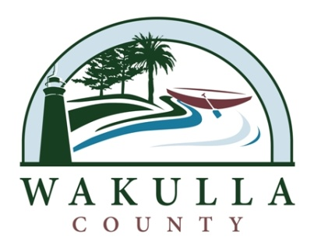 NEWS RELEASE

FOR IMMEDIATE RELEASE: August 11, 2014

Contact:
Jessica Welch
Office of Communications & Public Services
(850) 926-0919

Commissioner Ralph Thomas Accepted to FAC Advanced County Commissioner Program

Tallahassee, FL – Launched by the Florida Counties Foundation in 2006, the Advanced County Commissioner (ACC) education program, "The Florida Forum for County Leaders," is an advanced leadership program designed for graduates of the Certified County Commissioners (CCC) Program. The ACC program is organized as a series of three seminars, with 27 hours of course work. The course content focuses on leadership with an overarching theme of growth and development in Florida. Participating Commissioners must commit to fully participate in all three seminars in order to graduate. Topics Include: Leadership in These Turbulent and Transformative Times, Leading Your Communities During Turbulent Times, Understanding and Working with Stakeholders and County Decision Makers during these Turbulent Times.
All graduates of the Certified County Commissioners (CCC) Program are encouraged to participate in this program. Commissioner Thomas will be one of only 30 Certified County Commissioners to participate in the ACC program this year. The cost for the three sessions is $450. Commissioner Thomas received 1 of 8 full Scholarships, available to small counties with populations of less than 75,000. Commissioner Thomas said, “I am thankful to the Florida Association of Counties for my acceptance into the ACC program. The knowledge and experience I receive from FAC, makes me a better Commissioner and a better servant to the citizens of Wakulla County.”

For more information about the ACC program and courses, visit the FAC web site at www.fl-counties.com. For over 85 years, the Florida Association of Counties (FAC) has represented the diverse interests of Florida’s counties, emphasizing the importance of protecting home rule – the concept that government closest to the people governs best. The Florida Association of Counties helps counties effectively serve and represent Floridians by strengthening and preserving county home rule through advocacy, education and collaboration.

