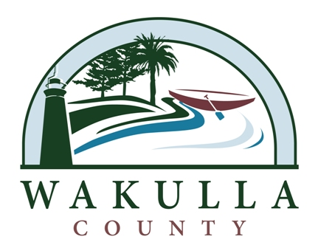 NEWS RELEASE

FOR IMMEDIATE RELEASE: April 8, 2013

Contact:
Jessica Welch
Office of Communications & Public Services
(850) 926-0919

Commissioner Ralph Thomas Represents Wakulla at the Florida Association of Counties and the Florida Association of Small Counties Legislative Meetings

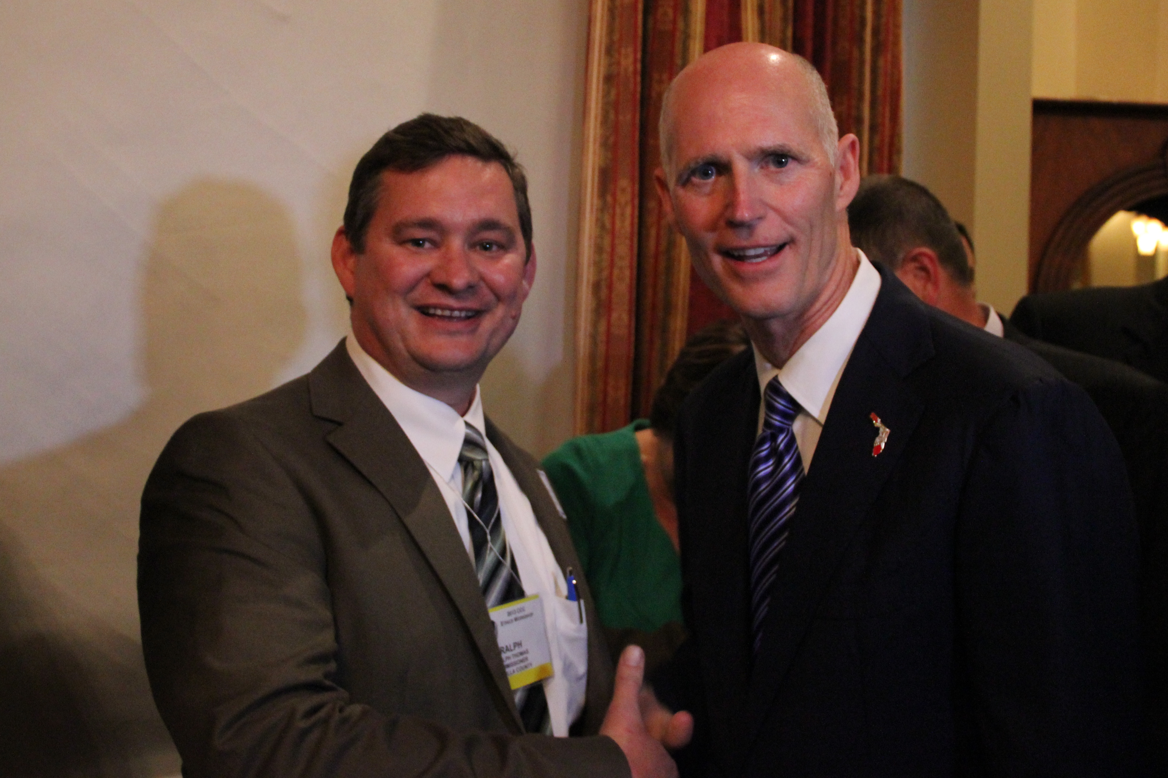
Crawfordville, Florida – Last week was a big week for Florida counties at Florida’s Capitol as the Florida Association of Counties (FAC) and the Association of Small Counties (FASC) held annual legislative meetings in Tallahassee. These meetings provide counties with updates on important legislation impacting Florida counties as well as providing County officials and staff an opportunity to meet with Florida’s Governor, Senators and Representatives on important issues facing Wakulla County.

Commissioner Ralph Thomas is the Board’s delegate on both the FAC and FASC organizations. Last week Commissioner Thomas was working hard for Wakulla County to support Wakulla’s legislative agenda and funding for priority projects. While attending meetings and workshops, Commission Thomas had the opportunity to meet Governor Scott as well as many key legislators.

For more information relating to this story, please contact Sheree Keeler at 850-926-0919 ext. 705.

