Wakulla Cal Ripken Baseball League
Opening/Family Fun Day


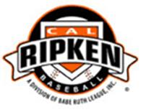

**When:  Saturday, March 5th 2016 at the Wakulla Rec Park**

Schedule of Events

8:30-9:00am          Parade of Teams

9:00-11:00am       Minor/Major League games

11:00-1:00pm       Lunches will be sold

Home Run Derby and other Fun Events

($2.00 per event or 3 events for $5.00)

**Prizes will be awarded in each event, so be sure to come and bring your “A” Game!!**

1:30-3:30pm         Minor/Major League Games

Raffle Drawings

Yeti Cooler (Tan/45 Quart) Raffle - $10 per ticket

Gun Raffle (Remington 870 20 gauge) - $10 per ticket

Limited number of tickets per raffle, so be sure to get a few!!

**Come on out and support your community and the Wakulla Cal Ripken Baseball League – it’s sure to be a fun day for all!**

