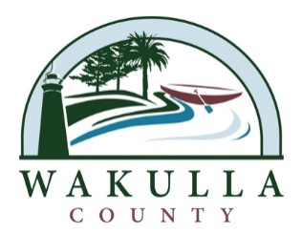

NOTICE OF PUBLIC MEETING

The Wakulla County Marine Advisory Committee will hold a Public Meeting on
Thursday, April 10, 2014, 4:00 p.m. at the
Wakulla County Administration Building at
3093 Crawfordville Hwy., Crawfordville, Fl. 32327
(850) 926-0919

Purpose of Meeting:
To Conduct General Business of the Marine Advisory Committee per Ordinance #2013-32

Persons with a disability needing a special accommodation should contact the Wakulla County Board of County Commissioners Administration Office at least two (2) days prior to the meeting at (850) 926-0919; Hearing & Voice Impaired at 1-800-955-8771; or email at ADARequest@mywakulla.com

