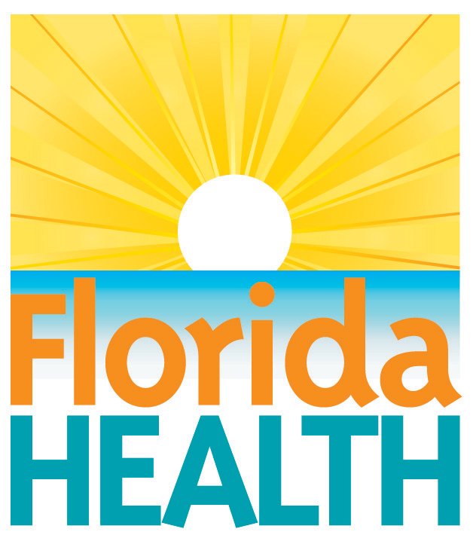
Sept. 22, 2015
FREE HANDS-ONLY CPR TRAINING
IN Wakulla COUNTY
Help the Florida Department of Health Celebrate World Heart Day
Contact:
Grace Keith
Grace.Keith@flhealth.gov
850-926-0400
Crawfordville — The Florida Department of Health in Wakulla County invites you to participate in Hands-Only™ CPR training on Sept. 29. The department is hosting trainings in each county in celebration of World Heart Day, an annual event created by the World Heart Foundation to remind everyone that heart disease and stroke are the world’s leading causes of death.
Hands-Only™ CPR is cardiopulmonary resuscitation without mouth-to-mouth breaths. It is recommended for use by people who see a teen or adult suddenly collapse in an “out-of-hospital” setting, such as at home, at work or in a park. In the event of a cardiac emergency, people are more likely to perform Hands-Only™ CPR and ultimately save a life.
What: Hands-Only™ CPR Training
When: Sept. 29, 2015
10am-12noon
2pm-4pm
7pm-9pm
Where: 48 Oak Street, Crawfordville
World Heart Day is celebrated in collaboration with Healthiest Weight Florida, a public-private collaboration bringing together state agencies, not-for-profit organizations, businesses and entire communities to help Florida's children and adults make consistent, informed choices about healthy eating and active living. To learn more about how to be active and make nutritious food choices, visit www.healthiestweightflorida.com.

About the Florida Department of Health
The department works to protect, promote and improve the health of all people in Florida through integrated state, county and community efforts.
Follow us on Twitter at @HealthyFla and on Facebook. For more information about the Florida Department of Health please visit www.FloridaHealth.gov.

