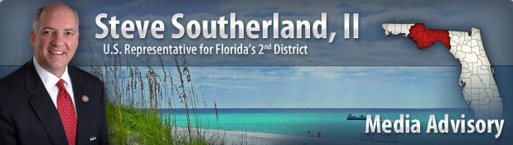

**\*\*\*ADVISORY: SOUTHERLAND STAFF TO HOST WAKULLA COUNTY MOBILE OFFICE HOURS\*\*\***

**PANAMA CITY, FL** – U.S. Representative Steve Southerland, II announced today that his Florida staff will be hosting mobile office hours in **Wakulla** County on Monday, June 30th.

**WHAT:** Rep. Southerland mobile office hours in Wakulla County

**WHEN:**          Monday, June 30th   

10:00am – 12:00noon ET

**WHERE:** County Administration Building

                        3093 Crawfordville Hwy

                        Crawfordville, FL

**WHO:** Residents of Wakulla County and the surrounding area are invited to join Rep. Southerland’s staff to provide input on legislation, ask questions or request assistance with a federal agency on issues including: Social Security, Medicare, Housing and Urban Development, IRS, Veterans Affairs, and Immigration.

**CONTACT:** For questions, please contact Lori Hutto at (850) 561-3979 or [Lori.Hutto@mail.house.gov](mailto:Lori.Hutto@mail.house.gov)