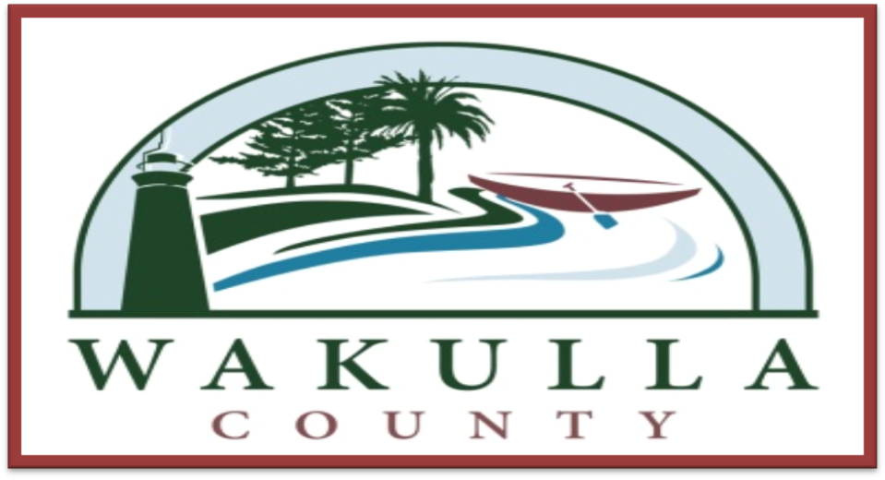

Fiscal Year 2013-2014
Tentative Budget & Five Year Plan

Public Hearing September 3, 2013

J. David Edwards, County Administrator
Wakulla County Commission Complex
3093 Crawfordville Highway
Crawfordville, FL 32327

[This Page Left Intentionally Blank]

Table Of Contents

Page #
Section 1 – Introduction 5-6
- Administrator’s Budget Message 7-16
- Reader’s Guide to the Budget 17-18
- Overview of the County 19-20
- County Government 21-26
- Organizational Chart 27-28
- Budget Calendar 29-30
- Budget Process & Financial Policies 31-36

Section 2 - Fiscal Year 2013-2014 Budget Summary 37-38
- County-wide Budget Summary 39-42
- General Fund Budget Summary 43-46
- Special Revenue Funds Budget Summary 47-50
- Capital Project Funds Budget Summary 51-54
- Enterprise Funds Budget Summary 55-58

Section 3 – Fiscal Year 2013-2014 Detailed Budgets 59-60
- General Fund Departmental Detailed Budgets 61-114
- Special Revenue Funds Detailed Budgets 115-180
- Capital Project Funds Detailed Budgets 181-212
- Enterprise Fund Detailed Budgets 213-222
Section 4 - Historical Data 223-224
- Revenue History 225-238
- Millage Rate & Taxable Value History 239
- General Fund Cash History 240
- Long-term Debt Schedule 241-242
Section 5 – FY 2014-15 to FY 2018-19 Five Year Plan 243-244
- Forecast Summary and Assumptions 245
- General Fund 246-248
- Major Special Revenue Funds 249-255
- Major Capital Project Funds 256-259
- Major Enterprise Funds 260-263
- Capital Projects 5 Year Plan 264

Section 6 – FY 2013 – 14 Constitutional Officers Detailed Budgets 265-266
- Clerk of Court 267
- Property Appraiser 268
- Sheriff 269 - 271
- Supervisor of Elections 272
- Tax Collector 273

[This Page Left Intentionally Blank]

Section 1

Introduction

[This Page Left Intentionally Blank]

County Administrator’s Budget Message

Members of the Board of County Commissioners
Wakulla County Commission Complex
3093 Crawfordville Highway
Crawfordville, Florida 32327

Honorable Chairman and Commissioners:
I am pleased to present the Tentative Fiscal Year 2013/2014 Operating Budget and Five Year Plan. The total tentative budget is $38,593,694; an overall decrease of 12.0% from the current fiscal year budget as amended May 31, 2013.
This is the first year the budget preparation process was managed by the Clerk of Court’s Finance department. As part of the transition, the Finance department demonstrated a new software program that will be utilized to forecast revenues and expenses in the future based on historical data and performance measures. By accurately predicting the future trends of revenues and expenses, the budget process will be simplified and changes to the budget will be based on sound assumptions. This method also enables the County to focus on long term planning and the effect that each year’s budget has on the County’s future financial position.
The FY2013/2014 tentative budget places a strong emphasis on continuing fiscal discipline. Funding adequate reserves and eliminating the use of cash balances to fund on-going operations continue to be priorities. The overall fiscal health of the County has improved even as we face challenging economic times. Staff has continued to trim the budget. In fact, this budget has been trimmed to the degree that does not allow for any unforeseen major problems that arise. Therefore as has been discussed in prior budget meetings, if an issue arises that calls for spending outside of what has been forecasted, staff will have to come back to the BOCC to ask for a budget amendment.
Neither the FY2013/2014 Tentative Budget nor the Five Year Plan fully addresses all the infrastructure and building maintenance needs of the County. Below is a list of items not addressed:
- Panacea Woman’s Club. The building is currently closed due to mold and a leaking roof and general overall poor condition.
- Maritime Museum Site. The funding for this project has not come to fruition as planned by Florida Foresight. A new plan for this property needs to be created.
- Wakulla Welcome Center. The building is in need of major repairs. The TDC is working on cost estimates for renovation with anticipation of funding coming from the RESTORE ACT.
- Medart Fire/EMS Station 5. The building is in need of major renovation.
- BOCC Administration Complex. FDOT is moving up funding for the four laning of HWY 319 from the Tallahassee Airport to HWY 98 and eventual relocation of the building will be needed.
- Sewer Force Main on HWY 319. This will be to be relocated to just outside the right of way due to future four-laning of HWY 319.
- Lift Station maintenance and replacement. The county owns and operates 73 lift stations and the annual budget for major maintenance and replacement is only $100k.
- Animal Control Shelter and office. The facility is very old and in need of major renovations. The work environment for our employees and the living conditions for the animals is not good.
- Public Works Facility. The roof needs to be replaced and storm drainage corrected around the building.
- BOCC Meeting Chamber relocation.
- Newport Park Renovation. The parks infrastructure is in need of renovation. The county makes $25k each year from RV and camping site rentals.
Budget Process Overview
The formulation of the FY2013/2014 budget began in March 2013, with a meeting with all Constitutional Offices and BOCC department directors. The Board held its first budget workshop soon after providing an opportunity to give staff direction in the budget development process and for the public to voice their opinions and concerns.
In accordance with Florida law, the maximum millage rate that may be approved by a simple majority (three out of five) vote of the Board of Commissioners is the roll back rate (or “roll-up” rate due to the decline in taxable value this year), calculated pursuant to section 200.065, F.S., adjusted for growth in personal income. That millage rate is 8.8972. At the first budget workshop, the Board directed staff to prepare the Tentative Budget with a millage rate of 8.500. Significantly, this millage rate reflects a 4.46% property tax reduction below the county’s roll back rate, as defined under state law.
The Board’s direction to reduce countywide property tax revenues by capping the tentative millage rate at 8.5000 mills created a $269,283 deficit in property tax revenues generated as compared to fiscal year 2012/2013.
The Board will be able to accomplish this property tax reduction through the following direction given during their first two budget development workshops:
- Zero program growth across county government.
- Cost of living increase only for county employees earning below a living wage.
- No health insurance cost increase for employees.
- Enhance focus on grant opportunities.
- 8.5000 millage rate as basis for FY13/14 budget.

General Fund Revenues
Wakulla County has a diversified approach to funding governmental operations. Reliance on Ad Valorem taxes which was traditionally done in the past has proven to be problematic over time. The property values fall and rise dramatically and the Legislature continues each year to attack Counties ability to collect Ad Valorem taxes by passing major exemptions. As a result of the value fluctuations and growing exemptions, the County added the Public Services Tax (PST) and increased the Communications Services Tax (CST) to the revenue funding formula in 2011. By adding these taxes, a more stable funding source is being realized allowing for better cash flow management. Also, these fees are collected from all residents of the county, not just land and home owners.
Ad Valorem Taxes. If approved during the final budget public hearing, the final millage rate utilized in this budget plan will generate $8,741,022, of which 95% will be budgeted to support core government services within Wakulla County. The tax is broken down and $7,236,199 is being sent to fund the Sheriff’s Fine and Forfeiture Fund and the remaining $1,067,772 will go towards supporting the General Fund operations in addition to an estimated $10,000 in delinquent taxes. This tentative budget plan, in accordance with the Board’s direction from the first two workshops of the 2013/2014 budget development cycle, has been prepared using this proposed millage rate of 8.5000 mills as described above. As the gross taxable value for the County has decreased by $41,948,572 or 3.92%, property (commercial and residential) owners should experience an overall net property tax decrease.
PST and CST Tax. The tentative FY2013/2014 budget projects that the current rates levied will remain the same as the current year. The anticipated increase of $87,012 is a result of additional population and an increase in the economic environment. Each tax will bring in the following:
- PST - $1,029,000
- CST - $838,338
Intergovernmental Revenues. These revenues come from various federal, state and local agencies and make up $4,780,791 of the General Fund budget as listed individually below:
- Fiscally Constrained Counties appropriation - $1,626,072 which is a reduction from the current year budget by $78,133.
- Half Cent Sales Tax – $1,692,516 which is an increase of $178,885 from the current year budget.
- State Revenue Sharing - $562,757 which in as increase of $31,747.
- Race Track Fund - $446,500 which is the same as last year. This revenue is split with the Wakulla County School Board.
- State Grants - $95,946 which is an increase of $2,288
- Miscellaneous State funding - $ 357,000 which is an increase of $12,588
Local Revenues. These revenues are collected as fees charged for various county services, fines assessed and other miscellaneous revenues. The FY2013/2014 tentative budget for these revenues is $1,695,842, an increase of $30,882. The highlights of these local revenues are:
- Planning & Community Development Fees - $105,742 which is an increase of $35,642
- Probation Fees - $112,500 which is an increase of $3,500
- EMS Fees - $800,000 which is an increase of $50,000
- Building Fees - $240,702 which is a decrease of $42,058

Transfers & Cash Forward. Inter-fund transfers of $98,392, an increase of $30,000 and cash forward of $587,825, an increase of $485,319 are planned for the FY2013/2014 tentative budget.

- Inter-fund transfers of $13,392 for the E-911 Fund to support the GIS Mapping program, $15,000 for the Building Department for building rent, $30,000 for the Road Fund and $40,000 for the Fire Department Fund for indirect administrative support based on previous cost allocation plans.
- The Cash Forward comes from $168,325 set aside in the Facilities Management Department for the scheduled contamination cleanup, $247,190 set aside for repairing the Sheriff’s Office roof, $18,000 set aside in the Agriculture Extension Department for air conditioner replacement, $30,000 set aside in the Library Grant and $124,310 set aside in the Building Department for use as planned and directed by the BOCC to spend down the restricted fund balance.
General Fund Expenditures
The tentative General Fund budget for all programs and services under the Board of County Commissioners is $9,860,770. This is an overall increase of $491,384 or 5.25% over the previous year. This increase is summarized below:
- Salaries & Wages – increased $115,343 due to wage adjustments to 8 employees and 3 new positions
- FICA tax – increased $8,600
- Retirement costs – increased $71,483 due to the State raising the retirement contribution rates
- Insurance costs – increased $225, 020 due to a 6% rate increase and adjustments necessary for the future implementation of the Affordable Care Act.
- Worker’s Compensation and Unemployment Compensation – increased $6,678
- Operating costs – increased $9,278
- Equipment costs – increased $259,745 due to roof repairs at the Sheriff’s Office
- Transfers to other funds and agencies – decreased $117,892
- Transfers to Constitutional Officers – increased $36,406
- Budgeted Reserves increased – $124,013
The following are highlights of each General Fund departmental FY2013/2014 budget.
The General Administration departments encompass a wide variety of county-wide expenses. The key components of Administration are:
- Board of County Commissioners - $270,861
- County Administrator - $527,789
- County Attorney - $205,819
- County Auditor - $79,461
- Worker’s Compensation - $100,000
- Unemployment Compensation - $15,000
- Property Insurance - $180,000
- Liability Insurance - $115,000
- Employee Flex Plan - $125,000
- Aid to School Board - $247,250
- Budgeted Reserves - $160,405
- Inter-fund Transfers - $88,159
- Telephone & Utilities - $106,890
- Other Miscellaneous - $173,685
Each year the Board approves funding for local service agencies and organizations, State mandated health and human service costs and various memberships to organizations that perform critical public services that may otherwise fall to government to perform. The services provided by these agencies greatly enhance the quality of life for residents of the County. In addition, these organizations also leverage substantial private sector and state funding and support for these human service-type programs.
The tentative FY 2013/2014 budget includes $580,059 of funding for these initiatives. Below is a list of these expenditures:
- Memberships – Florida Association of Counties, Small County Coalition, CRTPA, Apalachee Regional Planning Council, Municipal Code Corporation, and Wakulla Chamber of Commerce - $39,855

- Health and Human Services - $539,976. A breakdown of these services are:
  - Medicaid cost share $277,460
  - Health Department contribution $55,000
  - Senior Citizen’s Center contribution $69,101
  - Medical Examiner $55,415
  - Sanity Inquisitions $55,000
  - Other miscellaneous services $28,000
The Board’s ability to maintain funding for these services during a meager budget year is a remarkable achievement and indicative of the ongoing support of these initiatives.
The Planning and Community Development department’s tentative budget of $277,813 increased $124 while revenues increased by $35,642. The increase in expenses was due to realignment and adjustment of personnel and increased health insurance costs. The increase in anticipated revenue is a result of the increased activity in permitting which is anticipated to continue into next year.
The Code Enforcement department’s tentative budget of $113,816 increased $39,523. This increase is due primarily to adding an additional Code Enforcement officer and increasing funding for property cleanup.
The Animal Control department’s tentative budget of $187,529 increased $20,018. This increase is primarily due to a health insurance cost increase for a position that was filled in which the previous employee did not have health coverage with the County and increases in scheduled overtime.
The Airport department’s tentative budget of $5,950 increased $2,450 due primarily to additional funding for maintenance costs.
The Library department’s tentative budget of $353,119 decreased $11,551. The Library’s budget is comprised of $207,273 in General Fund revenue support, $22,000 in Friends of the Library support and $123,846 in State Grant funding. The General Fund support increased $161, the Friends of the Library support increased $16,000 and the State Grant funding decreased $27,712. The net decrease in funding is due to less State Grant cash forward being budgeted in the coming year.
The Agricultural Extension department’s tentative budget of $178,920 increased $16,268. Overall operational costs decreased by $1,732 while $18,000 in cash forward was budgeted for air conditioner replacement through the Extension office buildings.
The Facilities Management department’s tentative budget of $600,464 increased $456,504. The substantial increase is due to $168,325 in anticipated expenses for the fuel contamination cleanup that is being mandated by the Florida Department of Environmental Protection (FDEP). $247,190 of the increase is the estimated cost to repair the Sheriff’s Office roof. $25,223 of the increase is attributable to personnel costs which corrected salary allocations between this department and the Parks Department. The remaining increase of $15,766 is for replacement cost of HVAC units, installation of energy efficient switches and lights and additional maintenance needs due to the continuing degradation of our facilities.
The Probation department’s tentative budget of $159,699 increased $6,848. Health insurance and retirement costs increased $12,449 and operational costs decreased $5,601.
The Veteran’s Service department’s tentative budget of $42,999 increased $163. Health insurance and retirement costs increased $6,275 and operational costs decreased $6,112.
The Emergency Medical Service department’s tentative budget of $1,676,750 increased $19,421. Revenue from the collection of patient billings increased $50,000. Health insurance and retirement costs increased $24,738 while operating costs decreased $5,317. Programs implemented during the current year have proven effective and overtime is now being controlled by properly staffing all shifts and also providing extended ambulance service (4th and 5th ambulance) with the cross trained staffing program. With the replacement of two ambulances and the elimination of an eighth ambulance the department will realize maintenance savings this year. Collections have improved dramatically due to increased management of the collections process and purchasing of new software that cuts down on errors and immediately files insurance claims.
The Recreation department’s tentative budget of $244,506 increased $42,200. This increase is due primarily to an increase in health insurance and retirement costs of $29,995 and $20,000 in maintenance costs for the Community Center and Ochlockonee Bay Bike Trail.
The Parks department’s tentative budget of $260,788 increased $13,894. This increase is due an increase in health insurance and retirement costs of $16,944 and a decrease in operating costs of $3,050.
The Building department’s tentative budget of $ 365,013 increased $39,747. Several factors are involved in this increase. First, a significant reduction in residential inspection fees is planned in order to help reduce the fund balance of these restricted funds. This action will help to ease the cost of building in the county. Personnel costs increased $12,072 due to the planned replacement of a retiring employee, FICA tax increased $1,721 and health insurance and retirement costs increased $31,908. Operating costs decreased $10,954, equipment replacement costs decreased $20,000 and budgeted reserves increased $24,315. The combination of the planned decreased revenues and increased costs should reduce the fund balance to appropriate levels over the next 5 years.

Special Revenue Funds
The following are highlights of some of the major Special Revenue Funds FY2013/2014 budget.
The Boating Improvement Fund tentative budget is $74,250. This fund’s revenue is comprised of collection of boat ramp fees, annual passes and boat registration fees. The expenditure of these proceeds occurs primarily on boat ramps and marine related maintenance and construction.
The BP RESORE ACT Fund tentative budget is currently set at $75,000. If a settlement is reached and rules are passed down this budget could change dramatically. The $75,000 budget is set primarily to pay for expenses to attend Gulf Consortium meetings, pay dues to the Consortium and pay for potential consulting services if needed. If no funds are received from the settlement, the General Fund will cover these expenses.
The Road Department Fund tentative budget is $2,212,185. Gas tax revenues are up by $12,244. Anticipated expenses include the purchase of replacement equipment. An “arm mower” will be purchased while a dump truck and a “skid steer” will be lease purchased with a “buy-back” option. A bypass pump will be purchased with the cost being shared between this fund and the sewer fund. Funds have been budgeted for various bridge repair based on age and safety requirements.
The Fire Municipal Services Benefit Unit (MSBU) is the mechanism used to fund the fire service operating expenses and equipment for both the 1 professional and 10 volunteer fire service units. The tentative budget of $1,268,271 does not request an increase in the MSBU rate of $75. This budget has decreased by $1,205,771 over the previous year. This decrease is the result of $1,000,000 being budgeted last year for building construction which did not occur and a reduction in capital equipment purchases of $330,000. $215946 in cash forward is budgeted for the needed repairs to Station #8 repairs and a new fire truck is scheduled to be financed over the next 4 years costing $50,000 each year.
Capital Improvement Funds
The following are highlights of some of the major Capital Project Funds FY2013/2014 budget.
The Capital Projects Fund tentative budget is $1,384,512. The major project is the NCRS Mitigation Grant which will make needed repairs on Bostic Pelt Road at Mill Creek, on Walker Creek Road at Shell Point and on Surf Road at Buckhorn Creek. The total cost of the three projects is $1,279,250.
The One Cent Sales Tax Fund tentative budget is $2,955,034. One Cent Sales Tax revenues are estimated to decrease $26,318 in the coming fiscal year. The major projects to be funded by the One Cent Sales Tax are:
- $350,000 in road paving as determined by the BOCC
- $297,500 in grant match for the NRCS Mitigation Grant
- $100,000 in road striping as determined by safety factors
- $75,000 for EMS Facility design
- $400,000 for completion of Sheriff’s Annex Building
- $100,000 for Community Center completion
- $50,000 for air conditioner replacement
- $100,000 for soccer complex land purchase
- $295,000 for 9 Sheriff vehicles
- $100,000 for 1 Ambulance chassis remount
- $100,000 for Parks & Recreation equipment, lighting and construction
- $775,285 for debt service payments
- $8,400 for final installment of TDC Grant match
- $203,848 for budgeted reserves
The Road Paving Fund tentative budget is $1,409,225. The funds are provided by several Florida Department of Transportation grant programs such as SCRAP, SCOP, CIGP and SGIP. The roads that will be resurfaced using these grants funds are:
- Bostic Pelt Road
- Trice Lane
- Wakulla Arran Road
Enterprise Funds
The following are highlights of the Enterprise Funds FY2013/2014 budget.
The Wastewater Fund tentative budget of $2,067,901, a decrease of $7,656 does include an annual CPI rate increase of 2.4% to cover increases in chemical and testing cost increases. The budget assumes that Talquin sewer from the Oyster Bay WWTP will be connected and tap fees paid in the current FY 12/13 budget year. The County is currently working with the USDA Rural Development program to obtain financing for the expansion of the Otter Creek WWTP which if successful will allow an increase in capacity of 0.600 MGD and allow for the refinancing of the existing outstanding debt, therefore repositioning this fund to be solvent moving into the future.
The Riversink Water Fund tentative budget of $51,644, a decrease of $45,358 does not include an annual CPI rate increase since the rates were adjusted earlier in FY 12/13. This decrease is primarily due to cash forward being budgeted in the FY 12/13 for the painting of the water tower. This past year the rates increased for the customers on this system. This revenue will be monitored to ensure that this adjustment works to keep the fund healthy and also to make sure that the rates do not over charge the customers.
The Solid Waste Fund tentative budget of $3,845,851, a decrease of $714,667, does not request an increase in the Solid Waste fee of $196. This decrease is primarily due to the budgeting of cash forward in FY 12/13 for the “capping” of the landfill as required by the Department of Environmental Protection. This project has begun and is expected to be completed in FY 13/14 and will require the borrowing of $1,000,000 to go along with the $511,000 in cash that was set aside for this project. Currently, this fund can handle the scheduled payback of the loan without an increase to the current fee structure.
Reserves
The tentative FY2013/2014 reserves for all funds are anticipated to decrease in total by $2,409,784. While $1,003,098 has been set aside in various reserves in FY 13/14, $3,412,882 of existing cash has been budgeted to be spent on various capital projects. Below is a breakdown of the use of reserves of the County’s major operating funds. Also provided is the fund’s anticipated FY2013/2014 ending reserve levels which is highly dependent upon the current FY 12/13 ending fund balance levels.
FY 2013/2014 Reserve Total Estimated FY 13/14
Fund Increase (Decrease) Ending Fund Balance
General Fund $(302,425) $2,165,542
Building Department Fund (99,995) 535,107
Road Department Fund (4,802) 438,600
Sheriff Fine & Forfeiture Fund (134,657) 421,913
Fire MSBU Fund (180,410) 201,791
1 Cent Sales Tax (936,644) 521,397
Sewer Fund (2,131) 271,359
Solid Waste Fund (398,679) 38,274

Constitutional Officers
Constitutional Officers provide services ranging from property appraisal and tax collection to law enforcement and court services, election services and financial and accounting services. The FY 2013/2014 tentative budget for all constitutional offices is $12,500,966, a $363,594 decrease from the previous fiscal year. This reduction is primarily the result of $250,000 in reserves being removed from the Sheriff’s budget and a $150,000 cut to the Sheriff’s budget to stabilize fund balance over the 5 Year Plan. All of the constitutional offices are funded primarily through General Fund revenues.
The Clerk of Court’s tentative budget of $545,534 holds steady at the same level of funding as last year. The Board funds only a portion of the Clerk’s total budget. The Board provides funding for finance, accounting and budgeting functions and Clerk to Board official records functions. The Clerk’s office receives additional funding for court-related services, county recording services and information technology needs through the collection of fines, fees and service charges. The Clerk’s Office also receives a Child Support Enforcement grant to help defray the cost of child support enforcement services.
The Property Appraiser’s budget of $964,681 increased by $19,037 which is a result of FRS retirement and CHP health insurance rate increases. The Property Appraiser receives a small amount of funding from the Northwest Florida Water Management District. The Property Appraiser is responsible for determining the value of all property within the County. The Property Appraiser is also responsible for maintaining property ownership records, parcel ownership maps, and administering all tax exemptions.
The Sheriff’s budget of $9,960,056 decreased by $400,000 compared to last year. This reduction of $400,000 is the result of removing $250,000 in budgeted reserves and an actual cut of $150,000. The Sheriff’s budget is accounted for in the Fine and Forfeiture Fund. This fund allows the Sheriff to utilize all of the Housing Prisoner Revenue along with all associated Housing Prisoner Bed Revenue reserves as well as General Fund revenue support by assigning 7.9 Mils of the Ad Valorem tax revenue to this fund in support of Law Enforcement, Corrections and other public safety functions. The Sheriff’s Office also receives several grants and maintains many trust funds to help defray the costs of providing its various law enforcement and corrections related duties.
The Supervisor of Election’s budget of $358,699 increased by $18,995 which is a result of FRS retirement and CHP health insurance rate increases. The Supervisor of Elections is responsible for maintaining voting records and registration and supervising, tallying and reporting the votes cast by Wakulla’s citizens in its various elections. The Supervisor of Elections is also responsible for maintaining all candidate forms and reports. The Supervisor of Elections receives grants from time to time to help defray the costs of supervising elections and providing necessary election equipment.
The Tax Collector’s budget of $671,996 decreased by $1,626. The Tax Collector’s office is responsible for the collection of the County’s ad valorem taxes, MSBU fees and Solid Waste assessments as well as other miscellaneous local fees. The Tax Collector is also the local agent for several State agencies. The Tax Collector collects taxes for the Department of Revenue, vehicle and boat registration and driver’s license renewal fees for the Department of Highway Safety & Motor Vehicles and hunting and fishing licenses for the Florida Wildlife Fish & Game Conversation Commission.
In closing, I would like to express my appreciation to the Board, County staff and Constitutional Officers who have contributed and given guidance to this budget preparation process. I maintain my confidence that improvements in the annually crafted budget plan will continue to increase the quality, efficiency and transparency of Wakulla County government services for our citizens.

J. David Edwards
County Administrator

Reader’s Guide To The Budget

The Wakulla County budget document is intended to provide information in a way that is easily understood by a reader not familiar with the day to day operations of Wakulla County. The budget document outlines the operations of Wakulla County and is also intended to serve as a policy document, financial plan, and guide for county departments and programs. The Reader’s Guide provides basic budgeting information and a summary of each section found within this budget document. The following is a brief description of the information included in each section of this document.
Section 1 – Introduction
Administrator’s Budget Message
This section briefly summarizes the recommendations and goals proposed by the Board of County Commissioners in establishing the upcoming fiscal year 2013-2014 budget, the current financial status of the County and the tentative proposed budget for the General Fund, Special Revenue Funds, Capital Project Funds, Enterprise Funds and the total County-wide budget.
Overview of the County
This section provides information regarding various aspects and trends of the County such as geographic data; demographic data on population and housing; economic data on employment, education, income, business and tourism.
County Government
This section provides information regarding the formation and structure of the County’s government, its elected officials, and administrative leadership. This section also includes a County Organizational Chart as approved and amended by the Board of County Commissioners.
Budget Calendar
This section provides an outline of the budget calendar and budget adoption process as adopted and amended by the Board of County Commissioners. The budget calendar complies with all applicable Florida Statutes and the rules of the Florida Department of Revenue’s Truth In Millage (TRIM) process.
Budget Process and Financial Policies
This section outlines the budget adoption and budget amendment processes. It further provides for the budget and financial policies which guide the Budget Officer and County staff throughout the budgeting process.
Section 2 – Fiscal Year 2013-2014 Budget Summary

This section summarizes the total County-wide budget with two schedules. It also summarizes the General Fund, Special Revenue Funds, Capital Project Funds and Enterprise Funds with a brief description outlining the changes over the previous year followed by a schedule comparing FY 10/11 actual data, FY 11/12 budget and actual data, FY 12/13 budget and actual data and the tentatively proposed FY 13/14 budget. Each schedule also summarizes revenues and expenditures by category, functions and type.

Section 3 – Fiscal Year 2013-2014 Detailed Budgets

This section outlines the County’s General Fund revenues and expenditures by department by detailed line items. A brief outline of each department is provided before the department’s FY 2013/2014 tentative budget. A comparison to prior FY 2010-11, FY2011-12 and FY2012-13 is also provided.

Following the General Fund Departmental Detailed Budgets is a detailed budget for every Special Revenue Fund, Capital Project Fund and Enterprise Fund. A brief outline of each fund is provided before the fund’s FY 2013/2014 tentative budget. A comparison to prior FY 2010-11, FY2011-12 and FY2012-13 is also provided.

Section 4 – Historical Data

This section includes a history of the County’s major revenues, ad valorem millage rates, ad valorem taxable values, General Fund cash balances and a County-wide long-term debt schedule.

Section 5 – FY 2014-15 to FY 2018-19 Five Year Plan

This section includes a brief explanation of the forecast summaries and assumptions made in the current five year plan. Included is the five year plan for fiscal years 2014-15 to 2018-19 for the General Fund, and the major Special Revenue Funds, Capital Project Funds and Enterprise Funds. These five year plans provide a long-term picture of the impact of current budget policies, trends and goals on the County’s finances and fund balances and the financial feasibility of those policies, trends and goals in the long term.

Section 6 - FY 2013 – 14 Constitutional Officers Detailed Budgets

This section provides a detailed line by line budget for each Constitutional Officer. For the current Fiscal Year 2012/2013, actual expenditure data, the approved budget and year-end projected totals are provided. For Fiscal Year 2013/2014, the requested budget and tentatively proposed budget data is provided.

Overview of County

Geographic

Wakulla County (the County) is located in the “panhandle” of North Florida and consists of 606.42 square miles with approximately two-thirds of this land area being preserved by national, state and local forests, preserves, sanctuaries, management areas and parks. Wakulla County borders Leon County to the north, Liberty and Franklin Counties to the west, Jefferson County to the east and the Gulf of Mexico to the south.

With only two small incorporated towns, Sopchoppy and St. Marks, Crawfordville is the only unincorporated county seat in Florida. Crawfordville is centrally located within the County along the main arterial route U.S. Highway 319. Crawfordville is bound by the Apalachicola National Forest to the west and the St. Marks National Wildlife Refuge to the east and south.
Demographic

Population – The County’s population according to the 2010 census was 30,776. The estimated 2012 population is 30,818, an estimated increase of 42 persons or 0.1% increase. The estimated growth rate for the next 5 years is approximately 5.8% resulting in an estimated population of 32,548. The 10 year projection is 9.4% growth resulting in an estimated population of 35,595. Wakulla County was 42nd on the U.S. Census Bureau’s 2010 list of the 100 Fastest Growing Counties in the United States from 2000-2009. The average number of persons per square mile as of 2012 was 50.7 while the state average was 355.7.
Housing – In 2010 there were 12,804 housing units, of which 10,490 (81.9%) households were occupied with 8,490 (80.7%) of those houses being owner occupied. The average household size was 2.61 persons per household with 44% of those households reporting children under the age of 18.The median value of owner-occupied housing (2007-2011) is $136,900. Property valuations have taken a major decline with the national slow-down in the housing market. Property values have averaged an 8-10% decrease over the last 5 years. Property values for 2013 are expected to decline slightly again and move towards leveling off over the next several years. New home construction has declined dramatically over the last ten years. In 2000, 394 housing permits were issued; in 2010, 81 permits were issued (a 79.4% reduction); in 2011, 47 permits were issued, a 42% reduction over the prior year and an 88% reduction since 2000. In 2012 the estimated number of permits issued was 58 showing a slight growth in new home construction.
Economic
Employment – The average annual wage in 2011 was $30,819 (the state average was $41,570). The largest employer by category was Government (State and Local) with 37.1% of the workforce in 2011. In 2010, 64.5% of the County’s population was in the workforce with 8.3% unemployed. In 2012, 63.5% of the County’s population was in the workforce (a 1% reduction) with 7.0% unemployed (a 1.3% reduction). In comparison, the State average for 2012 is 62% of population in the workforce with 8.7% unemployment.
The largest private employers in Wakulla County are St. Marks Powder Plant employing approximately 350 people; Wal-Mart Super Center employing approximately 335 people; and North CSG Systems employing approximately 200 employees.
The largest public employers in Wakulla County are the Wakulla County District School Board employing approximately 700 people and Wakulla County employing approximately 335 people.
Education – The number of persons age 25 or older with a high school diploma or higher education was 86.5%. The number of persons age 25 or older with a bachelor’s degree or higher education was 17.3%. In comparison, the State average is 85.5% and 26.0% respectively.
The primary public education is provided to grades Pre-K through 12 by the Wakulla County District School Board through one high school, Wakulla High; two middle schools, Wakulla Middle and Riversprings Middle; four elementary schools, Crawfordville Elementary, Medart Elementary, Shadeville Elementary and Riversink Elementary and one education center, Sopchoppy Education Center, which focuses primarily on drop-out prevention. Other primary education centers located in Wakulla County are Wakulla Christian School and Wakulla’s C.O.A.S.T. Charter School.
Secondary education is available within the County at Wakulla Adult Education Center and Tallahassee Community College. Other regional secondary education centers include Florida State University, Florida A&M University, Tallahassee Community College, Keiser College, Lively Vocational and Technical Institute, and Taylor Technical Institute.
Income – In 2010, the per capita personal income was $28,711 and, in 2011, it was $29,157. The State average for 2011 was $39,636. The median household income (2007-2011) was $54,151 while the State average was $47,827 for the same period. The number of persons living below the poverty level (2007-2011) was 12.8% while the State average for the same period was 14.7%.
Business – Commercial development has seen a significant decrease over the last several years and is not expected to grow substantially in the near future. In 2010 there were 417 private non-farm establishments in Wakulla County employing 3,155 employees with a total annual payroll of $88,746,000 which averages to $28,129 per employee. In 2011 there were 402 establishments in Wakulla County employing 3,100 employees (a reduction of 55) with a total annual payroll of $86,762,000 (a reduction of $1,984,000) which averages to $27,988 per employee (a reduction of $144). Of the 417 establishments in 2010, 264 (63.3%) employed 1-4 employees (63.3%) and only 7 establishments (1.7%) employed more than 50 employees. Of the 402 establishments in 2011, 258 (64.2%) employed 1-4 employees and only 6 establishments (1.5%) employed more than 50 employees. Retail sales per capita in 2007 totaled $5,544 while the State average was $14,353.
Tourism – Tourism provides a major boost to Wakulla’s economy each year. The County has an abundance of recreational and wildlife opportunities and historical and cultural attractions.
Recreational opportunities include: bicycling, bird watching, boating, camping, canoeing, diving, fishing, hiking, hunting, golfing, kayaking, sailing and many sports programs.
The County’s wildlife and historical attractions include: Apalachicola National Forest, St. Mark’s National Wildlife Refuge and Lighthouse, Big Bend Scenic Byway, St. Mark’s Historical Trail, San Marcos de Apalachee Fort and Museum, Natural Bridge, Ochlocknee River State Park and Wakulla Springs Lodge and State Park.
The waters of Wakulla include the Ochlocknee River, Sopchoppy River, Wakulla River, Apalachicola Bay and numerous springs and sinks. All of these waterways can be reached by numerous public access boat ramps and facilities.
The County’s cultural events and festivals include: Big Bend Classic Fishing Tournament, Blue Crab Festival, Chamber of Commerce Annual Trade Show, Earth Day Celebration; Natural Bridge Re-Enactment, Veteran’s Day parade, Rotary Club Valentine’s Day Parade, Shell Point Sailboat Regatta, City of Sopchoppy 4th of July Celebration, Sopchoppy Worm Gruntin’ Festival and St. Mark’s Humanatee Celebration.
County Government
Wakulla County is a political subdivision of the State pursuant to Article VIII, Section 1(a) of the Constitution of the State of Florida. The County is a Chartered County pursuant to Article III, Section 1(c) and (g) of the Constitution of the State of Florida. Wakulla’s citizens, pursuant to Florida Statute 125.8, approved a home rule charter on a ballot initiative on November 4, 2008. The Board of County Commissioners (the BOCC) codified the governance of its Home Rule Charter in Wakulla County Ordinance 2008-14. The Charter became effective on January1, 2009 making Wakulla County the smallest Charter County out of twenty in the State of Florida. In 1968, the electors of Florida granted local voters the power to adopt charters to govern their counties. Charters are formal written documents that confer powers, duties or privileges on the county. They resemble state or federal constitutions and they must be approved, along with any amendments, by the voters of a county. Under a charter form of government, the county has all the authorized powers of self-government except those specifically prohibited or pre-empted by the State. The charter approved by the citizens of Wakulla does the following:
- maintains the pre-existing government structure
- encourages citizen participation
- allows for the county to govern itself on issues of local concern at the local level
- provides additional power to the people to propose ordinances and charter amendments by the public petition process by obtaining 30% of the votes in each of the five commissioner districts to be voted by the people
- allows for charter review every eight (8) years
Board of County Commissioners
The County is governed by an elected five member Board of County Commissioners. The Constitution of the State of Florida, Article VIII, Section 1(e) created the Board of County Commissioners. Each commissioner is elected on an “at large” basis and each serves a four year term. The Board elects a Chairman in November of each year who serves as presiding officer. The current Board of County Commissioners, their contact information, and the year in which their term expires are as follows:
Commissioners

Ralph Thomas, District 1 (850) 926-0919 Ext. 710
3093 Crawfordville Highway hkessler@mywakulla.com
Crawfordville, Florida 32327 Term Expires: 2016
(850) 926-0919 Ext. 709
rthomas@mywakulla.com Jerry Moore, District 4
Term Expires: 2016 3093 Crawfordville Highway
Crawfordville, Florida 32327
Randy Merritt, Chairman, District 2 (850) 926-0919 Ext. 711
3093 Crawfordville Highway jmoore@mywakulla.com
Crawfordville, Florida 32327 Term Expires: 2014
(850) 926-0919 Ext. 708
rmerritt@mywakulla.com Richard Harden, Vice Chairman, District 5
Term Expires: 2014 3093 Crawfordville Highway
Crawfordville, Florida 32327
Howard Kessler, District 3 (850) 926-0919 Ext. 712
3093 Crawfordville Highway rharden@mywakulla.com
Crawfordville, Florida 32327 Term Expires: 2016
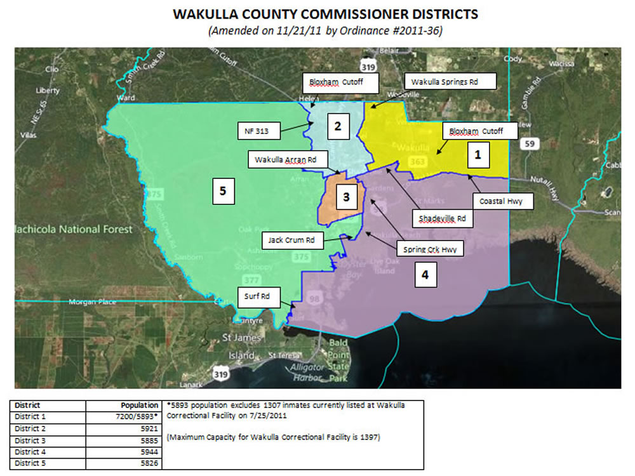

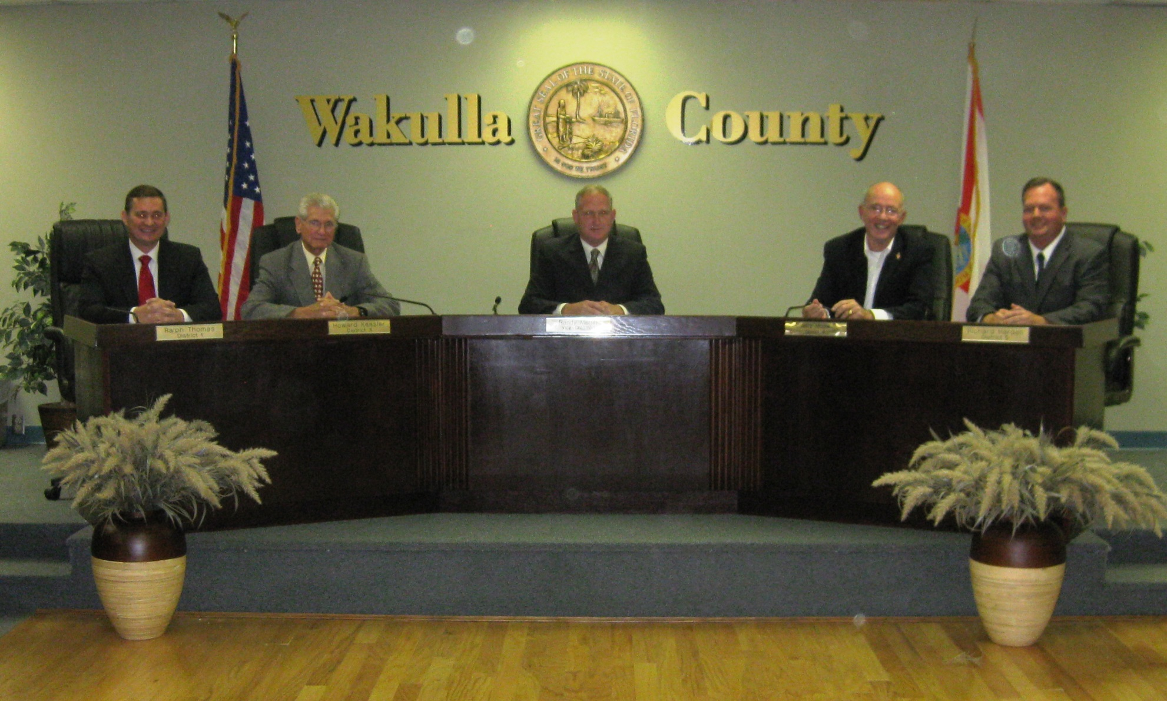
Constitutional Officers
The County is also governed by five elected Constitutional Officers. The Constitution of the State of Florida, Article VIII, Section 1(d) created the offices of the constitutional officers. Each Officer serves a four year term. While the constitutional officers maintain separate accounting records and budgets from the BOCC, their budgets are presented as part of this total County-wide budget since their funding is derived from the County. The current Constitutional Officers, their contact information and the year in which their term expires are as follows:
Clerk of the Circuit Court

The Clerk of the Court is a Constitutional Officer under Article VIII Section 1 (d) and Article V Section 16 of the Florida Constitution and operates under Chapter 28, and various other chapters of the Florida Statutes.
The Clerk of Court is the Clerk to the Circuit and County courts and is responsible for maintaining all court files. The Clerk of Court is also Clerk to the Board of County Commissioners and responsible for maintaining the Board’s official documents and recordings. The Clerk of Court is the accountant, auditor and custodian of all County funds. The Clerk of Court is also the County Recorder and is responsible for recording and maintaining all the various documents that are required to be filed and held as public documents. The contact information for the Clerk is:
Brent X. Thurmond
3056 Crawfordville Highway
Crawfordville, FL 32327
Phone: (850) 926-0905
www.wakullaclerk.com
Term Expires: 2016

Property Appraiser

The Property Appraiser is a Constitutional Officer under Article VIII Section 1 (d) of the Florida Constitution and operates under Chapter 195 and various other chapters of the Florida Statutes.
The Property Appraiser is responsible for determining the value of all property within the County. The Property Appraiser is also responsible for maintaining property ownership records, parcel ownership maps, and administering all tax exemptions. The contact information for the Property Appraiser is:
Donnie R. Sparkman
3115-A Crawfordville Highway
Crawfordville, FL 32327
Phone: (850) 926-0500
www.qpublic.net/wakullapa
Term Expires: 2016

Sheriff

The Sheriff is a Constitutional Officer under Article VIII Section 1 (d) of the Florida Constitution and operates under Chapter 30, and other various chapters of the Florida Statutes.
The Sheriff is responsible for Law Enforcement, Corrections, Courthouse Security, Emergency Management and other public safety related functions. The contact information for the Sheriff is:
Charlie Creel
15 Oak Street
Crawfordville, FL 32327
Phone: (850) 745-7100
www.wcso.org
Term Expires: 2016

Supervisor of Elections

The Supervisor of Elections is a Constitutional Officer under Article VII Section 1 (d) of the Florida Constitution and operates under Chapter 98 and various other chapters of the Florida Statutes.
The Supervisor of Elections is responsible for maintaining voting records and registration and supervising, tallying and reporting the votes cast by Wakulla’s citizens in its various elections. The Supervisor of Elections is also responsible for maintaining all candidate forms and reports. The contact information for the Supervisor of Elections is:
Henry (Buddy) Wells
3115-B Crawfordville Highway
Crawfordville, FL 32327
Phone: (850) 926-7575
www.wakullaelection.com
Term Expires: 2016

Tax Collector

The Tax Collector is a Constitutional Officer under Article VIII Section 1 (d) of the Florida Constitution and operates under Chapter 197 and various other chapters of the Florida Statutes.
The Tax Collector’s office is responsible for the collection of the County’s ad valorem taxes, MSBU fees and Solid Waste assessments as well as other miscellaneous local fees. The Tax Collector is also the local agent for several State agencies collecting taxes for the Department of Revenue, vehicle and boat registration and driver’s license renewal fees for the Department of Highway Safety & Motor Vehicles and hunting and fishing licenses for the Florida Wildlife Fish & Game Conversation Commission. The contact information for the Tax Collector is:
Cheryll Olah
202 Ochlocknee Street
Crawfordville, FL 32327
Phone: (850) 926-3371
www.wakullacountytaxcollector.com
Term Expires: 2016

County Administration

The BOCC appoints a County Administrator to serve as the chief administrative official of the County. Florida Statutes, Chapter 125 and the County’s Charter, Article 3 establishes the powers and duties of the County Administrator.
The County Administrator is responsible to the Board for administrative operations and management of the various departments of the County. The County Administrator is also responsible to the Board for the execution of all Board policies and the preparation of an annual operating and capital improvement program budget for the County. The County Administrator is supported by staff that provide day-to-day administrative and management oversight for numerous county departments under the direct administrative responsibility of the County Administrator. The contact information for the County Administrator is:
J. David Edwards, County Administrator
Wakulla County Commission Complex
3093 Crawfordville Highway
Crawfordville, FL 32327
Phone: (850) 926-0919
www.mywakulla.com

An organizational chart of the County’s various offices and their relationships is shown on the following page.

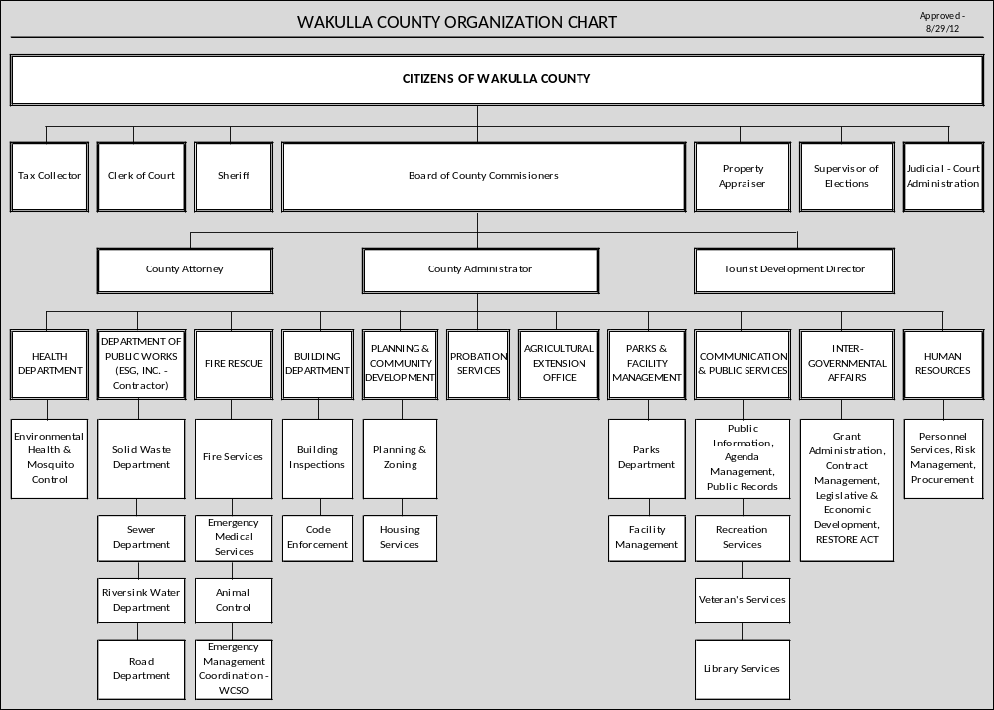

[This Page Left Intentionally Blank]

Budget Calendar
As Amended July 15, 2013
DATES ACTION
January 22, 2013 BOCC Approval of the FY2013/14 Budget Calendar
March 5, 2013 Mandatory Budget Kick-Off Meeting with all Departments from 10:00 a.m. – 12:00 p.m.
March 7, 2013 1st Budget Development Workshop
April 1, 2013 Board Priorities Workshop
April 15, 2013 All BOCC Department Budget Requests are due to Finance to begin analysis.
April 16-26, 2013 Meetings with Departments to review requested budgets.
May 1, 2013 Final Day for Constitutional Officers to Submit Budget Requests to Board (F.S. 129.03 [2])
May 6-17, 2013 Meetings with Constitutional Officers to review requested budgets.
June 6, 2013 2nd Budget Development Workshop (Rescheduled to June 13, 2013)
June 14, 2013 Board submits number of hardship exemptions to Property Appraiser (2 weeks prior to July 1)
July 1, 2013 Certification of Taxable Property Values by the Property Appraiser to Board (193.023 F.S.) – DR-420 Form
July 15, 2013 Tentative Balanced Budget is placed on the desks of the Board of County Commissioners. (F.S. 129.03 [3a])
July 15, 2013 Board Sets First and Second Public Hearing Dates and adopts Preliminary Rate Resolutions for Solid Waste Assessment and Fire M.S.B.U. (Municipal Services Benefit Unit)
By August 1, 2013 Board to Advise Property Appraiser of Proposed Millage Rate, Roll Back/Up Rate, Date, Time and Place of First Public Hearing. (200.065.[4b]F.S.]
August 8, 2013 3rd Budget Development Workshop.
August 13, 2013 Property Appraiser mails Notice of Proposed Property Taxes (200.065 [4b]F.S.) (*within 55 days of Certification or 10 days after tax roll is adopted or 20 days prior to tentative hearing for non-ad valorem assessments)

August 14, 2013 Last day for the Board of Commissioners or the Property Appraiser to submit additional information or testimony to the Department of Revenue regarding the Property Appraiser’s tentative budget request. (195.087[1a]F.S.]
August 15, 2013 Deadline for Department of Revenue to make Budget Amendments or changes to the Property Appraiser’s Budget.
August 16, 2013 Deadline to submit appropriate Preliminary TRIM notice to Wakulla News
August 22, 2013 Preliminary TRIM Notice published in Wakulla News
August 30, 2013 County posts tentative budget on website 2 days prior to first public hearing (129.03[3c] F.S.)
September 3, 2013 Board adopts the Preliminary Rate Resolutions for Road Paving Assessments
September 3, 2013 Public Hearing to be scheduled on Tentative Budget and Proposed Millage Rate (200.065[4bc] F.S.) (*within 80 days/no sooner than 65 days from Certification)
September 6, 2013 Deadline to submit Final TRIM Notice to Wakulla News
The following dates are based on the Public Hearing to Tentatively Adopt Budget and Proposed Millage Rated taking place on September 3, 2013.
September 12, 2013 Advertise Notice of Final Budget & Millage Rate & Intent to Adopt a Millage Rate & Final Budget (200.065[4d] F.S.) (*within 15 days after the tentative hearing)
September 16, 2013 Public Hearing to be scheduled on Final Budget & Adopt a Millage Rate by Resolution or Ordinance (200.065[4d(3)] F.S.) (*within 2 to 5 days from time Notice of Intent is published)
September 20, 2013 Board to forward Resolution or Ordinance adopting Final Millage to Property Appraiser, Tax Collector and Department of Revenue.
October 16, 2013 Certified Compliance to the Department of Revenue.
October 16, 2013 County posts final budget on website within 30 days of final budget hearing (129.03[3c] F.S.)

Budget Process & Financial Policies

Budget Process

Budget Adoption and Modification
The County follows the statutory requirements established in F.S. 129 and 200 regarding budgeting and taxation. Chapter 129 of the Florida Statutes, titled “County Annual Budget” requires the County to establish “an annual budget for such funds as may be required by law or by sound financial practice and generally accepted accounting principles.” Chapter 200 of the Florida Statutes, titled “Determination of Millage” defines the process for how the County generates monies through taxation of real, personal and tangible property.
Additionally, Florida Department of Revenue has established “Truth In Millage” (TRIM) procedures, guidelines and forms for the County to use to ensure adherence to the laws and statutory requirements related to taxation. It is the policy of the County to follow all of these laws, statutes and approved procedures in preparing its annual budget. The following is a summary of the many detailed and specific procedures and requirements used to adopt and modify the annual budget.
Original Budget
In March of every year, the County’s budget officer (County Administrator) provides budget forms and documents to each department to initiate the budget process. The County Administrator and Finance & Accounting staff meet with each department director numerous times to evaluate the personnel, operational and capital needs of each department and to review revenue projections of the ensuing year. Constitutional Officers are included in this process and are required by Florida Statute to submit their proposed budgets to the County by June 1. Consistent with Florida Statute 129.03, the Board approved Resolution #09-07 on February 3, 2009 which requires each Constitutional Officer to submit their proposed budget requests to the Budget Officer one month earlier or by May 1 of each year.
Preliminary budget workshops are held to 1) allow BOCC direction on particular projects or services to be offered, 2) receive BOCC guidance on particular issues or challenges, 3) offer the public an opportunity to provide input into the budget process. A tentative balanced budget is compiled and presented to the BOCC by July 15.
The BOCC conducts several budget workshops in July and August to offer the public additional opportunity to review, discuss and offer comment on the proposed tentative budget. Prior to September 30, a legally required public budget hearing is held to set the tentative millage rate and tentative budget and to offer additional public input. A second legally required public budget hearing, again held prior to September 30, is held to adopt a final millage rate and final budget and to offer additional public input. The original budget and millage rate is adopted by resolution of the BOCC at this final hearing. Please refer to the budget calendar on the previous pages for more detail on the process of adopting the budget.

Amended and Final Budget
The County has three methods of budget modification as outlined in F.S. 129.06(2). The originally adopted budget can be modified by resolution of the BOCC, by adopting a budget amendment, or by holding a supplemental budget hearing.
- Budget Resolution
The County increases its originally adopted budget as a result of receiving any unanticipated revenues. Typically such an increase is the result of receiving new grant revenue, the adoption of new fees or charges, or the transfer of funds from one fund to another. In general, a budget resolution is required anytime a particular fund’s budget will increase.
- Budget Amendment
The County changes its originally adopted budget as a result of routine operational activity. A budget amendment may be required due to a shortfall in revenues or an unexpected increase in the expenditures of a particular fund or department. A budget amendment transfers originally budgeted dollars from one budget line to another thus no change in the overall fund budget occurs. Some budget amendments require BOCC approval depending on the dollar amounts of the amendment and line item accounts involved.
- Supplemental Budget Hearing
A supplemental budget hearing is required for the Board to increase the budget of any fund when the revenue was or should have been anticipated. This requirement of law eliminates the possibility of the BOCC artificially adopting a lower budget during the original budget process and later increasing the same budget without public input or comment.

Financial Policies

Budgetary Accounting Policy
Budgets are adopted at the fund level and each fund must be “balanced”, that is, all revenues from all sources and use of cash within a fund must equal all expenditures from all uses including any reservations of cash. Sound fiscal planning requires some revenues to be budgeted at 95% to account for potential variations in estimates but at least 95% of all estimated revenues are budget for in accordance with F.S 129.01(2) (b).
Governmental fund budgets are adopted on the modified accrual basis of accounting. All increases and amendments to the legally adopted budget are presented on this same basis of accounting. Therefore, the actual and budgetary data provided in various County reports are presented on a comparable basis.
The Proprietary fund budgets are adopted on the modified accrual basis of accounting while actual revenues and expenses and assets and liabilities are kept on the full accrual basis of accounting.
The adopted budget is integrated into day-to-day operations and is used as a management control device in all funds and budgeted appropriations lapse at the end of the fiscal year. Directors or assigned staff review monthly reports, Finance staff reviews budget authority and available budget levels prior to purchase or payment for services to ensure all departments stay within approved budgets.
Fund Accounting Policy

The financial activities of Wakulla County are recorded in separate funds. A fund is a set of self-balancing accounts that record assets, liabilities and fund balance on the fund’s balance sheet and revenues, expenses and net profit or loss on the fund’s statement of activities. This policy is set by “generally accepted accounting principles” and the State’s “Uniform Chart of Accounts”. There are three types of funds categories: (1) governmental funds, (2) proprietary funds and (3) fiduciary funds.

- There are five types of governmental funds: general fund, special revenue funds, capital project funds, debt service funds and permanent funds. A brief description of each follows:

General Fund – Wakulla County has one general fund. This fund is used to budget and account for the general operational activity of the County. It is used to account for all transactions that are not required to be accounted for in a different type of fund.

Special Revenue Funds – These funds are used to account for any revenues that are restricted as to what or how they may be spent. Those restrictions may be set by external forces such as Florida Statutes or grant agencies. Those restrictions may also be set internally by Board resolution or ordinance.

Capital Project Funds – These funds are used to account for the acquisition or construction of major governmental capital facilities. Typically these funds are also considered “restricted” in nature as described above under Special Revenue Funds.

Debt Service Funds – The County does not currently use debt service fund types. Debt service funds are used to account for the centralized payments of principal and interest of the County’s General Long-term Debt Account Group. The County pays its principal and interest payments directly from the funds that are responsible for the debt.

Permanent Funds – The County does not currently use permanent funds. Permanent funds are funds where only the “earnings” from the fund may be used and not the “principal” of the fund. Endownment funds are a good example of these funds.

- There are two types of proprietary funds: enterprise funds and internal service funds. A brief description of each follows:

Enterprise Funds – These funds are used to account for all County activity that is expected to be run “like a business” hence the term “business-type activity”. These funds, unlike all other funds, are expected to generate profits at a level determined by the County.

Internal Service Funds – The County does not currently use internal service funds. These funds are used to account for “shared services”. That is, indirect costs incurred by the County are allocated across all departments that make use of those services derived from the cost. Use of internal service funds requires an extensive cost allocation plan.

- There are four types of fiduciary funds: agency funds, pension trust funds, investment trust funds, and private-purpose trust funds. Fiduciary funds are funds that the County is holding on behalf of another government, agency or individual. A brief description of each follows:

Agency Funds – These funds are funds that are held in a custodial capacity. These funds may be held temporarily until transferred to the owner of the funds (taxes transferred upon collection from one government to another) or they may be held for a longer period of time due to some arrangement such as grant restrictions such as the arrangement the County has with Wilderness Coast Public Libraries. These funds are held on their behalf and transferred to WILD only as they are “earned”.

Pension Trust Funds – The County currently does not use pension trust funds. The funds held by pension trust funds are held on behalf of the members of the pension. Typically these funds are invested on behalf of the members and paid out to its members as set forth in the pension document.

Investment Trust Funds – The County does not currently use investment trust funds. These funds are typically the “commingling” or “pooling” of assets owned by other agencies for the express purpose of investing the funds on behalf of those agencies.

Private-purpose Trust Funds – The County does not currently use private-purpose trust funds. As the name suggests, these funds are funds held on behalf of an individual, private organization or other government agency for a purpose that a) does not fall into one of the other fiduciary type descriptions and b) is not for public purpose or use.

Since the County may not spend fiduciary funds for public purposes or on County-run programs, these funds are not included in the County-wide budget figures.
Capital Improvement Policy
Each year the County updates it “5 Year Capital Plan”. This 5 year capital improvement plan must be consistent with the County’s adopted “Comprehensive Plan”. In order for a project to be added or removed from the 5 year plan, the addition or removal must be approved by the BOCC. Each capital project should identify its impact on the operating budget of the County. The use of funds for capital purposes must always be consistent with the restricting documents establishing the funds to be used.
Debt Policy
The purpose of the County’s debt policy is simply to ensure it does not borrow too much. The County maintains appropriate debt levels that will ensure its ability to pay its on-going debt payments and allow for future borrowing as needed. As described in the fund balance policy below, appropriate fund balances levels are required in certain funds to ensure one year of debt service payments are available at all times. Long term debt is to be used for capital improvement projects and not for operational activities.
Fund Balance Policy
The County maintains fund balances in accordance with Governmental Accounting Standards Board Statement (GASB) No. 54 “Fund Balance Reporting and Governmental Fund Type Definitions”. There are five components of fund balance: non-spendable, restricted, committed, assigned and unassigned amounts.
- Non-spendable Fund Balance – Amounts that are not in spendable form (assets, inventory or long-term receivables) or amounts that are required to be maintained intact (the principle of a permanent fund).

- Restricted Fund Balance – Amounts that can be spent only for specific purposes stipulated by external resource providers such as creditors, grantors, contributors or laws or regulations of other governments or imposed by law through constitutional provisions or enabling legislation.

- Committed Fund Balance – Amounts that can only be used for specific purposes pursuant to constraints imposed by formal action (resolution or ordinance) of the County Commission. Committed fund balance can only be uncommitted by formal action of the BOCC.

- Assigned Fund Balance – Amounts set aside by the County Commission or by County management intended to be used for a particular purpose. Assigned amounts can be used for any public purpose.

- Unassigned Fund Balance – The residual amounts of fund balance that are not non-spendable, restricted, committed or assigned. Unassigned fund balance is available for any general public purpose.

When more than one category of fund balance exists, the most restricted amounts are used first followed by the less restricted fund balance, i.e. restricted fund balance is to be used before committed fund balance and committed fund balance is to be used before assigned fund balance.
Fund balance reserves should be maintained at the following levels:
- General Fund – Unassigned fund balance should be no less than three months or 25% of regular General Fund operating revenues or expenditures. The maximum unassigned fund balance should be no more than four months or 33% of regular General Fund operating revenues or expenditures.

- Special Revenue Funds – Typically, since special revenue funds are inherently restricted to a particular purpose which may require the spending of all available funds, no minimum or maximum fund balance is required. Wakulla County does use several special revenue funds for operational purposes and essential services (Road and Fire Departments). Such funds should maintain no less than three months or 25% of operating revenues or expenditures.

Special arrangements have also been established for the Sheriff’s Fine & Forfeiture Fund setting the fund balance levels at two years of the Corrections portion of the budget in addition to the standard three months or 25% of operating revenues or expenditures
- Capital Project Funds – Typically, since capital project funds are inherently restricted to a particular purpose which may require the spending of all available funds, no minimum or maximum fund balance is required.

- Enterprise Funds – Each enterprise fund should maintain no less than three months or 25% of regular operating revenues or expenditures.

- Debt Service – No matter the fund type, any fund that has debt obligations should carry an additional fund balance equal to one year of debt service payments.
Cash Forward Policy
Consistent with the Fund Accounting Policy and Fund Balance Policy, cash reserves should be carried forward into the new budget and used only as those fund restrictions allow. Cash reserves should only be budgeted for specific non-recurring uses and not used to balance revenue and expenditures unless fund reserve levels have been met. Cash reserves may be used for recurring operational uses only when fund balance levels have been exceeded and the Board intends for those balances to be decreased through their use and/or a decrease in revenue rates is integrated into the budget plan.

Section 2

Fiscal Year 2013-2014 Budget Summary

[This Page Left Intentionally Blank]

County-wide Budget Summary

The total tentative budget for FY 2013-2014 is $38,593,694, a net reduction of $5,271,026 or -12.0% as compared to FY 2012/13 Budget as amended.
This decrease is the result of:
- The General Fund increased $738,674 or 7.9%.
- The Special Revenue Funds decreased $4,867,886 or -22.8%.
- The Capital Project Funds decreased $374,133 or -5.8%.
- The Enterprise Funds decreased $767,681 or -11.4%.
The changes in each particular fund category will be discussed on the following pages. Below are two charts summarizing the County-wide budget for FY 2013-2014. The first summarizes the FY 2013-2014 Budget by revenue and expenditure type. The second summarizes the FY 2013-2014 Budget by revenue and expenditure type and compares those revenues, expenditures to the FY 2012-2013 Budget.

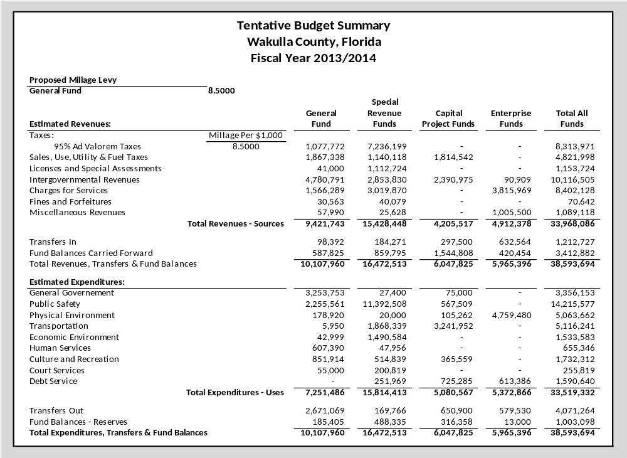
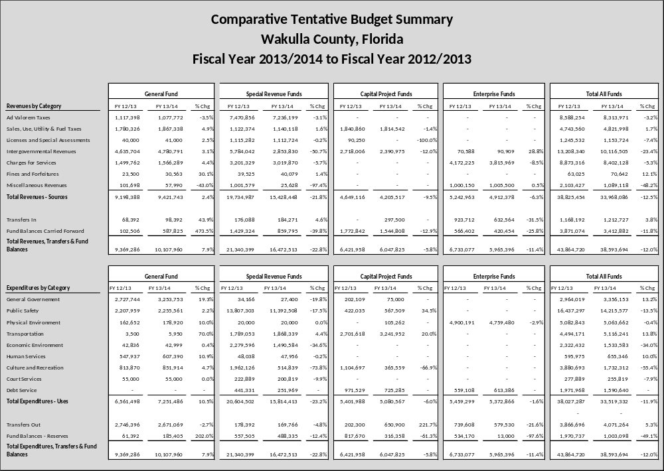

[This Page Left Intentionally Blank]

General Fund Summary

The General Fund is the general operating fund of the County as established by F.S. 129.02(1). The General Fund is used to account for all activities that are not required to be segregated into a separate fund.
The total tentative budget for the General Fund is $10,107,960, an increase of $738,674 or 7.9% as compared to FY 2012/13 Budget as amended. For accounting purposes, the Building Department Fund, while restricted, is included in the General Fund calculations. This budget document combines the General Fund and Building Fund to be consistent with the annual financial report.
On the revenue side, this increase is the result of:
- Taxes increased $47,386 which is comprised of a $39,626 reduction in ad valorem taxes and an increase of $87,012 in the public service and communication service taxes.
- Intergovernmental State shared revenues increased overall by $146,087.
- Local charges for program services increased by $66,527 with the majority of the increase coming from EMS billing.
- Fine revenue increased $7,063.
- Miscellaneous revenues decreased $43,708.
- Inter-fund transfers increased $30,000.
- Budgeted cash forward increased $485,319 which is a result of a $168,325 for the non-recurring contamination cleanup, $247,190 for the Sheriff’s Office roof repair and $124,310 budgeted in the Building Department.
On the expense side, this increase is the result of:
- Personnel expenses increased $427,124. This increase is due to wages increasing $115,343 due to the addition of three positions – a grants coordinator, a code enforcement officer, and a building inspector and several wage adjustments. Retirement rates increased substantially this year causing a $71,483 increase in retirement costs. Health insurance rates increased 6 percent and health insurance coverage has been budgeted for every full-time position in anticipation of the implementation of the Affordable Care Act causing a $225,020 increase in health insurance costs. Worker’s compensation rates, unemployment compensation costs, and FICA tax comprise the remaining increase of $15,278.
- Operating costs increased $9,278. A non-recurring cost of $168,325 for contamination cleanup offset a $159,047 reduction in other operating expenses.
- Operating equipment increased $259,745. The majority of the increase is due to much needed roof repairs at the Sheriff’s Office which will cost $247,190.
- Inter-fund transfers decreased $111,733.
- Aid to Governmental Agencies decreased $6,159.
- Transfers to constitutional officers increased $36,406.
- Budgeted reserves increased $124,013.
On the following two pages are summary schedules of the General Fund revenues and expenditures.
General Fund Revenue Summary
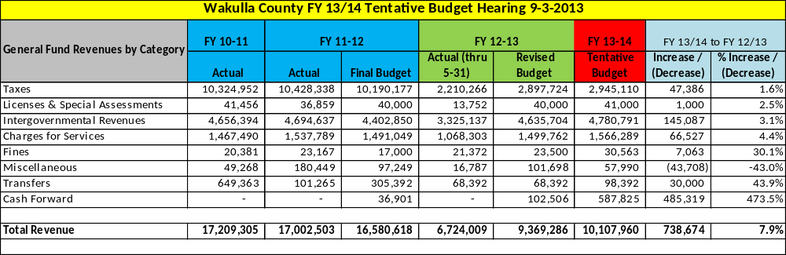

General Fund Expense Summary
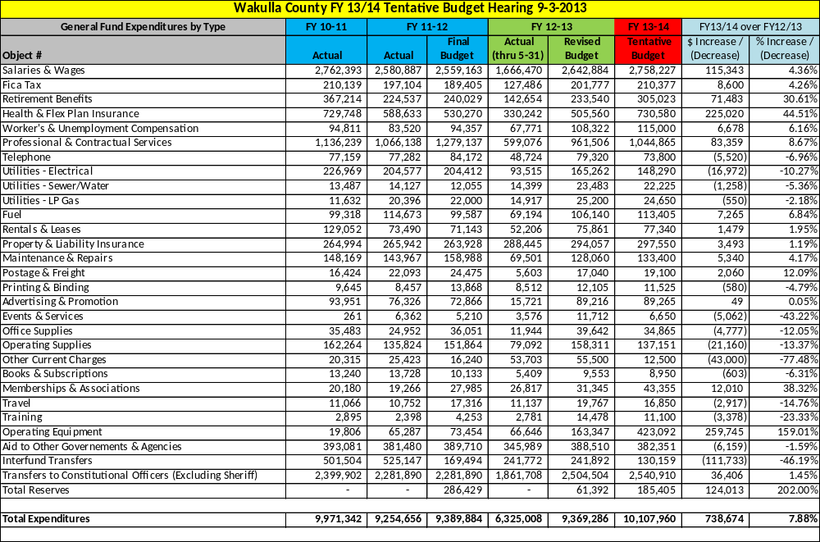

[This Page Left Intentionally Blank]

Special Revenue Funds Summary

The total tentative budget for the Special Revenue Funds is $16,472,513, a decrease of $4,867,886 or -22.8% as compared to FY 2012/13 Budget as amended.
On the revenue side, this decrease is the result of:
- Ad valorem taxes decreased $234,657 which is a result of eliminating $250,000 in budgeted reserves and an increase of $15,343 due to a correction in the Fine & Forfeiture Fund.
- Other taxes increased by $17,744.
- Licenses and special assessments decreased by $2,558.
- Intergovernmental State shared revenues decreased overall by $2,930,212 which is largely a result of less grant revenue.
- Local charges for program services decreased by $181,459 which is the result of a $200,000 decrease in Housing Prisoner revenues in the Fine & Forfeiture Fund.
- Fine revenue increased $554.
- Miscellaneous revenues decreased $975,951 since the $1,000,000 loan proceeds in the Fire MSBU Fund was budgeted in FY 2012/13 but not in FY 2013/14.
- Inter-fund transfers increased $8,183.
- Budgeted cash forward decreased $569,529.

On the expense side, this decrease is the result of:
- Personnel costs increased $14,216 due to increased retirement rates and health insurance costs.
- Operating costs decreased $3,213,812 due largely to a decline in grant revenue.
- Capital outlay costs decreased $1,189,021 due largely to a decline in grant revenue.
- Debt service costs decreased $189,362.
- Aid to Other Governments and Organizations increased $1,500.
- Inter-fund transfers decreased $8,626.
- Transfers to constitutional officers (primarily the Sheriff’s Office) decreased $214,410.
- Budgeted reserves decreased $69,170.
On the following two pages are summary schedules of the Special Revenue Fund revenues and expenditures.

Special Revenue Fund Revenue Summary

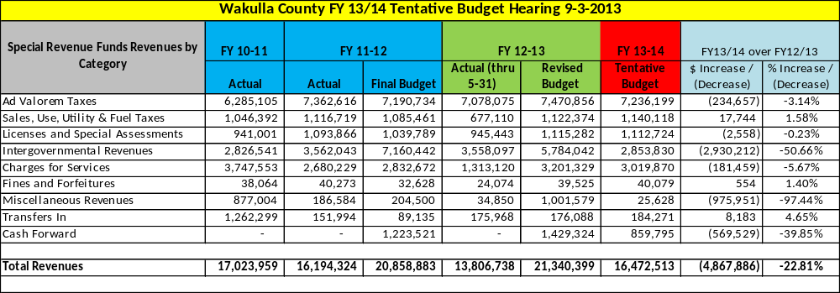

Special Revenue Fund Expense Summary

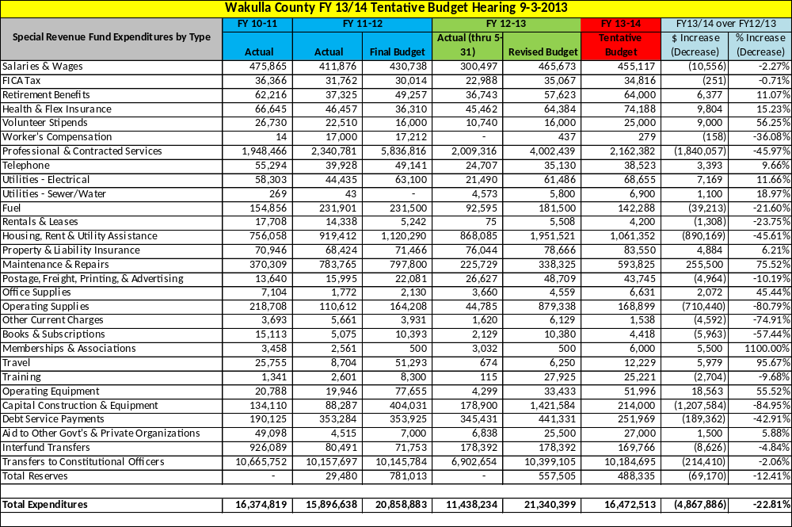

[This Page Left Intentionally Blank]

Capital Project Funds Summary

The total tentative budget for the Capital Project Funds is $6,047,825, a decrease of $374,133 or -5.8% as compared to FY 2012/13 Budget as amended.
On the revenue side, this decrease is the result of:
- Tax revenue decreased by $26,318 due to a reduction in in estimated one cent sales tax revenues.
- Licenses and Special Assessments decreased by $90,250 due to decrease in budgeted impact fee revenue.
- Intergovernmental revenues decreased $327,031 due to a reduction in grant revenue.
- Inter-fund Transfers In increased $297,500
- Budgeted cash forward decreased by $228,034.
On the expense side, this decrease is the result of:
- Equipment purchases decreased $288,743.
- Building and other construction decreased $326,768.
- Road & Bridge construction & repaving increased $837,834
- Debt service payments decreased $246,244.
- Inter-fund transfers increased by $50,100.
- Transfers to constitutional offices (Sheriff’s Office) increased $101,000
- Budgeted reserves decreased by $501,312.
On the following two pages are summary schedules of the Capital Project Fund revenues and expenditures.

Capital Project Fund Revenue Summary
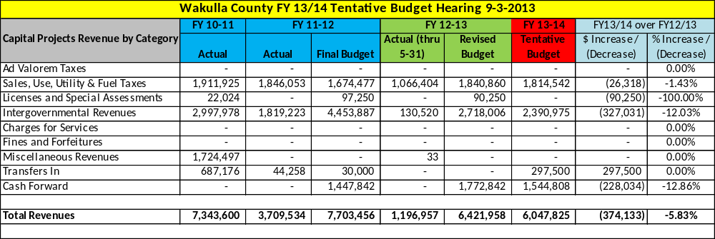

Capital Project Fund Expense Summary

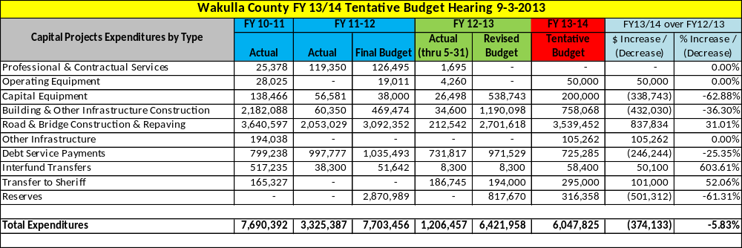

[This Page Left Intentionally Blank]

Enterprise Funds Summary

The total tentative budget for the Enterprise Funds is $5,965,396, a decrease of $767,681 or -11.4% as compared to FY 2012/13 Budget as amended.
On the revenue side, this decrease is the result of:
- Intergovernmental revenues increased by $20,321 due to an increase in the State’s Solid Waste grant.
- Charges for services decreased $356,256 due primarily to a decline in sewer access fees.
- Miscellaneous revenues increased $5,350.
- Inter-fund transfers decreased $291,148.
- Budgeted cash forward decreased by $145,948.
On the expense side, this decrease is the result of:
- Operating costs decreased $101,465.
- Equipment purchases decreased $39,246.
- Debt service payments increased $54,278 due to the new State Revolving Loan for the Talquin/Oyster Bay line expansion.
- Inter-fund transfers decreased by $160,078.
- Budgeted cash reserves decreased by $521,170.
On the following two pages are summary schedules of the Enterprise Fund revenues and expenditures.

Enterprise Fund Revenue Summary

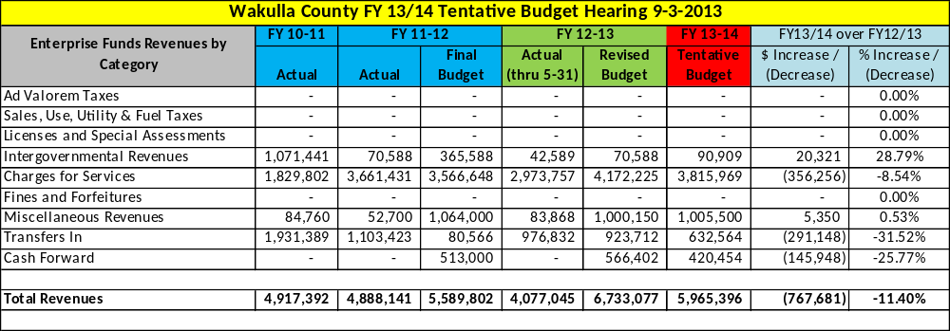

Enterprise Fund Expense Summary

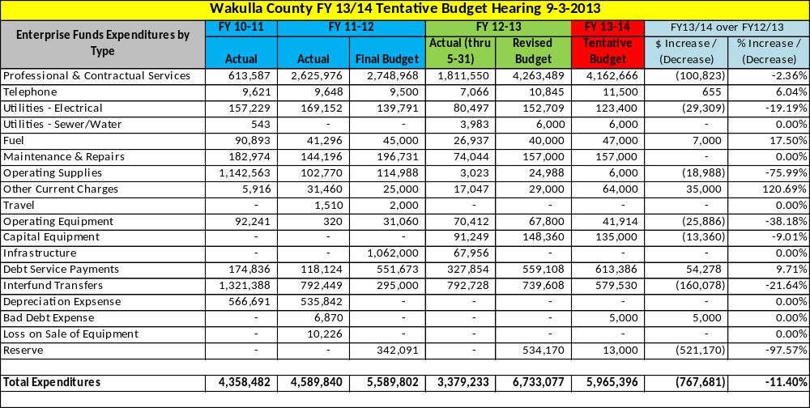

[This Page Left Intentionally Blank]

Section 3

Fiscal Year 2013-2014 Detailed Budgets

[This Page Left Intentionally Blank]

General Fund Departmental Detailed Budgets

The total tentative budget for the General Fund is $10,107,960, an increase over FY 2012-2013 of $738,674 or 7.9%. For accounting purposes, the Building Department Fund, while restricted, is included in the General Fund calculations. This budget document combines the General Fund and Building Fund to be consistent with the annual financial report.
The General Fund is accounted for in 17 different departments:

- Board of County Commissioners
- County Administrator
- Constitutional Officers (Excluding Sheriff – See Special Revenue Fine & Forfeiture Fund)
- General Administration
- Planning & Community Development
- Code Enforcement
- Animal Control
- Airport
- Library
- Agriculture Extension
- Facilities Management
- Probation
- Veteran’s Services
- Emergency Medical Services
- Recreation
- Parks
- Building

On the following pages is a brief summary of each department followed by a detailed line item budget. Actual data for FY 2010-11 and actual and budgetary data for FY 2011-12 and FY 2012-2013 are also provided for comparative purposes.

If a department is responsible for the collection of any revenues, those revenues will be shown at the top of the schedule followed by the department’s expenditures. At the bottom of each schedule is a Net Profit / (Loss) line showing the net cost to the County after the collection of revenue.

Board of County Commissioners

The County is governed by an elected five member Board of County Commissioners. The Constitution of the State of Florida, Article VIII, Section 1(e) created the Board of County Commissioners. Each commissioner is elected on an “at large” basis and each serves a four year term. Article 1 and 2 of the County’s Charter outline the duties and powers provided to the County Commissioners. This department accounts for the costs directly associated with these five county commissioners. The commissioners have all legislative authority and are responsible for establishing and adopting policy. The commissioners conduct County business by meeting twice a month (only once in July and December) at regularly scheduled public meetings. For more information regarding their work please go to www.mywakulla.com.

Staffing
Ralph Thomas | County Commissioner, District 1 | rthomas@mywakulla.com
Randy Merritt | County Commissioner, Chairman, District 2 | rmerritt@mywakulla.com
Howard Kessler, MD | County Commissioner, District 3 | hkessler@mywakulla.com
Jerry Moore | County Commissioner, District 4 | jmoore@mywakulla.com
Richard Harden | County Commissioner, Vice Chairman, District 5 | rharden@mywakulla.com

Service Outputs
Fiscal Year | 2010/11 | 2011/12 | 2012/13 (thru June)
# of Board Meetings/Workshops | 54 | 44 | 28
# of Ordinances Adopted | 28 | 51 | 28
# of Resolutions Adopted | 47 | 71 | 50
# of Pages of Minutes Recorded | 2,719 | 3,055 | 3,088

Board of County Commissioners Revenue & Expense Detail

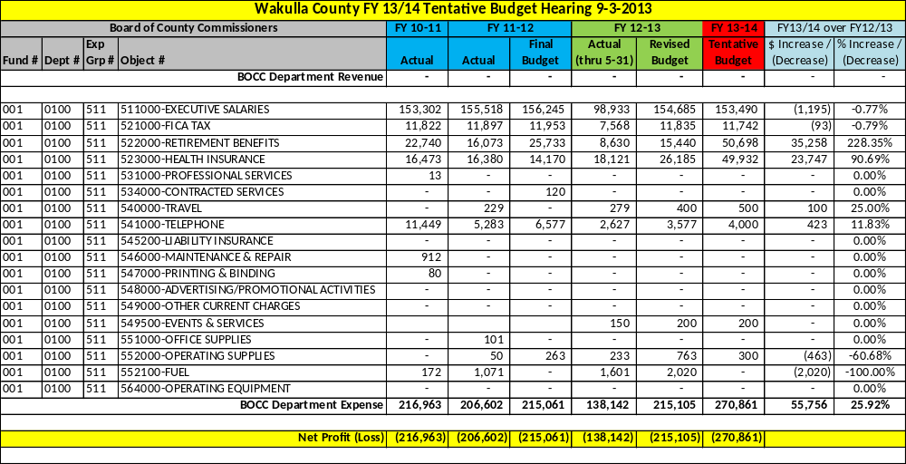

County Administrator

This office is the central point of contact for Wakulla County Citizens. For FY 2013-2014, a new full-time position responsible for grant writing and processing is budgeted to be filled.
David Edwards is appointed by, and serves at the pleasure of the Wakulla County Board of Commissioners. The County Administrator is the chief executive officer of the county and all executive responsibilities and powers are assigned to and vested in him, and shall exercise all executive authority, powers and duties authorized by general or special law. It is the responsibility of the County Administrator to implement all decisions, policies, programs and motions made by the Board. This is done through the department directors and staff who report directly to the County Administrator. The County Administrator regularly meets with constituents and others on various county issues to facilitate communications between government and community.
For a list of departments reporting directly to the County Administrator, please see the Wakulla County Organizational Chart. For more information please go to www.mywakulla.com.
Staffing
David Edwards | County Administrator | dedwards@mywakulla.com
Patty Taylor | Administrative Assistant | ptaylor@mywakulla.com
Debbie DuBose | Employee Support Services Director | ddubose@mywakulla.com
Jessica Welch | Communications and Public Services Director | jwelch@mywakulla.com
Sheree Keeler | Intergovernmental Affairs Director | skeeler@mywakulla.com
Katie Taff | Administrative Coordinator | ktaff@mywakulla.com
New Position | Grants Coordinator
Susan Fleming | Grants Coordinator, (part time) | sfleming@mywakulla.com

Service Outputs
Fiscal Year | 2010/11 | 2011/12 | 2012/13 (thru July15)
# of RFP/RFP/ITB’s Issued | - | 12 | 27
# of Agenda Items Prepared | - | 470 | 349
# of Grants applied for | - |  | 14
# of Public Record Requests | - | 188 | 80

County Administrator Revenue & Expense Detail

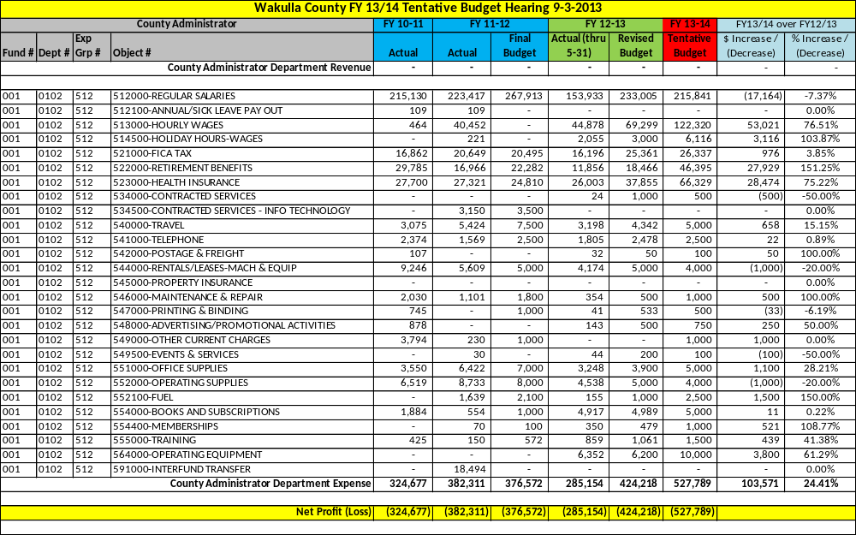

Constitutional Officers

Please note that the Sheriff’s Office budget is found in the Special Revenue Fine & Forfeiture Fund.

Clerk of Court
The Clerk of the Court is a Constitutional Officer under Article VIII Section 1 (d) and Article V Section 16 of the Florida Constitution and operates under Chapter 28, and various other chapters of the Florida Statutes.

The Clerk’s Office serves many roles as directed by Florida Statutes and arrangements with the County. The Clerk of Court is the Clerk to the Circuit and County courts and is responsible for maintaining all court files. The Clerk of Court is also Clerk to the Board of County Commissioners and responsible for maintaining the Board’s official documents and recordings. The Clerk of Court is the accountant, auditor and custodian of all County funds. The Clerk of Court is also the County Recorder and is responsible for recording and maintaining all the various documents that are required to be filed and held as public documents. Under arrangements with the Board, the Clerk’s Office also provides management and budget services to the County Administrator and janitorial and maintenance services to the Courthouse and its tenants.

The Clerk’s Office is comprised of five departments: Court Services; Finance & Accounting; Official Records; Maintenance and Information Technology. Finance & Accounting and Maintenance and funded by the Board of County Commissioners and those budgets are presented below. Court Services, Official Records and Information Technology are funded by user fees, fines and service charges. Those budgets are not presented below but will be on the Clerk’s website as required by Florida Statutes. For more information please go to www.wakullaclerk.com.

Staffing
Brent X. Thurmond | Clerk of Court | bxt@wakullaclerk.com
Finance & Accounting
Greg James | Finance Director; Chief Deputy Clerk | gjames@wakullaclerk.com
Suzanne Hawkins | Asst. Finance Director | shawkins@wakullaclerk.com
Tiffany Conn | Revenue & Trust Clerk | ktaff@mywakulla.com
Lea Dias | Accounts Payable & Purchasing Clerk | ldias@wakullaclerk.com
Evelyn Evans | Clerk to Board | eevans@wakullaclerk.com
Rachel Harvey | Accounting Clerk | rharvey@wakullaclerk.com
Brandy Price | Budgeting Clerk | bprice@wakullaclerk.com
Leila Smith | Payroll Clerk | lsmith@wakullaclerk.com
Maintenance
Joe Finch | Maintenance | jfinch@wakullaclerk.com
For information on the non-Board funded staffing please call 850-926-0919

Service Outputs
Fiscal Year | 2010/11 | 2011/12 | 2012/13 (thru May)
# of Board A/P Checks Processed | 6,439 | 6,228 | 4,302
# of Board Payroll Processed | 3,017 | 2,649 | 1,494
# of Board Obligations Processed | 13,797 | 13,537 | 9,713
# of Budget Amendments Processed | 101 | 64 | 25
# of Budget Resolutions Processed | 10 | 11 | 5
# of Grants Administered | 58 | 47 | 39

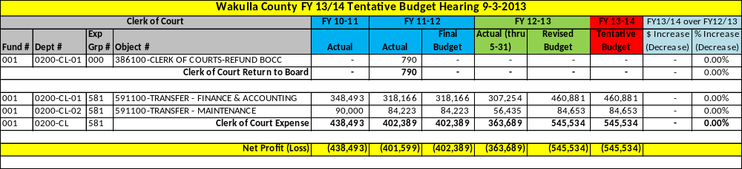

A detailed budget for the Clerk of Court can be found in Section 6 beginning on page 265.

Property Appraiser

The Property Appraiser is a Constitutional Officer under Article VIII Section 1 (d) of the Florida Constitution and operates under Chapter 195 and various other chapters of the Florida Statutes.

The Property Appraiser is responsible for determining the value of all property within the County. The Property Appraiser is also responsible for maintaining property ownership records, parcel ownership maps, and administering all tax exemptions. For more information please go to www.qpublic.net/wakullapa.

Staffing
Donnie Sparkman | Property Appraiser | dsparkman@mywakullapa.com
Brad Harvey | Chief Deputy Property Appraiser | bharvey@mywakullapa.com
Real Property
James Burke | Asst. Property Appraiser | jburke@mywakullapa.com
Nisha Walker | Director of Assessment Administration | nwalker@mywakullapa.com
Leola Franklin | Deputy Clerk 1 | lfranklin@mywakullapa.com
Tangible Personal Property
Debra Russell | Director of Taxpayer Services & Exemptions | drussell@mywakullapa.com
GIS Services
Michael Atchison | GIS Specialist II | matchison@mywakullapa.com
Sybil Taylor | GIS Specialist I | staylor@mywakullapa.com
Field Services
Stacey Roddenberry | Director of Field Services | sroddenberry@mywakullapa.com
Mike Musachio | Field Appraiser II | mmusachio@mywakullapa.com
Keith Linton | Field Appraiser II | klinton@mywakullapa.com
Flynn Ridley | Field Appraiser II | Fridley@mywakullapa.com

Service Outputs
Fiscal Year | 2010/11 | 2011/12 | 2012/13 (thru June)
# of deeds processed | 2,050 | 1,231 | 1,619
# of address changes processed | 2,161 | 1,386 | 1,778
# of mapping edits processed | 2,131 | 1,352 | 1,798
# of real property assessments | 24,821 | 24,847 | 24,845
# of new real property parcels | 70 | 26 | (2)
# of tangible personal property assessments | 758 | 712 | 687
# of new tangible personal property accounts | (37) | (44) | (50)
# of fire special assessments processed | 23,109 | 23,137 | 23,135
# of solid waste special assessments processed | 12,236 | 12,169 | 12,091
# of road paving special assessments processed | 0 | 28 | 28
# of field appraisals performed | 6,080 | 6,125 | 5,846
# of website visits | 3,012,314 | 2,915,259 | 2,686,589

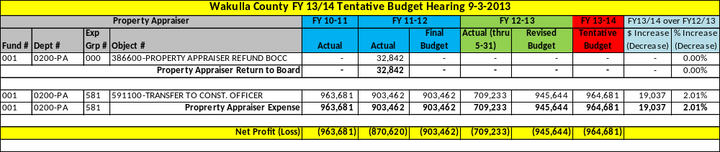

A detailed budget for the Property Appraiser can be found in Section 6 beginning on page 265.

Supervisor of Elections
The Supervisor of Elections is a Constitutional Officer under Article VII Section 1 (d) of the Florida Constitution and operates under Chapter 98 and various other chapters of the Florida Statutes.

The Supervisor of Elections is responsible for maintaining voting records and registration and supervising, tallying and reporting the votes cast by Wakulla’s citizens in its various elections. The Supervisor of Elections is also responsible for maintaining all candidate forms and reports. The Supervisor’s Office also receives several State grants that assist the office in providing election support staff, election education related material and equipment.

The Supervisor of Election’s also conducts elections each year at each of the elementary schools and the high school to assist in their school elections and to provide an educational voting experience for County students. For more information please go to www.wakullaelection.com.

Staffing
Henry “Buddy” Wells | Supervisor of Elections | hwells@mywakulla.com
Joe Morgan | Chief Deputy | jmorgan@mywakulla.com
Celina Green | Deputy Supervisor of Elections | cgreen@mywakulla.com
Sarah Harvey | Deputy Supervisor of Elections | sharvey@mywakulla.com
Paul Davenport | OPS Clerk (part-time)

Service Outputs
Fiscal Year | 2010/11 | 2011/12 | 2012/13 (thru July 15)
# of Voter Registrations | 527 | 879 | 507
# of County Elections | 3 | 4 | 3
# of School Elections | 4 | 4 | 3

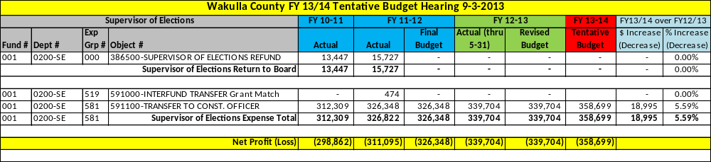

A detailed budget for the Supervisor of Elections can be found in Section 6 beginning on page 265.

Tax Collector
The Tax Collector is a Constitutional Officer under Article VIII Section 1 (d) of the Florida Constitution and operates under Chapter 197 and various other chapters of the Florida Statutes.

The Tax Collector’s office is responsible for the collection of the County’s ad valorem taxes, MSBU fees and Solid Waste assessments as well as other miscellaneous local fees. The Tax Collector is also the local agent for several State agencies collecting taxes for the Department of Revenue, vehicle and boat registration and driver’s license renewal fees for the Department of Highway Safety & Motor Vehicles and hunting and fishing licenses for the Florida Wildlife Fish & Game Conversation Commission. For more information please go to www.wakullacountytaxcollector.com.

Staffing
Cheryll Olah | Tax Collector | olahwakullatc@yahoo.com
Lisa Craze | Asst. Tax Collector | crazewakulla71@yahoo.com
Shannon Corbin | Bookkeeping Clerk
Laura Rogers | Service Supervisor | laurawakullatc@yahoo.com
Candice Good | Senior Revenue Clerk | candicewakullatc@yahoo.com
Debbie Olah | Revenue Clerk
Erika Gwaltney | Revenue Clerk
April Anderson | Revenue Clerk
Kathy Sumner | Revenue Clerk | kathysumnerwakullatc@yahoo.com
Kristin Craze | Posting Clerk

Service Outputs
Fiscal Year | 2011 | 2012 | 2013
# of tax bills processed | - | 24,600 | 22,632
# of address corrections | - | 1,640 | 1,256
# of occupational licenses issued | - | 1,850 | 1,565
# of Fish & Game licenses sold | - | 1,934 | 2,050
# of tax roll corrections | - | 900 | 304
# of escrow bills | - | 4,600 | 6,798
# of delinquent tax refunds mailed | - | 702 | 654
# of driver’s licenses issued | - | 4,573 | 4,690
# of ID cards issued | - | 518 | 544
# of temporary permits issued | - | 391 | 418
# of non-citizen permits issued | - | 37 | 24
# of driver’s license exams performed | - | 1,117 | 909
# of driver’s license tests performed | - | 978 | 809
# of voids on license | - | 104 | 82
# of customer calls | - | 12,948 | 13,605
# of lockbox drop offs | - | 50 | 57
# of certified mail deliveries | - | 406 | 624

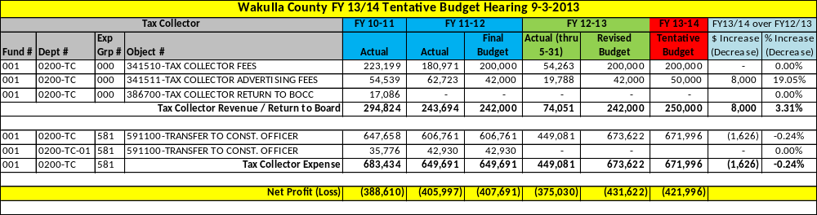

A detailed budget for the Tax Collector can be found in Section 6 beginning on page 265.

General Administration

The General Administration Department is where all General Fund revenues and expenditures that are not associated with a particular department are accounted for. These General Administration expenditures include county-wide information technology costs, worker’s compensation and unemployment costs, property and general liability insurance coverage, aid to public and private organizations, county memberships in various organizations and health and human service related costs.

Staffing
N/A – No staffing is required for this department.

Service Outputs
N/A – No service outputs are tracked for this department.

General Administration Revenue Detail

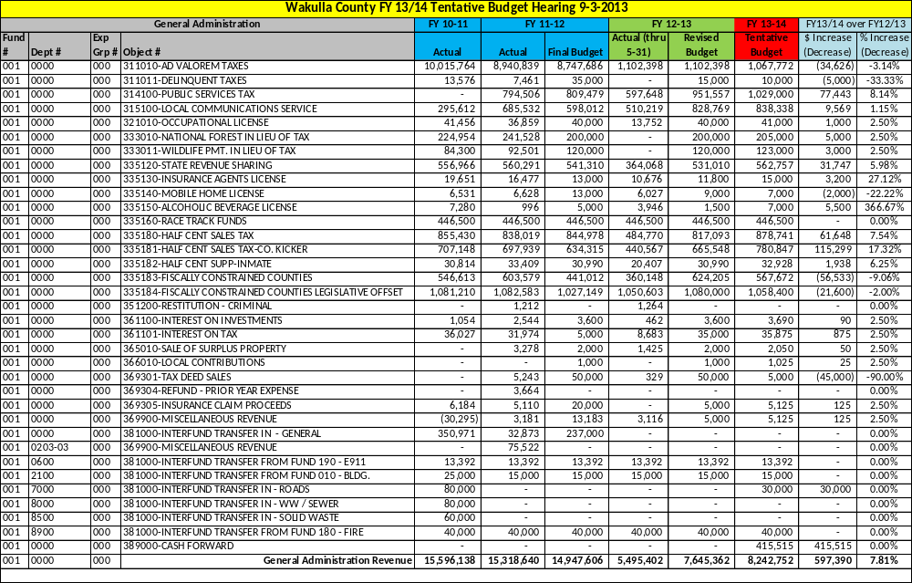

General Administration Expense Detail

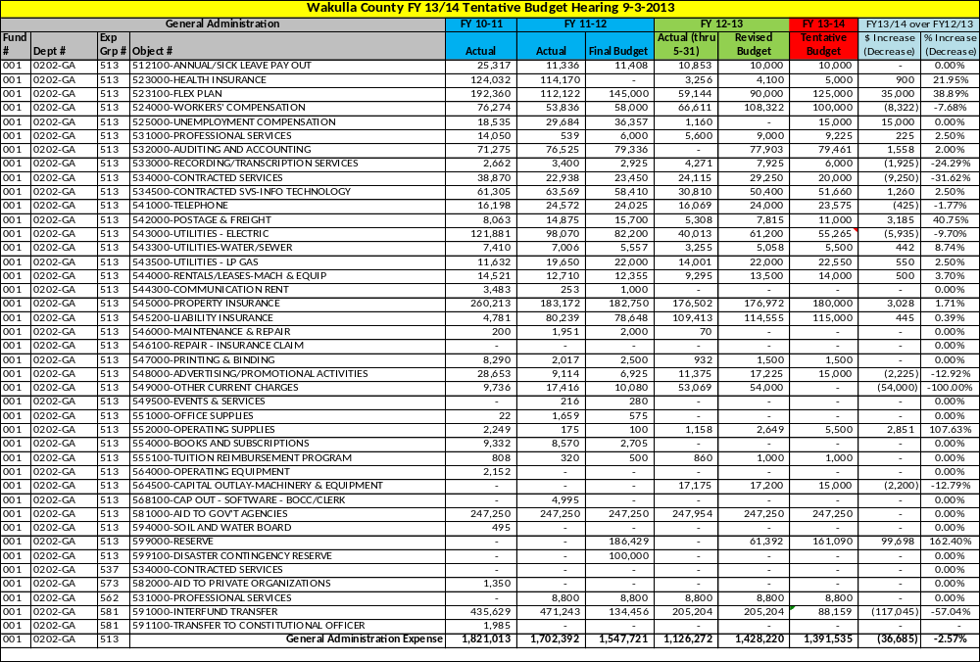
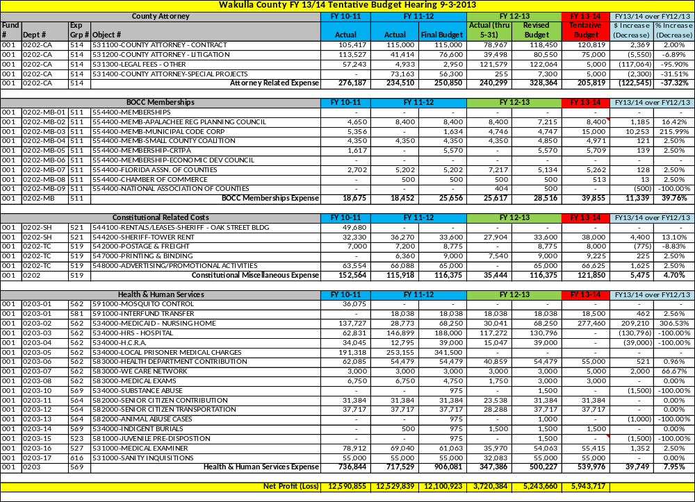
Planning & Community Development

This department is responsible for the long-range comprehensive planning of future growth and preservation of natural resources. This department performs the daily operations associated with the adherence of the Wakulla County Comprehensive Plan; provides technical planning support other County departments and the public, provides interpretations and implements the current planning, site plan, design, environmental, subdivision and zoning regulations; processes development permit applications; and administers the Technical Review Committee process. It is also responsible for staffing the Planning Commission, Local Planning Agency, Board of Zoning Adjustment and any citizen’s advisory committees established by the Board to address planning and zoning issues. This department takes an active role in coordinating with local, regional and state organizations on transportation, environmental and land use issues. This department is also responsible for updating the Land Development Code and the Capital Improvements Element of the Comprehensive Plan. For more information please go to www.mywakulla.com.

Staffing
Luis Serna | Planning & Community Development Director | lserna@mywakulla.com
Melissa Coleman Corbett | Planner II | mcorbett@mywakulla.com
Somer Strickland | Planner I | sstrickland@mywakulla.com
Donna Buchanan | Planning Technician | dbuchanan@mywakulla.com
Pamela Joy | Administrative Assistant (part-time) | pjoy@mywakulla.com

Service Outputs
Fiscal Year | 2010/11 | 2011/12 | 2012/13 (thru June)
# of Re-Zoning Applications | 4 | 11 | 6
# of Comp Plan Amendments | 5 | 9 | 7
# of Land Development Code Applications | 2 | 7 | 6
# of Site Plan Applications | 24 | 19 | 15
# of Conditional Use Applications | 6 | 4 | 4
# of Preliminary Plat Applications | 2 | 1 | 0
# of Final Plat Applications | 5 | 3 | 5
# of Subdivision Determination Applications | 12 | 11 | 13
# of Simulated Gambling Applications | 2 | 2 | 2
# of Temporary Use Applications | 17 | 17 | 12
# of Variance Applications | 3 | 11 | 7
# of Mobile Vending Applications | 0 | 5 | 14
# of Occupational License Applications | 125 | 150 | 129

Planning & Community Development Revenue & Expense Detail

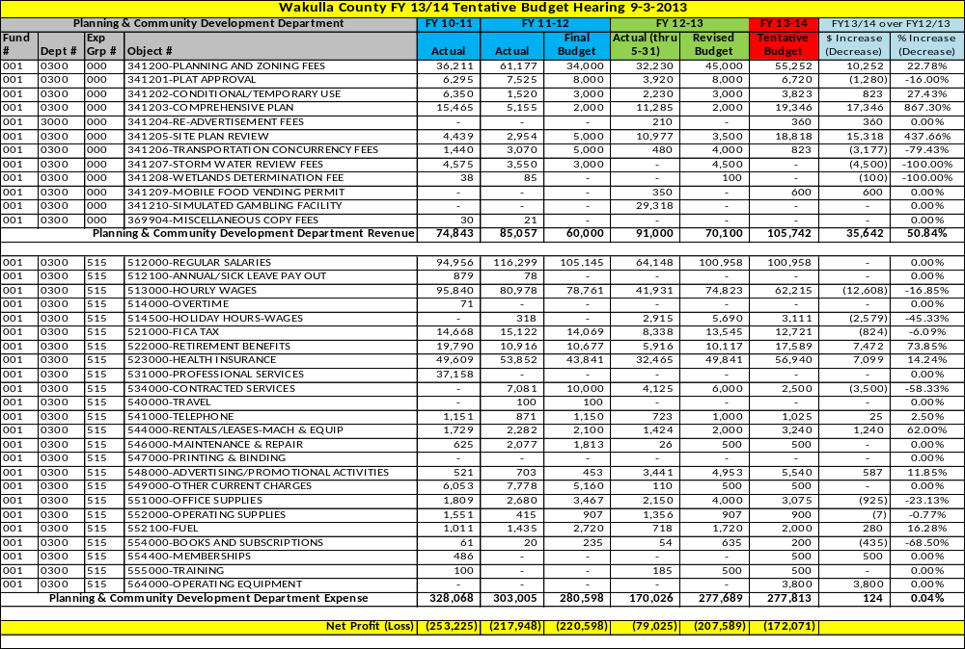
Code Enforcement

This department is responsible for enforcing Wakulla County Codes and Ordinances. “Stop-work” orders, “cease and desist” orders, “condemnation orders” and demolition of existing buildings/structures are processed in this office. The Code Enforcement officers handle citizen complaints and investigations for the entire County. The Commissioners established the Code Enforcement Board, a quasi-judicial board, which handles code enforcement cases. The Code Enforcement Board meets on a regularly scheduled bi-monthly basis. For more information please go to www.mywakulla.com.

Staffing

Jaime Baze | Code Enforcement Officer | jbaze@mywakulla.com
Deanna Jones | Code Enforcement Officer | dejones@mywakulla.com

Service Outputs
Fiscal Year | 2010 | 2011 | 2012
# of filed complaints | 296 | 208 | 326
# of inspections | 303 | 246 | 344
# of code board cases | 32 | 28 | 24
# of code case w/ paid fines | 12 | 12 | 9
# of code case w/ liens | 15 | 15 | 15

Code Enforcement Revenue & Expense Detail

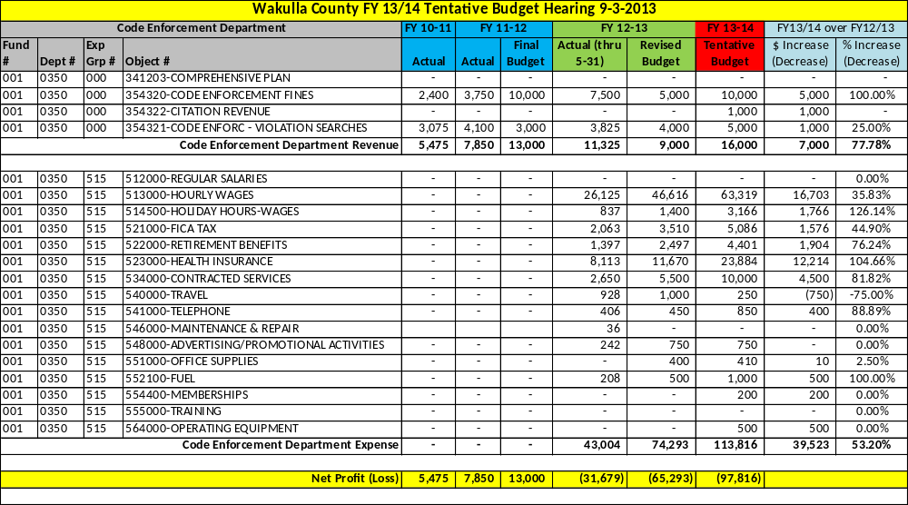

Animal Control

Animal Control is charged with enforcing county codes, rules and regulations concerning pets and animals in Wakulla County. The County also operates a shelter that houses animals until an appropriate disposition is made. Animal Control is housed in a temporary office building next to the animal shelter on the Sheriff’s Office compound. Next door to the Animal Control facility, CHAT (Citizen’s for Humane Animal Treatment) operates a shelter facility that focuses on adopting animals that they get from the county shelter. For more information please go to www.mywakulla.com.

Staffing
Ivanhoe Carroll | Animal Control Director | icarroll@mywakulla.com
Bonnie Brinson | Animal Control Officer | bbrinson@mywakulla.com
Mark Carter | Animal Control Officer | mcarter@mywakulla.com

Service Outputs
Fiscal Year | 2010/11 | 2011/12 | 2012/13 (thru June)
# of surrendered animals | 471 | 510 | 125
# of seized animals | 432 | 436 | 120
# of stray animals | 1,418 | 1,410 | 401
# of reclaimed animals | 290 | 275 | 92
# of rescued animals | 978 | 1,034 | 397
# of euthanized animals | 1,028 | 1,055 | 169
# of service calls | 2,197 | 2,091 | 1321
# of animal bites to humans | 103 | 104 | 64
Euthanasia Rate | 43.9% | 44.3% | 25.7%
Return to Owner Rate | 15.7% | 14.9% | 17.7%

Animal Control Revenue & Expense Detail

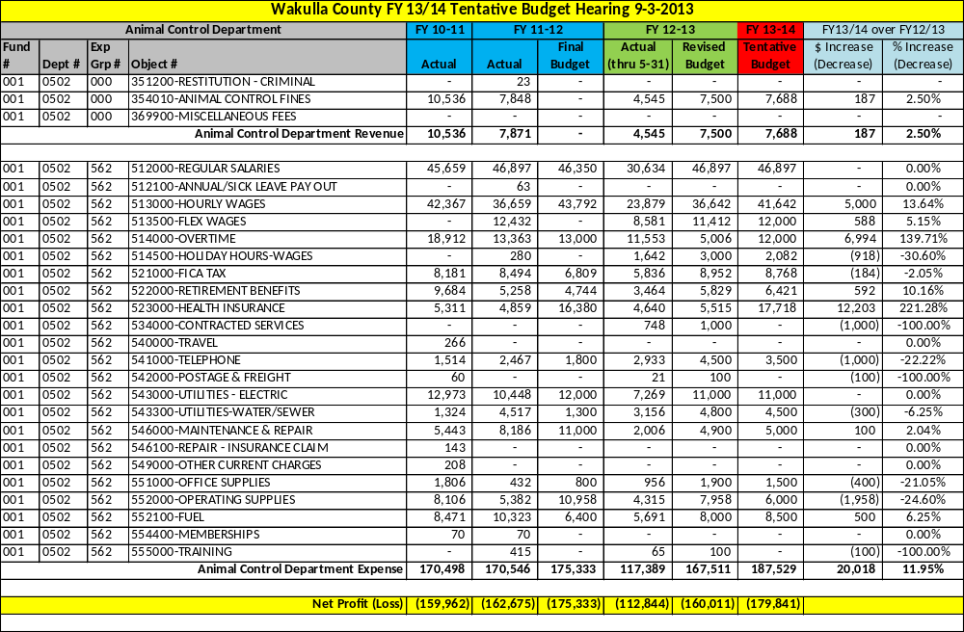
Airport

The Wakulla County Airport is a county owned, public use airport activated in 1966. It is located three nautical miles south of Panacea, Florida. The airport does not have a control tower and requires a call ahead for ground access by calling 850-321-0373. The airport encompasses 15 acres at an elevation of 11 feet above mean sea level. The airport has one grass runway with a turf surface of 2,590 feet by 70 feet. The FAA Identifier is 2J0 and its coordinates are 29°59’22”.0400N / 084°23’43”.4100W. For more information please go to www.mywakulla.com.

Staffing
N/A – The airport currently has no staffing.

Service Outputs
Fiscal Year | 2010* | 2011 | 2012**
# of Aircraft operations | 5,475 |  | 5,668
# of Multi-engine aircraft based at airport | 0 |  | 1
# of Single-engine aircraft based at airport | 9 |  | 2
# of Ultra-light aircraft based at airport | 1 |  | 1
% of General Aviation Use / Transient Use | - |  | 70% / 30%
* 2010 Data per the FAA Airport Master Record ** 2012 Data per AirNav.com

Airport Revenue & Expense Detail

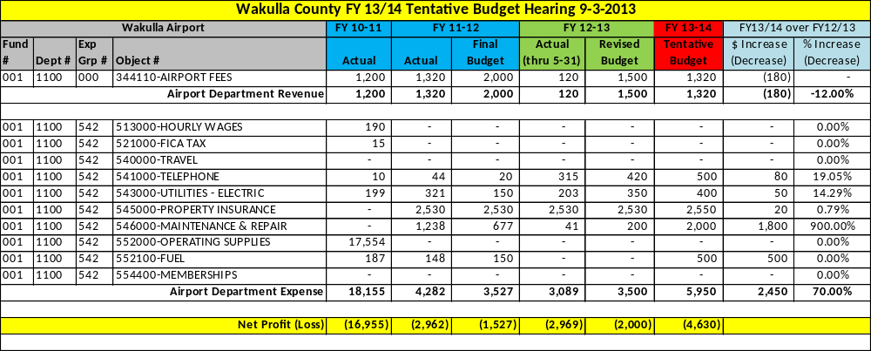

Library

The Public Library offers a wide variety of materials, programs, technology, and facilities to Wakulla County citizens. It provides easy access to books, videos, DVD’s, audio books, public access computers, software, and Internet resources to meet the information needs of its current and potential users. The library also offers a variety of programs for children, adults, and families, and makes available meeting room space to numerous groups and organizations.

The budget for the Public Library is made up from three direct funding sources and one indirect source: Local revenue from the General Fund (ad valorem tax dollars and federal e-rate refunds), State Aid to Libraries (grant funding), and contributions from the friends (Friends of the Library) consisting of memberships and donations are the direct funding sources while the Wilderness Coast Public Library (WILD) provides indirect support through a State grant. The WILD grant is not part of the General Fund.

A 7 member Library Advisory Board provides oversight to the library and acts a liaison to the Wakulla Board of County Commissioners recommending policies and funding. Each county commission district has one member and there are 2 at-large members. Their terms coincide with those of the Board members whose districts they represent.

As mentioned, the library is a member of Wilderness Coast Public Libraries (WILD), a 3 county multi-county public library cooperative including Franklin, Jefferson, and Wakulla counties. They are governed by a 6 member Board consisting of 2 members from each county. WILD has administrative offices in Monticello, and Systems Librarian Jonathan McCaughan and the servers that provide library automation to the tri county area are housed at the Wakulla County Public Library.

The Library serves as the home for the Friends of the Library, Wakulla County Historical Society and the Iris Garden Club. The Friends support many library services and contribute to the library budget. The historical society contributes to the library’s local history resources and sponsors monthly local history programs for the public. The Iris Garden Club has landscaped and cared for the library grounds for at least 25 years and also offers monthly gardening programs for the public. A number of other groups and organizations meet regularly at the library. We maintain a flexible meeting room policy with the only requirement that all meetings are free and open to the public.
The library also serves as an IRS tax site for forms and income tax help from January 1st to April 15th of each year. We offer a wide range of summer programs for children and their families all summer long, and we provide free computer classes to the public in a 12 person computer learning lab throughout the year. For more information please go to www.mywakulla.com.

Staffing
Scott Joyner | Library Director | scottj@wakullalibrary.org
Tristan Mor | Library Assistant II-Cataloger | tristan@wakullalibrary.org
Stephanie Grenz | Library Assistant I | stephanie@wakullalibrary.org
Pam Mueller | Library Assistant I | pam@wakullalibrary.org
Annie Brown | Library Assistant I | annie@wakullalibrary.org
Leilania Nichols | Children & Youth Specialist (OPS) | leilania@wakullalibrary.org
Molly Clore | Children & Youth Specialist (OPS) | molly.a.clore@gmail.com

Service Outputs
Fiscal Year | 2010 | 2011 | 2012
# of Registered borrowers | 16,132 | 11,646 | 11,877
Circulation | 103,469 | 91,027 | 83,620
Collection | 50,530 | 49,413 | 48,953
# of Adult Programs | - | 280 | 400
# of Children Programs | - | 165 | 300
Total Program Attendance (estimated) | - | 9,400 | 15,500
Public Computer Users | 18,960 | 14,607 | 15,860

Local Library & Friends of Library Department Revenue & Expense Detail

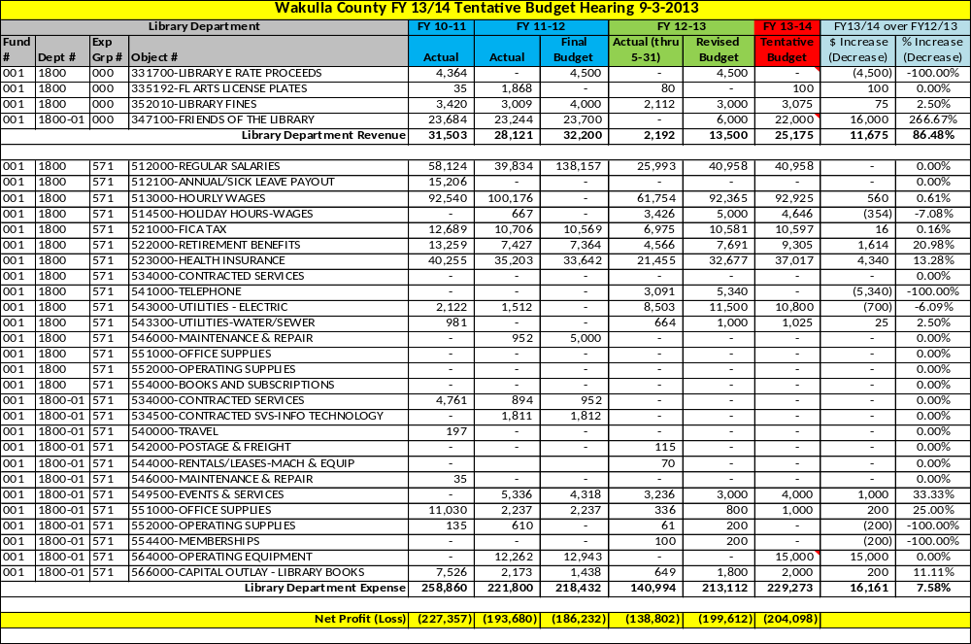

State Aid Library Department Revenue & Expense Detail

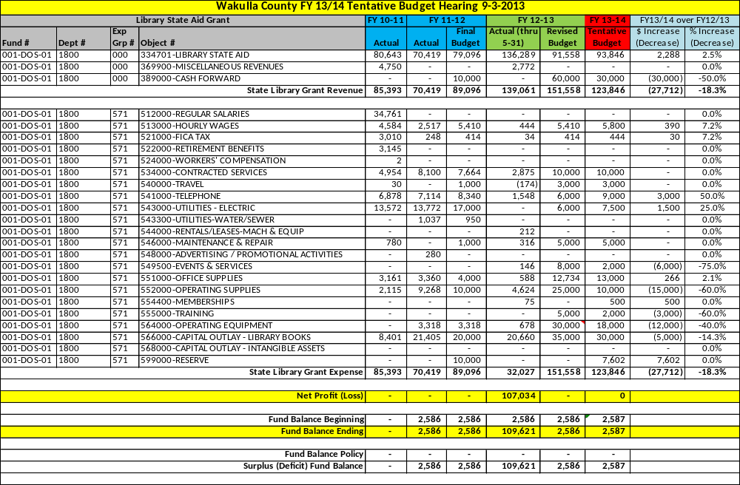
Agriculture Extension
The Cooperative Extension Service is a nationwide service that was established by the Smith-Lever Act of 1914. It is a partnership between state land grant universities, the United States Department of Agriculture (USDA) and county governments throughout the nation. All of these groups share in the planning, financing, and operation of extension programs. In Florida, the Cooperative Extension Service is administered by the University of Florida. The Wakulla County Board of County Commissioners provides support for local faculty, staff and facilities.
The Wakulla County Cooperative Extension Service conducts research-based educational programs in agriculture, horticulture, natural resources, family and consumer sciences, marine interest and 4-H youth development. Locally based advisory committees assure that programs are designed to meet community needs. Volunteer training is strongly emphasized in our programs to enable us to reach more of the county’s population. For more information please go to www.wakulla.ifas.ufl.edu.
Staffing
George Les Harrison | Cooperative Extension Director | harrisog@ufl.edu
Sherri Kraeft | 4H / Youth Development Extension Agent | sjkraeft@ufl.edu
Shelley Swenson | Family & Consumer Sciences Extension Agent | sswenson@ufl.edu
Cathy Frank | Extension Office Manager | cathy52@ufl.edu
Ariel Robinson | Receptionist | arieltrobinson@ufl.edu
Caitlin Martin | Receptionist | crmartin722@ufl.edu

Service Outputs
Fiscal Year | 2010 | 2011 | 2012
Agriculture & Natural Resource
Educational materials prepared |  |  | 66
Field consultations |  |  | 51
Office consultations |  |  | 593
Telephone consultations |  |  | 1,023
E-mail consultations |  |  | 665
Group learning participants |  |  | 429
Web page visits |  |  | 559,717
Family & Consumer Sciences
Educational materials prepared | 73 | 36 | 26
Field consultations | 118 | 127 | 128
Office consultations | 106 | 76 | 67
Telephone consultations | 157 | 91 | 130
E-mail consultations | 150 | 93 | 89
Group learning participants | 1,096 | 2,595 | 3,389
Web page visits |  | 648,731 | 236,489
4-H & Youth Programs
Educational materials prepared | 28 | 46 | 107
Field consultations | 81 | 88 | 135
Office consultations | 25 | 36 | 99
Telephone consultations | 67 | 330 | 137
E-mail consultations | 4,565 | 165 | 242
Group learning participants | 15,951 | 2,298 | 46,028
Web page visits (estimated) | 27,000 | 35,000 | 80,863

Agricultural Extension Department Revenue & Expense Detail

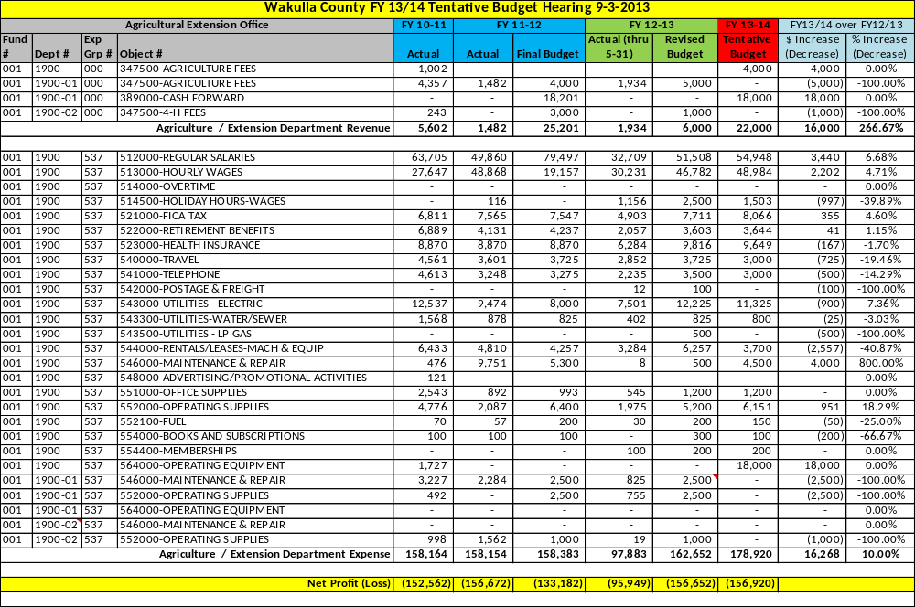

[This Page Left Intentionally Blank]

Facilities Management

The Facilities Management department provides janitorial and maintenance services for many of the County owned buildings and facilities. This department is also responsible for repair and replacement of infrastructure-related equipment and assists in various county construction-related projects. For more information please go to www.mywakulla.com.

Staffing
Rod Revell | Facilities Management Director / Parks Director | rrevell@mywakulla.com
John Gerhardt | Facility Maintenance | jgerhardt@mywakulla.com
Larry Thompson | Facility Maintenance | lthompson@mywakulla.com

Service Outputs
Fiscal Year | 2010/11 | 2011/12 | 2012/13
# of Buildings maintained | - | - | 44
# of square footage maintained | - | - | 193,500
# of acres associated with buildings | - | - | 22.0 +/-
# of air conditioner units | - | - | 91

Facilities Management Department Revenue & Expense Detail

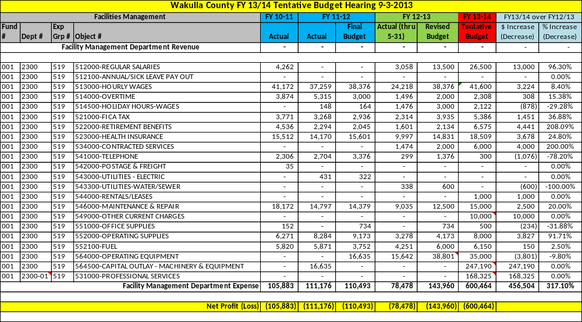

Probation

The Wakulla County Probation Division serves the community by providing supervision for county probation, diversions, deferred prosecution agreements, GPS tracking, (electronic monitoring), house arrest, and pre-trial or conditional bond supervision to all defendants who are ordered either by the County Court or the State Attorney/Circuit Court. The Probation/Pre-trial program is responsible for directing the offenders toward successful completions of the court-imposed mandates in lieu of incarceration. The Pre-trial Release component is a cost effective program that allows the Court an alternative to incarceration and is designed to help manage the jail population.
Pretrial Release is an alternative to jail. The high-risk offenders are classified as intensive supervision which report to our office two to five times a week. Offenders on probation report in office a minimum of once a month. Pretrial release requires a minimum contact of one time a week and the higher risk may report daily. Electronic monitoring is a service provided by Pretrial Release. Standard Court Ordered Probation Offenders report once a month. Each month they have certain ordered conditions which they must provide proof of completing. If an offender fails to comply with the Court Order, a violation may be issued and the offender remains in jail until they answer the violation before a judge. Deferred Prosecution cases are referred by the State Attorney. Offenders report once a month to provide proof that the agreement made with the State is in compliance. Upon those met conditions, the case is then dismissed. Diversions cases are referred be the State Attorney. Offenders typically provide proof of competing 1 day work- camp; pay a one-time fee to probation and the State Attorney’s Office.
The staff of Wakulla County Probation works closely with the Judges, State Attorney, Public Defender, Clerk’s Office, local counselors and private attorneys. The staff must stay current with all providers for Substance Counseling, Anger Counseling, Chemical Testing agencies, and Inpatient Care Facilities throughout the area and the state. When applicable, offenders are provided with a list of counseling providers. Drug testing duties such as urine analysis screens are outsourced and conducted offsite. The local office performs in house breathalyzers and saliva drug testing activities. For more information please go to www.mywakulla.com.
Staffing
Nakeisha Oliver | Probation Director | noliver@mywakulla.com
Priscilla Roberts | Administrative Assistant | proberts@mywakulla.com
Michelle Christensen | Probation Officer I | mchristensen@mywakulla.com

Service Outputs
Fiscal Year | 2010 | 2011 | 2012
# on County Probation * | 6,446 | 6,175 | 6,370
* Includes Probation, Pre-Trial, Diversion, Deferred Prosecutions, VOB’s, VOP’s and incarcerations.

Probation Department Revenue & Expense Detail

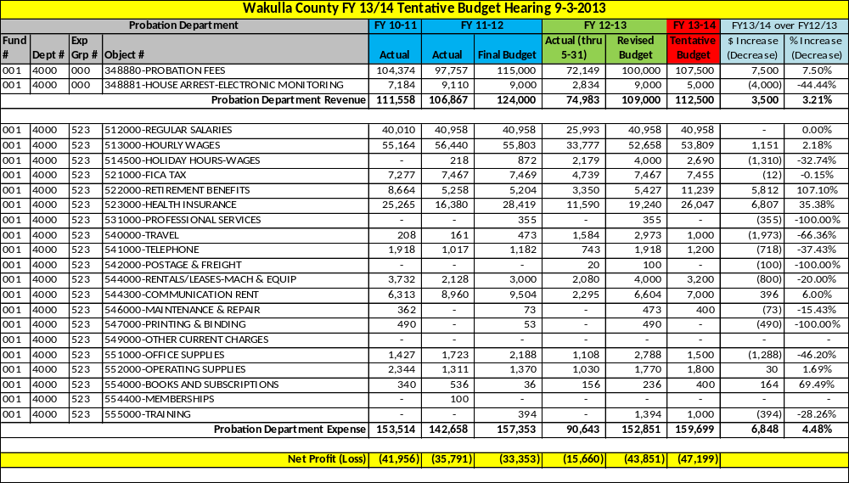

Veteran’s Services

The County Veterans Service Office is staffed with an Accredited National Service Officer that assists veterans and their dependents with general information, claims preparation, claims development, appeals of Department of Veterans’ Affairs (VA) final decisions, General information regarding the Board of Veterans Appeals and the Court of Veterans Appeals procedures. County Veterans Service Officers are governed by the rules and regulations of the U.S. Department of Veterans Affairs, and Florida, Department of Veterans’ Affairs.
The most popular VA benefits and services are related to health care. There are approximately 3,200 veterans in Wakulla County, with 654 active files. There are approximately 4,000 files that must be maintained in the event that a veteran or family member needs information or documents that are filed with the Veteran’s Department.
The Veteran’s Office also oversees special functions such as planning and coordinating the Memorial Day Ceremony, Veteran’s Day Ceremony and Parade, and Welcome Home Rallies for local veterans returning from service, as well as other veteran-related activities in the community. For more information please go to www.mywakulla.com.
Staffing
James “JD” Johnson | Veteran’s Service Officer | jjohnson@mywakulla.com

Service Outputs
Fiscal Year | 2010 | 2011 | 2012
# of active files | 519 | 578 | 671
# of signed in customers | 390 | 721 | 691

Veteran’s Services Department Revenue & Expense Detail

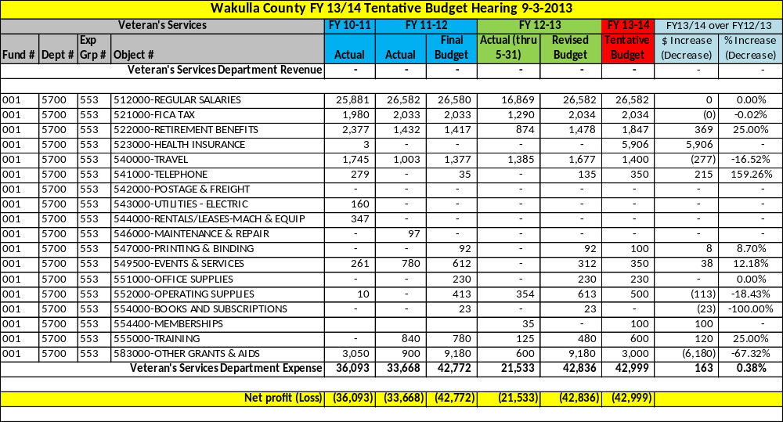

Emergency Medical Services

Emergency Medical Services (EMS) provides advanced life support care on a 24 hour basis to all of Wakulla County. There are three stations manned at all times: Crawfordville, Medart and Wakulla Station. The Supervisor also is assigned to man a fourth ambulance when situations arise that exceed the capabilities of the on duty resources. EMS has also implemented a dual certification program that provides pay incentives to employees that are currently certified in Florida as firefighters to be able to use their skills to help during medical emergencies. This program saves the county thousands of dollars in salaries by allowing a single employee to serve two roles. EMS also coordinates with the Sheriff’s Emergency Management Director for disaster and emergency preparation and response. For more information please go to www.mywakulla.com.
Staffing
Michael Morgan | Fire Chief / EMS Director | mmorgan@mywakulla.com
Michael Lusko | Medical Director
Colleen Skipper | Administrative Coordinator– EMS & Fire Services | cskipper-mitchell@mywakulla.com
Shirley Hanifin | Administrative Assistant | shanifin@mywakulla.com
Karolyn Griffin | Paramedic
Joseph Haskins | Emergency Medical Technician
Stephen Pigott | Emergency Medical Technician
James Posey | Emergency Medical Technician
Randy Williams | Emergency Medical Technician
Claude Bowman | Emergency Medical Technician / Fire Fighter | abowman@mywakulla.com
Donald Burton | Emergency Medical Technician / Fire Fighter | dburton@mywakulla.com
Chris Chatham | Emergency Medical Technician / Fire Fighter
David Crum | Emergency Medical Technician / Fire Fighter | dcrum@mywakulla.com
Paul Gautier | Emergency Medical Technician / Fire Fighter
Lee Cassels | Paramedic
Dylan Jones | Paramedic
James Osteen | Paramedic | josteen@mywakulla.com
Michael Register | Paramedic | mregister@mywakulla.com
Phillip Rutten | Paramedic
Randall Waltman | Paramedic / Fire Fighter | rwaltman@mywakulla.com
Alexander Benitez | Paramedic / Fire Fighter
Scott McDermid | Paramedic Supervisor | smcdermid@mywakulla.com
Marvin Walters | Paramedic Supervisor | mwalters@mywakulla.com
Joey Tillman | Paramedic Supervisor | jtillman@mywakulla.com

Service Outputs
Fiscal Year | 2010 | 2011 | 2012
# of call outs (runs) | 3,130 | 3,138 | 3,391

Emergency Medical Services Department Revenue & Expense Detail

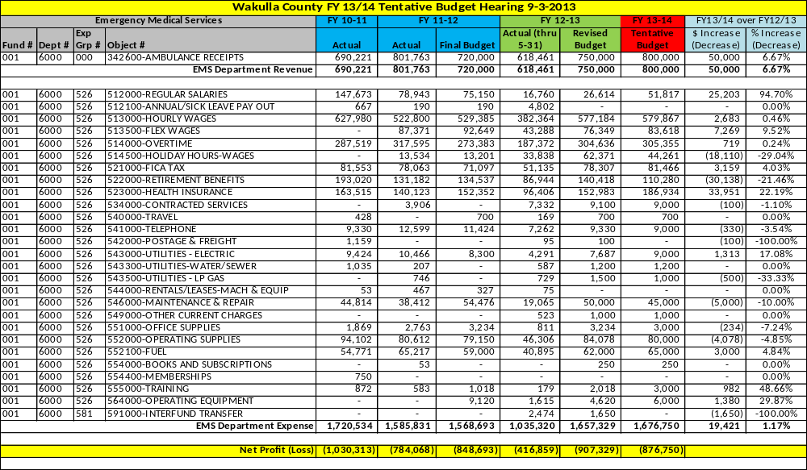
Recreation

The Recreation Department provides infrastructure and program support for recreational opportunities and leisure services such Flag Football, Cheerleading, Tackle Football, Winter and Spring Soccer, Basketball, T-ball League, Pitching Machine League, Player Pitch League, Cal Ripken League, Babe Ruth League, Girl’s Softball League and Adult Softball League. The Recreation Department is responsible for the practice and game scheduling of all the athletic events and the maintenance of the 40 acre Medart Recreation Athletic Facility which includes 9 baseball/softball fields, 2 football/soccer fields, 2 tennis courts and 4 basketball courts.
The Recreation Department has also hosted various baseball tournaments affiliated with the National Cal Ripkin Youth Baseball Association and the National Babe Ruth Youth Baseball Association. Additionally, the Department has hosted many N.F.L. Punt, Pass, & Kick contests, M.L.B. Baseball Skill Diamonds contests, and the N.B.A. Basketball Skills contests which allow for local youth to possibly advance to State and National Qualifying events associated with the respective professional sports organization that sponsors these events. It is estimated that the Medart Recreational Athletic Facility hosts approximately 130,000 visitors each year.
The Recreation Department oversees project coordination and construction management on some County projects that are not handled through the Public Works Department. The Recreation Department works with the Grants Coordinator to facilitate all construction activities associated with grant projects.
The Recreation Board is a 12-member advisory Board established for the purpose of providing recommendations and feedback to the Board of County Commissioners and County staff in regard to the programs provided by the Recreation Department. Additionally the Recreation Board serves as consultants to the construction of recreational facilities in accordance with County Ordinance 07-47. For more information please go to www.WCPRD.com.
Staffing
Bryan Roddenberry | Director | broddenberry@mywakulla.com
Peggy Bennett | Administrative Assistant | pbennett@mywakulla.com
Noreen Britt | Park Attendant – Recreation | nbritt@mywakulla.com
Kevin Riggles | Maintenance | kriggles@mywakulla.com
Mike Hamilton | Maintenance | mhamilton@mywakulla.com

Service Outputs
Fiscal Year | 2010/11 | 2011/12 | 2012/13 (thru June)
# of Youth Basketball participants | 69 | 77 | 48
# of Youth Basketball events | 100 | 118 | 51
# of Winter Soccer participants | 459 | 360 | 449
# of Winter Soccer events | 400 | 510 | 605
# of T-Ball participants | 199 | 217 | 240
# of T-Ball events | 108 | 240 | 150
# of Pitching Machine participants | 92 | 70 | 79
# of Pitching Machine events | 48 | 72 | 80
# of Player Pitch participants | 36 | 38 | 38
# of Player Pitch events | 24 | 36 | 52
# of Cal Ripken League participants | 133 | 120 | 134
# of Cal Ripken League events | 125 | 137 | 150
# of Babe Ruth League participants | 45 | 48 | 54
# of Babe Ruth League events | 36 | 49 | 83
# of Girl Softball participants | - | 49 | 67
# of Girl Softball events | - | 60 | 60
# of Spring Soccer participants | 260 | 292 | 314
# of Spring Soccer events | 177 | 177 | 177
# of Adult Softball participants | 75 | 160 | 187
# of Adult Softball events | 24 | 50 | 70
# of Flag Football participants | 72 | 55
# of Flag Football events | 87 | 75
# of Tackle Football participants | 315 | 200
# of Tackle Football events | 158 | 238
# of Cheerleading participants | 113 | 95
# of Cheerleading events | 72 | 174

Recreation Department Revenue & Expense Detail

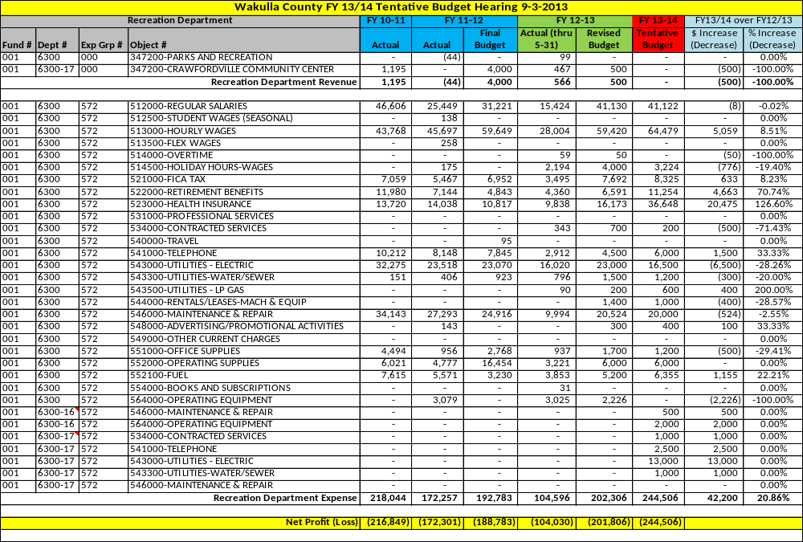

[This Page Left Intentionally Blank]

Parks

There are thirteen County owned parks located throughout Wakulla County. Those facilities are listed below. The services provided include rental of certain facilities for private use, and maintenance, repair and improvement of the grounds and facilities. The Parks Department also oversees project coordination and construction management on some County projects that are not handled through Public Works. For more information please go to www.WCPRD.com.
Facility | Acres | Amenities/Activities
Azalea Park | 7.4 | Lighted walking trail, water fountains, picnic tables, gazebos, benches, interpretive signage
Camilla Park | 1.75 | Passive undeveloped park
Crab Apple Park | 1.0 | Passive undeveloped park
Hickory Park | 4.0 | Pavilion, volleyball court, picnic tables, playground, tennis court.
Hudson Park | 3.8 | Pavilion with stage, picnic tables, restrooms
Equestrian Center | 163 | Equestrian Center, future site of Wakulla Wildlife Sanctuary
Mash Island Park | 489.76¹ | Boat ramp, fishing pier, beach access, trailhead with trail access for the Ochlockonee Bay Trail
Newport Park | 7.8 | Campsites (36), bathhouse, boat ramp, picnic tables, observation deck, fishing
Ochlockonee Bay Trail | 12² | 12 mile multi-purpose bicycle/pedestrian trail – currently under construction
Panacea Women’s Club | 2.1 | Building with kitchen facilities, restrooms, meeting room, small baseball field, basketball court
Shell Point Beach Park | 5.8 | Beach access, fishing, non-motorized boat launch, pavilion, shelters, playground, volleyball court, restrooms, outdoor showers
Rock Landing | .33 | Boat Ramp; 10 leased boat slips
Wooley Park | 3.25 | Stage area, restrooms, playground, lighted walking trail
¹ Approximately 50% is protected wetlands and cannot be developed. ² This is a linear park within existing right-of-way.

Staffing
Rod Revell | Facility Management & Parks Director | rrevell@mywakulla.com
Dolly Mitchell | Parks Attendant | dmitchell@mywakulla.com
Peggy Bennett | Administrative Assistant | pbennett@mywakulla.com

Service Outputs
Fiscal Year | 2010/11 | 2011/12 | 2012/13 (thru Mar)
# of park pavilion rentals | 19 | 18 | 10
# of park rentals | 0 | 2 | 7
# of yard sale rentals | 150 | 35 | 9
# of beach entries | 3,398 | 509
# of campground reservations | 672 | 444 | 269
# of park annual passes | - | - | 33
# of recreational acres maintained | 519 | 356
# of county sites maintained | 29 | 29 | 13
# of boat ramps maintained | 9 | 9 | 9
# of boat ramp launches | - | 44 | 804

Parks Department Revenue Detail

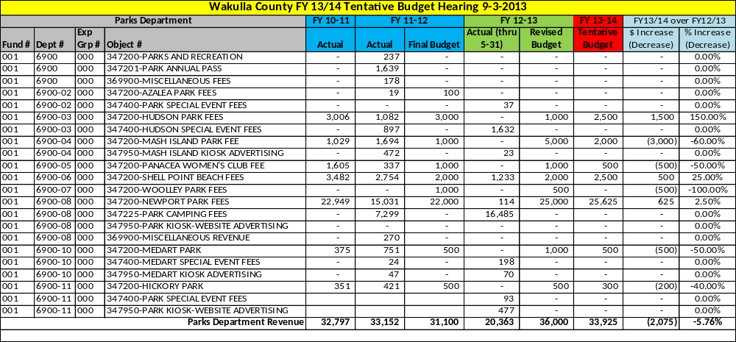
Parks Department Expense Detail

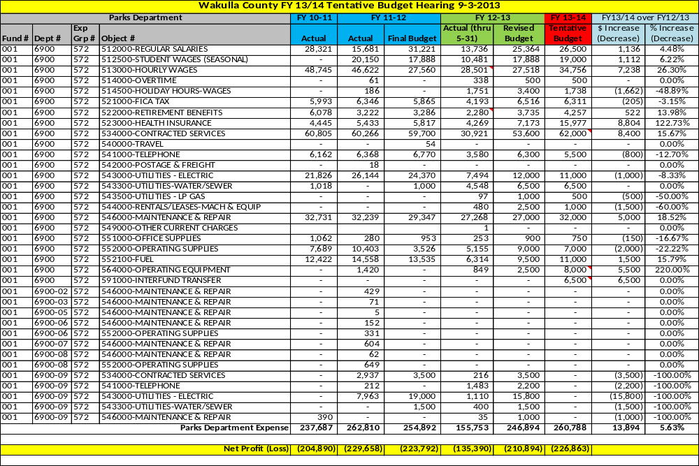

[This Page Left Intentionally Blank]

Building

This department reviews building and construction permit applications and performs plan reviews of construction documents for code compliance with the Florida Building Codes (FBC). In addition this department is responsible for the Florida Fire Prevention Code (FFPC) and inspections for code compliance accordance with the FBC and FFPC. This department also performs fire safety inspections and plans review for new and existing structures. This office serves as the county repository of required documents for issuance of building permits from the other departments/divisions, such as planning and zoning. For more information please go to www.mywakulla.com.

Staffing
James Melvin | Chief Building Official | jmelvin@mywakulla.com
Charles Ingle | Building Inspector | cingle@mywakulla.com
Tracy Chance | Fire Safety Inspector / Office Manager | tchance@mywakulla.com
Lawana Matthews | Building Technician | lmatthews@mywakulla.com
Replacement Position | Building Code Inspector

Service Outputs
Fiscal Year | 2010/11 | 2011/12 | 2012/13 (thru June)
# of SFD permits | 51 | 51 | 51
# of Commercial permits | 0 | 5 | 1
# of permits issued | 860 | 831 | 645
# of inspections | 3,734 | 3,255 | 2,365
# of plan reviews | 277 | 230 | 135

Building Department Revenue Detail

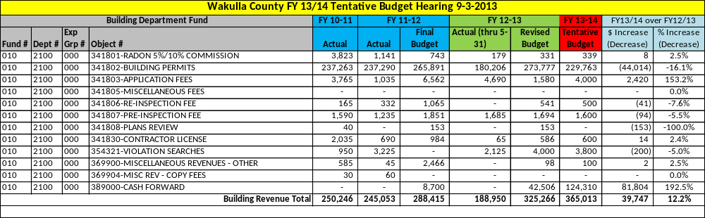

Building Department Expense Detail

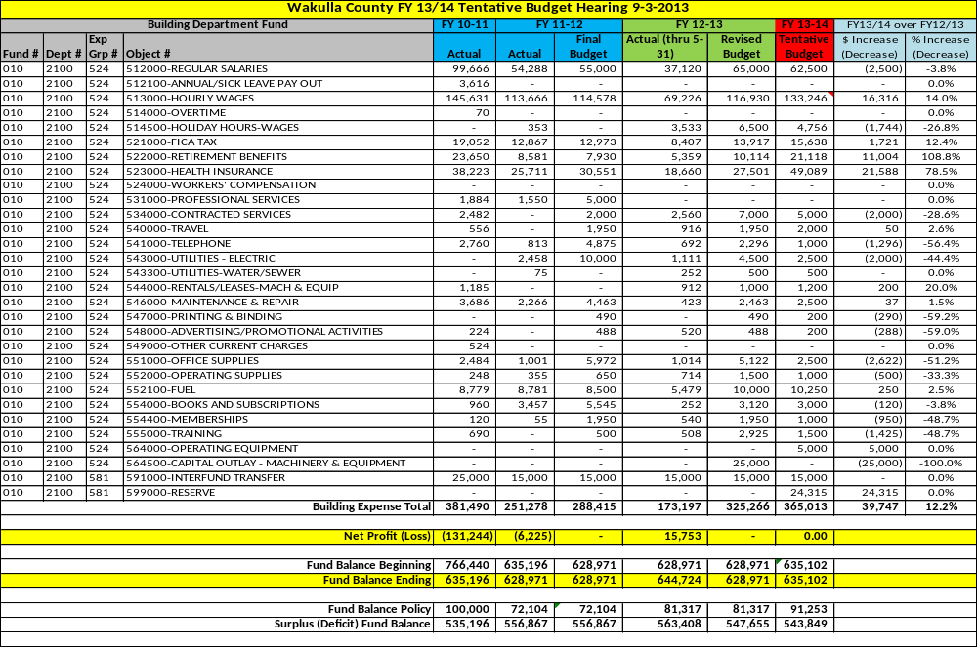
Service of Process Grant

The Service of Process Grant is a General Fund grant received from the U.S. Department of Health and Human Services and passed through the Florida Department of Revenue to offset a portion of the Sheriff’s cost of serving individuals regarding certain court proceedings as required by Florida Statute. The funds derived from this grant are transferred to the Sheriff’s Fine & Forfeiture Fund.

Staffing
N/A – No staffing is required by the BOCC for this grant.

Service Outputs
Fiscal Year | 2010/11 | 2011/12 | 2012/13 (thru June)
# of Writs / Services of Process | 273 | 113 | 126

Service of Process Grant Revenue & Expense Detail

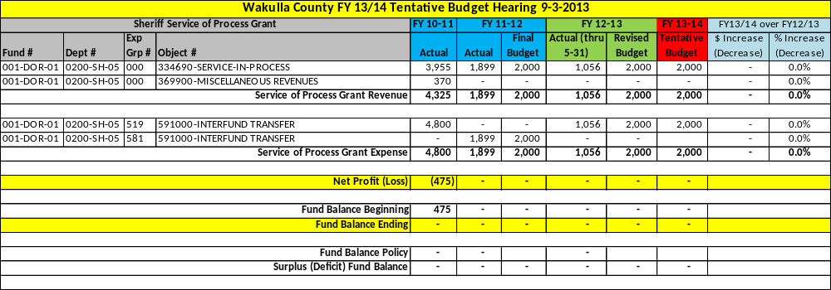

[This Page Left Intentionally Blank]

Special Revenue Fund Detailed Budgets

The total tentative budget for the Special Revenue Funds is $16,472,513, a decrease of $4,867,886 or -22.8% as compared to FY 2012/13 Budget as amended.

There are a total of 18 separate Special Revenue Funds. Those funds are listed below:

- Fund 104 – Justice Assistance Grants
- Fund 105 – Ochlockonee Bay Bike Trail Grants
- Fund 107 – Recreation User Fee Fund
- Fund 115 – Emergency Medical Service Grants
- Fund 118 – Mosquito Control Grant
- Fund 120 – Housing Assistance Grant
- Fund 124 – Boating Improvement Grants & User Fee Fund
- Fund 125 – State Housing Initiative Program (SHIP) Grant
- Fund 127 – Federal Emergency Management Assistance (FEMA) Fund
- Fund 128 – BP RESTORE Act Fund
- Fund 150 – Sheriff’s Fine & Forfeiture Fund
- Fund 154 – Court Fees Fund
- Fund 157 – Criminal Justice Fee Fund
- Fund 160 – Road Operating Fund
- Fund 165 – Airport Grants Fund
- Fund 180 – Fire Municipal Service Benefit Unit (MSBU) Fund
- Fund 188 – Tourist Development Tax & Grant Fund
- Fund 190 – E911 Surcharge & Grant Fund

On the following pages is a brief summary of each fund followed by a detailed line item budget. Actual data for FY 2010-11 and actual and budgetary data for FY 2011-12 and FY 2012-2013 are also provided for comparative purposes.

At the bottom of each schedule is a Net Profit / (Loss) line followed by the Beginning and Ending Fund Balance. If the fund is required to carry a minimum fund balance per the County’s Fund Balance Policy, the required minimum and surplus or deficit is shown.

Fund 104 – Justice Assistance Grants

This fund accounts for grants that are received via the Federal Government’s Office of Criminal Justice and passed through the State’s Department of Law Enforcement. The funds are transferred directly to the Sheriff’s Office.

Staffing
N/A – No staffing is required by the BOCC.

Service Outputs
N/A – The BOCC does not track outputs for this grant.

Fund 104 – Justice Assistance Grants Revenue & Expense Detail

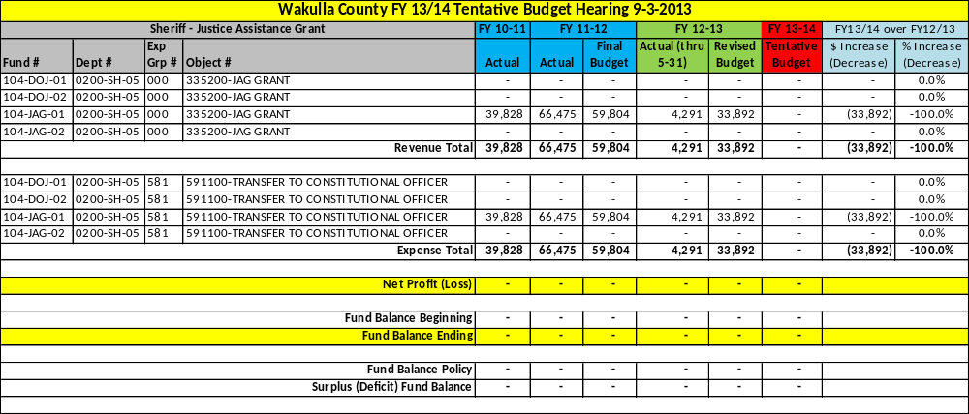

Fund 105 – Ochlockonee Bay Bike Trail Grants

This fund accounts for grants that are received via the Federal Government’s Department of Interior and Department of Transportation and passed through the State’s Department of Fish & Wildlife Services and Department of Transportation. The funds are being used to construct a 12 mile multi-use trail that parallels Mashes Sands Road and Surf Road beginning at Mash Island Park and ending near Sopchoppy. There are five phases of construction and 7 miles have been completed. The trail will be maintained by the Parks Department.

This trail will receive the State designation as a recreational trail and it will eventually connect to other regional greenways and trails and become part of the “Capital City to the Sea Trails” program.

Staffing
N/A – No staffing is required by the BOCC. Once completed, current staffing levels will be used to maintain the trail.

Service Outputs
N/A – No service outputs are currently being tracked.

Fund 105 – Ochlockonee Bay Bike Trail Revenue & Expense Detail

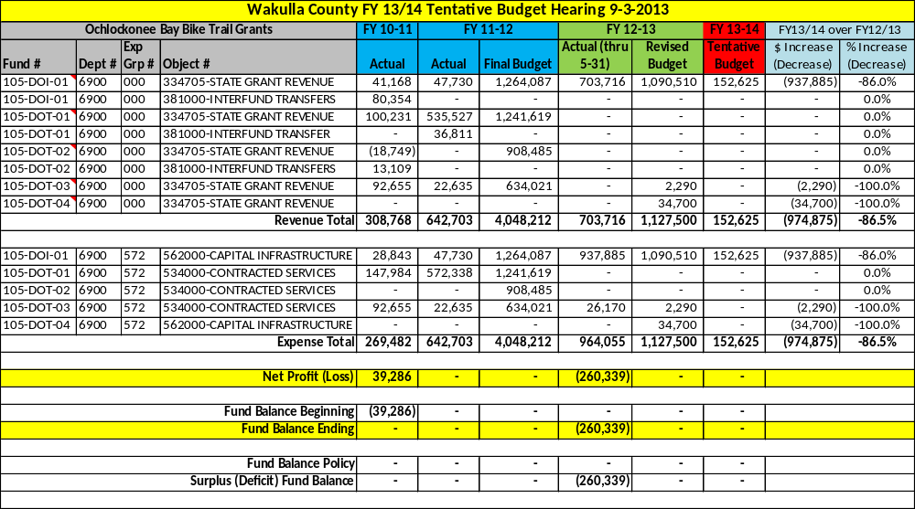

Fund 107 – Recreation User Fee Fund

This fund is used to track the fees collected from the users of the following Recreation programs: Flag Football, Cheerleading, Tackle Football, Winter and Spring Soccer, Basketball, T-ball League, Pitching Machine League, Player Pitch League, Cal Ripken League, Babe Ruth League, Girl’s Softball League and Adult Softball League. The fees from each program are used to offset the direct costs of the providing the programs.

Staffing
N/A – See the Recreation Department in the General Fund for staffing levels.

Service Outputs
N/A – See the Recreation Department in the General Fund for the service outputs for these programs.

Fund 107 – Recreation User Fee Revenue Detail

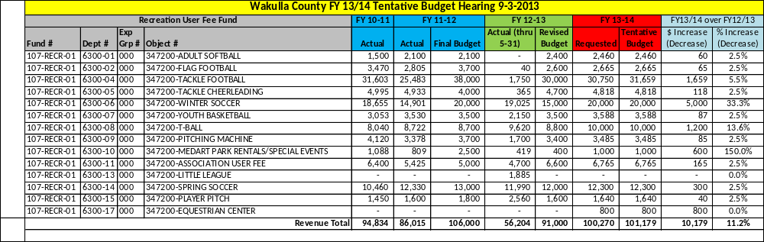

Fund 107 – Recreation User Fee Expense Detail

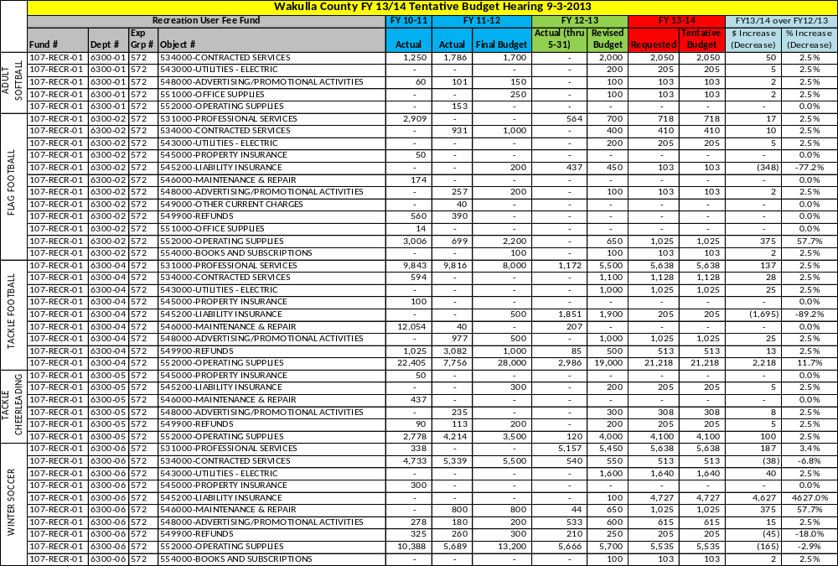
Fund 107 – Recreation User Fee Expense Detail

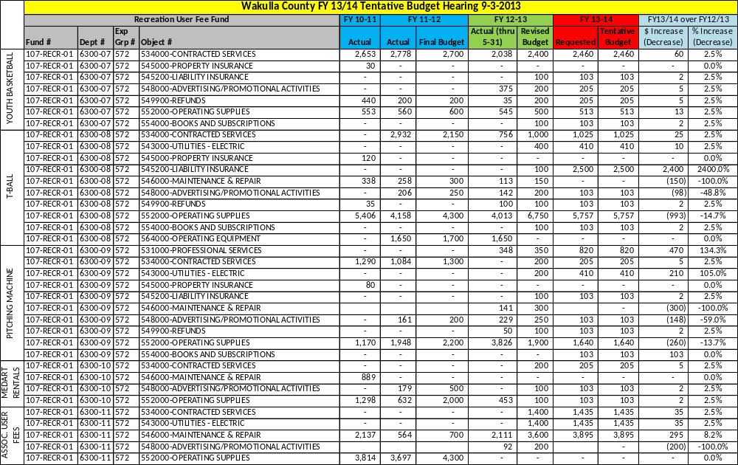

Fund 107 – Recreation User Fee Expense Detail

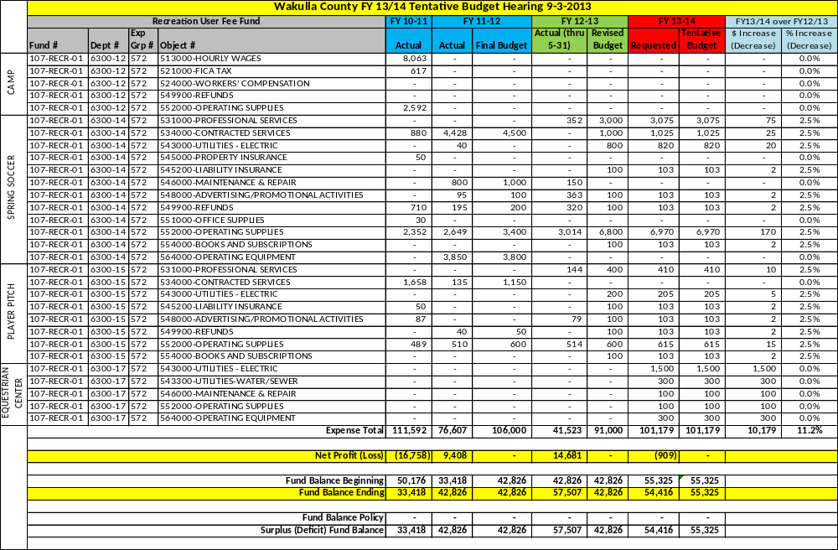

[This Page Left Intentionally Blank]

Fund 115 – Emergency Medical Service Grants

This fund accounts for grants that are received via the Florida Department of Health. The funds are used to provide needed equipment for the Emergency Medical Service Department’s buildings and vehicles.

Staffing
N/A – No staffing is required by the BOCC.

Service Outputs
N/A – No service outputs are tracked for the EMS grants. See the EMS Department service outputs in the General Fund.

Fund 115 – EMS Grant Revenue & Expense Detail

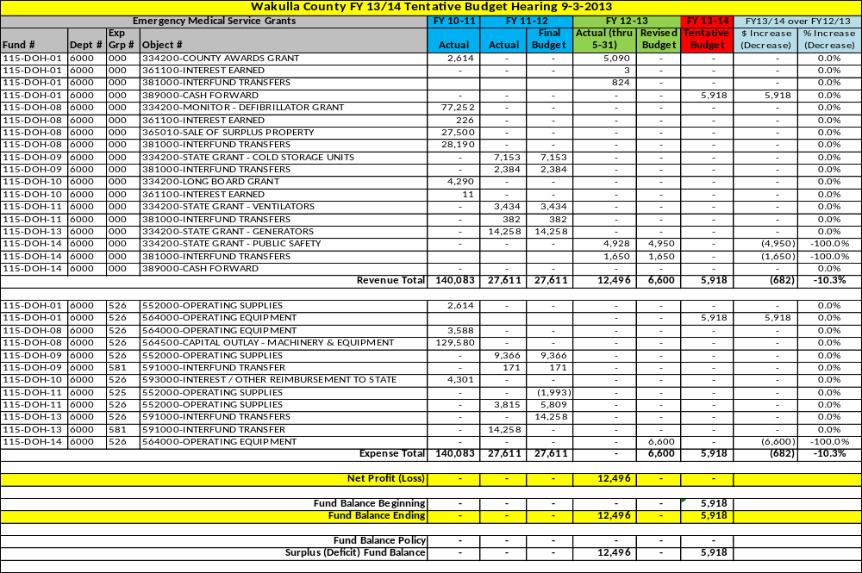
Fund 118 – Mosquito Control Grant

This fund accounts for grants that are received via the Florida Department of Agriculture & Consumer Service. The funds are used to provide mosquito control (spraying and larvicide) throughout the County. The program is administered by the County Health Department.

Staffing
N/A – No staffing is required by the BOCC. The Health Department supplies the required staffing for the Mosquito Control grant.

Service Outputs – Data not available at time of printing
Fiscal Year | 2010/11 | 2011/12 | 2012/13 (thru)

Fund 118 – Mosquito Control Grant Revenue & Expense Detail

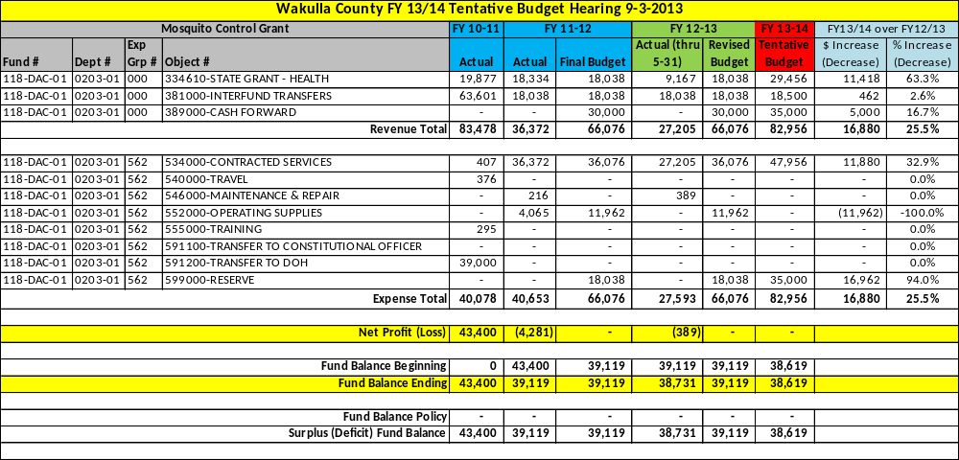

Fund 120 – Housing Assistance Grant

This fund accounts for grants that are received via the U.S. Department of Housing and Urban Development. The funds are used as an incentive to provide affordable housing. The funds are used to provide housing assistance through rent and utility subsidies to citizens who qualify for the program. The program is administered by Meridian Community Services Group Inc.

Staffing
N/A – No staffing is required for the Housing grant. The BOCC contracts with Meridian Community Services Group Inc.

Service Outputs
Fiscal Year | 2010/11 | 2011/12 | 2012/13 (thru July 15)
# of tenants | 121 | 120 | 145

Fund 120 – Housing Assistance Grant Revenue Detail

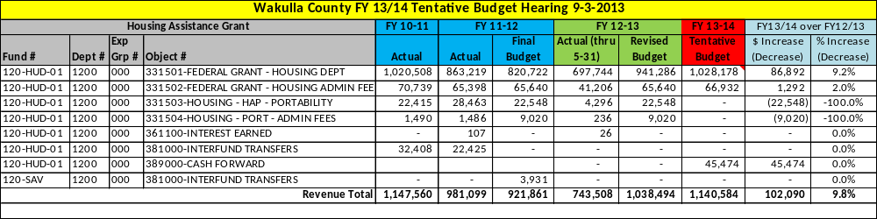

Fund 120 – Housing Assistance Grant Expense Detail

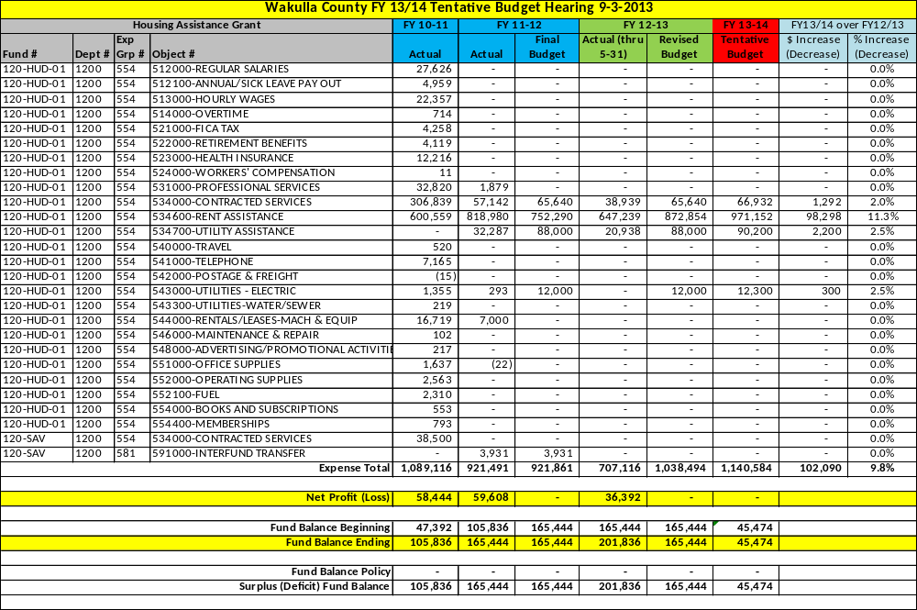
Fund 124 – Boating Improvement Grants & User Fee Fund

This fund is used to track the fees collected by County maintained boat ramp users, fees collected by the Tax Collector’s Office from boating vessel registrations and various grants received from the Florida Fish & Wildlife Commission. This funding is used to maintain the various boat ramp and boating facilities throughout the County. The following is a list of the County-owned boat ramps in which fees are being collected.

- Blue Dolphin
- Bottoms Road
- Levy Bay
- Lower Bridge
- Mash Island
- Newport Park
- Rock Landing
- Shell Point

Staffing
N/A – No additional staffing is required by the BOCC. This fund is staffed by the Parks Department staffing in the General Fund.

Service Outputs – Data not available at time of printing
Fiscal Year | 2010/11 | 2011/12 | 2012/13 (thru)

Fund 124 – Boating User Fee & Grant Revenue & Expense Detail

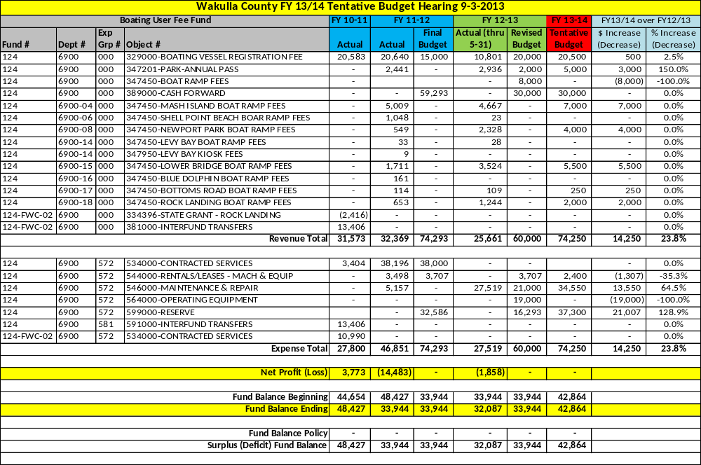
Fund 125 – State Housing Initiative Program (SHIP) Grant

This fund accounts for grants that are received via Florida Housing’s State Housing Initiatives Program. The funds are used as an incentive to produce and preserve affordable housing and multi-family housing. The funds and used to provide down payment assistance and housing rehabilitation assistance to citizens who qualify for the program. The program is administered by Meridian Community Services Group Inc.

Staffing
N/A – No staffing is required for the Housing grant. The BOCC contracts with Meridian Community Services Group Inc.

Service Outputs
Fiscal Year | 2010/11 | 2011/12 | 2012/13 (thru June)
# of down payments / rehabilitation assistance | 8 | 1 | 11

Fund 125 – SHIP Grant Revenue Detail

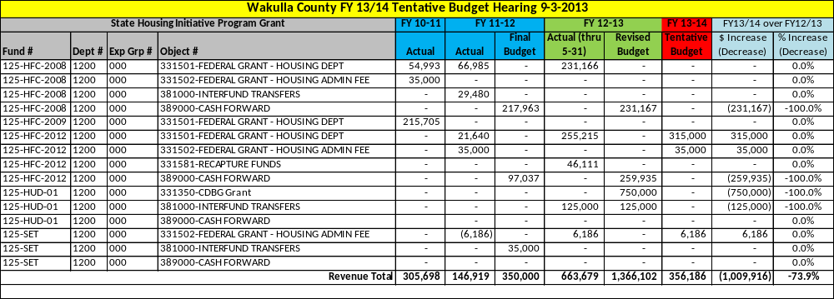
Fund 125 – SHIP Grant Expense Detail

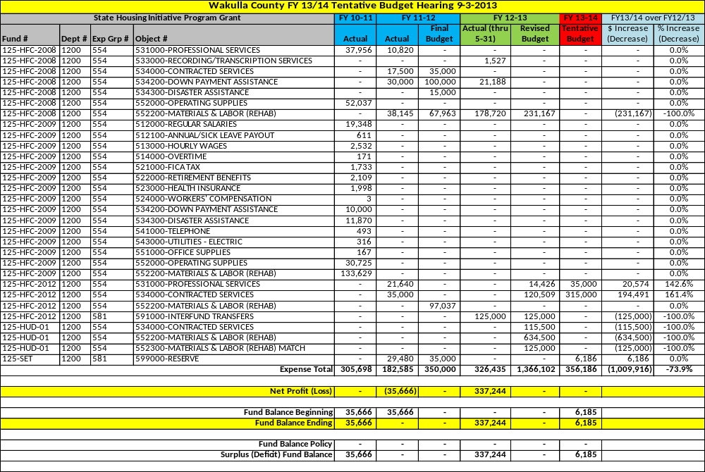
Fund 127 – Federal Emergency Management Assistance (FEMA) Fund

This fund is used to account for federal disaster assistance received by the County from the U.S. Department of Federal Emergency Management Agency as passed through the Florida Department of Emergency Management. To receive assistance the State must declare an event (typically weather related such as hurricane or flooding) to be a disaster of such magnitude that local government entities will need funding assistance to recover from the damages caused by the event. Funds are received on a reimbursement basis and only a percentage, typically 87.5%, are reimbursed.

Staffing
N/A – No staffing is required by the BOCC.

Service Outputs
N/A – No service outputs are tracked for this fund.

Fund 127 – FEMA Grant Revenue & Expense Detail

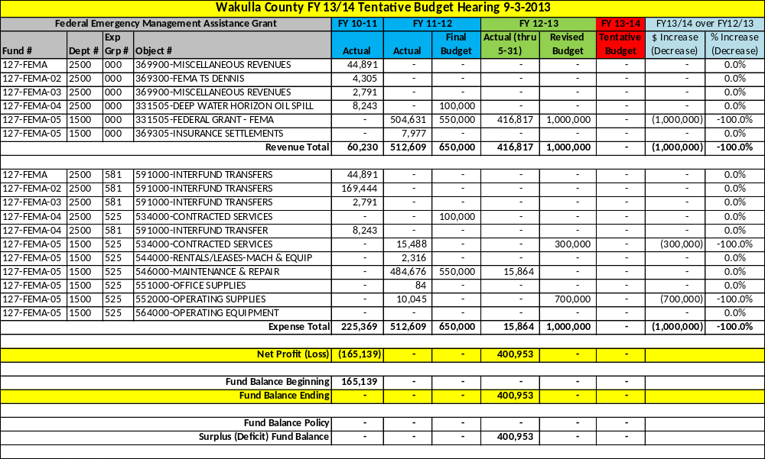

Fund 128 – BP RESTORE Act Fund

This fund was established to capture the fines from the Deep Water Horizon oil spill that occurred in the Gulf of Mexico in 2010. These fines will be paid by the various companies ultimately found responsible for the oil spill. The formulas and allocations are very complicated but, in summary, 80% of the fines will be paid to the five states affected (Texas, Louisiana, Mississippi, Alabama and Florida). The funds will be further divided among those counties that were affected with the most affected 8 counties in Florida (disproportionate counties) receiving the larger portion of funds. Those 8 counties will then divide the funds based on a multi-factored formula.

The Board adopted Ordinance 2012-30 and Resolution 2012-60 which established the Wakulla County RESTORE ACT Committee which is responsible for preparing a recommended list of projects to be present to the BOCC for approval.

Staffing
N/A. Currently no staffing is required by the BOCC. If fully funded, 1 dedicated FTE will be used to manage these projects.

Service Outputs
N/A – No service outputs are currently being tracked for this fund.

Fund 128 – BP RESTORE ACT Revenue & Expense Detail

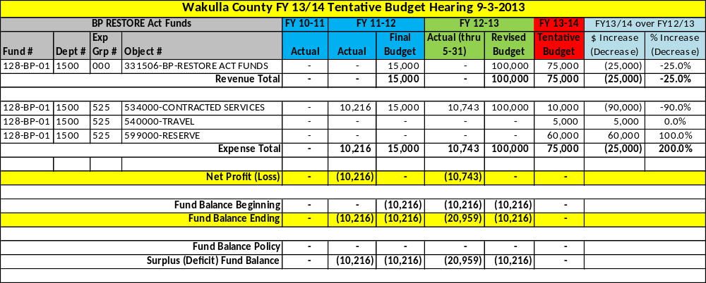

Fund 150 – Sheriff’s Fine & Forfeiture Fund

This fund, established pursuant to F.S. 129.02, is used to account for the revenues and expenses related to the Sheriff’s Office. The Sheriff is a Constitutional Officer under Article VIII Section 1 (d) of the Florida Constitution and operates under Chapter 30, and other various chapters of the Florida Statutes.
The Sheriff is responsible for Law Enforcement, Corrections, Courthouse Security, Emergency Management and other public safety related functions.

Staffing
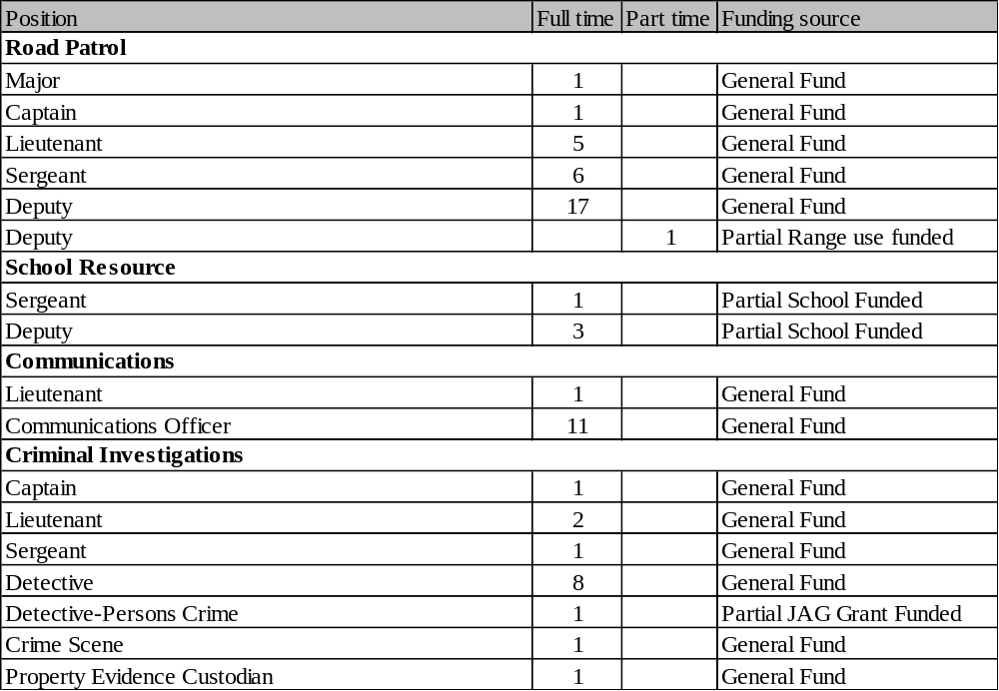
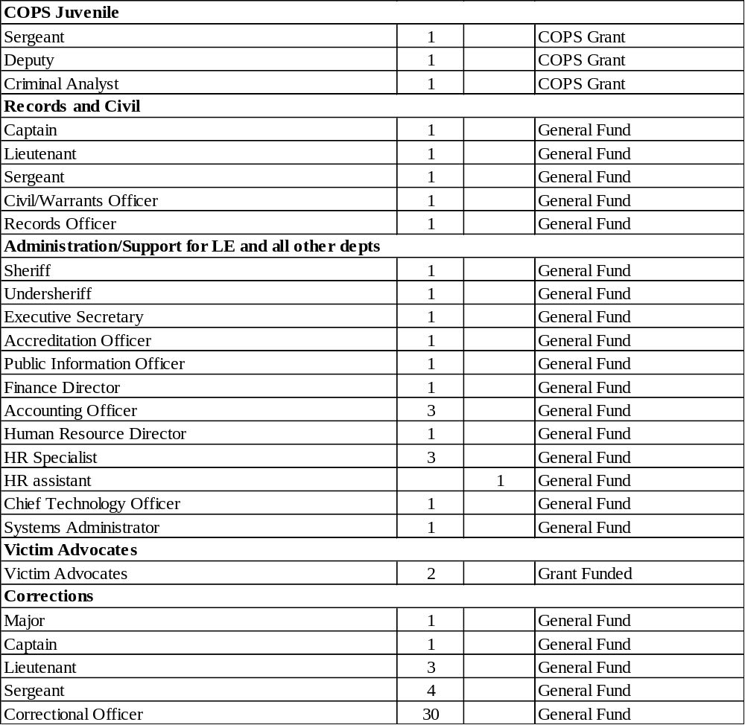
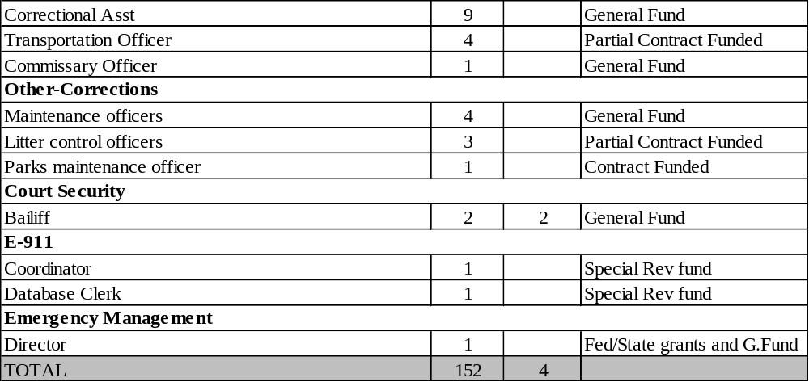

Service Outputs
Fiscal Year | 2010/11 | 2011/12 | 2012/13 (Projected))
Law Enforcement
# of uniform patrol calls for service | 53,542 | 48,517 | 56,000
Total UCR crimes reported | 841 | 776 | 800
# of E911 calls | 9,693 | 8,208 | 9,000
# of EMS service calls dispatched | 3,112 | 3,347 | 3,400
# of Fire service calls dispatched | 3,343 | 3,465 | 3,400
# of Communications center calls | 96,462 | 90,460 | 95,000
# of cases assigned to Criminal Investigations | 1,039 | 853 | 900
Corrections
Avg. local inmate population | 119 | 139 | 120
Avg. ICE inmate population | 117 | 100 | 75
Avg. U.S. Marshall’s inmate population | 5 | 3 | 3
Avg. inmate population | 241 | 242 | 198

Fund 150 – Fine & Forefeiture Revenue & Expense Detail

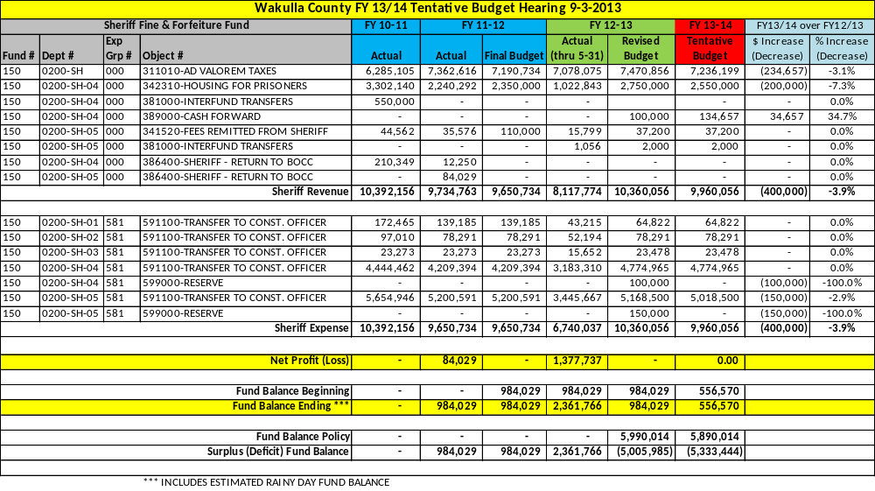

A detailed budget for the Sheriff’s Office can be found in Section 6 beginning on page 265.

Fund 154 – Court Fees Fund

This fund is used to account for the various court related fees that are collected by the Clerk of Court and distributed to the Board on a monthly basis. In Fund 154, there are many “sub-funds” which are smaller funds used to track the different court related fees and their restricted use. Each “sub-fund’s” revenue and related expense is described individually on the following pages. The two positions mentioned below are partially funded by the Board’s court related fees and by the other County’s within the 2nd Judicial Circuit. Those positions are recorded as staff since they are housed in the Wakulla County Courthouse. There are several other positions that are funded by these fees that are not housed in Wakulla County. Those positions include: a Juvenile Alternative Sanctions Coordinator, a Trial Court Marshall, and a Circuit Liaison.

There are several court affiliated offices that funding is provided to per Florida Statute for various purposes. Those offices are: Court Administration of the 2nd Judicial Circuit, the State Attorney’s Office, the Public Defender’s Office, the Circuit Judge’s Office, the County Judge’s Office, the Clerk of Court, the Probation Department and the Sheriff’s Office.

Staffing
Brian Honhart | User Support Analyst | honhartb@leoncountyfl.gov
Vacant Position | Integrated Computer System Interface Developer

Service Outputs
N/A – The BOCC does not track any service outputs for Court Administration.

Fund 154-CI – 25% Court Innovation Fund. This fund is supported by 25% of a $65.00 fee imposed on felony, misdemeanor and criminal traffic cases pursuant to F.S. 939.185(1)(a). These funds are used to provide support to court related program as approved by the Chief Judge of the 2nd Judicial Circuit.

Fund 154-CI – Court Innovation Revenue & Expense Detail

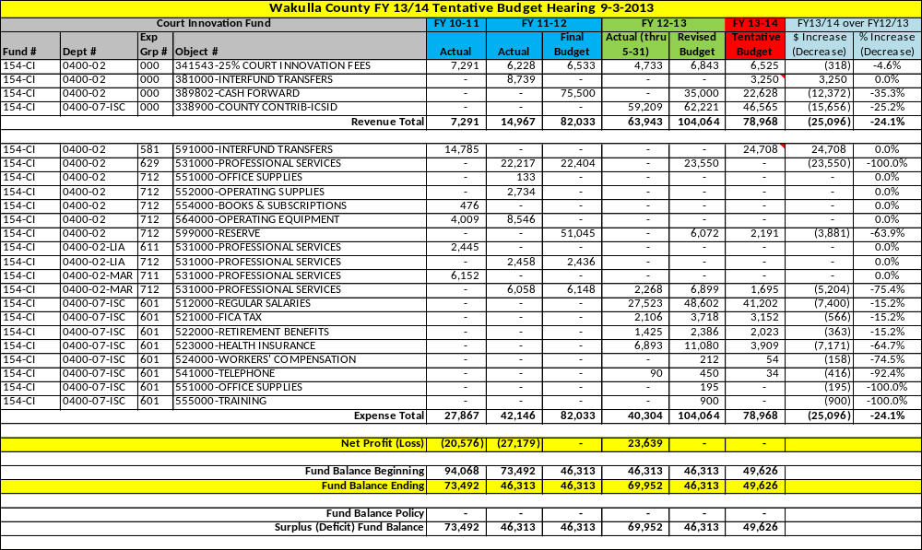
Fund 154-COU - $30 State Court Facility Fund. This fund is supported by a $30.00 surcharge on all criminal and civil traffic cases pursuant to F.S. 318.18(13). These funds are used to support the Courthouse Facility. This $30 surcharge was leveraged in 2011 to help complete the courthouse renovations. This debt will be paid off in 2021.

Fund 154-COU – State Court Facility Revenue & Expense Detail

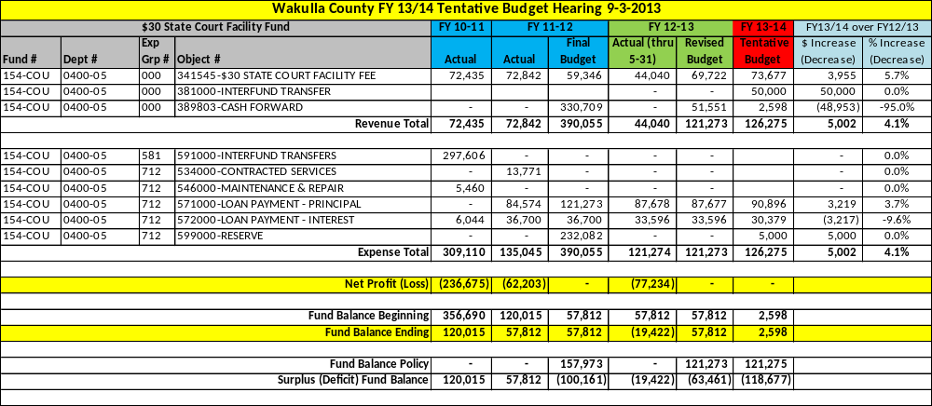

Fund 154-CRI – Crime Prevention Fund. This fund is supported by a $20.00 court cost all charges other than felony or a $50.00 court cost for felonies pursuant to F.S. 775.083(2). These funds are used to provide assistance in crime prevention and education.

Fund 154-CRI – Crime Prevention Revenue & Expense Detail

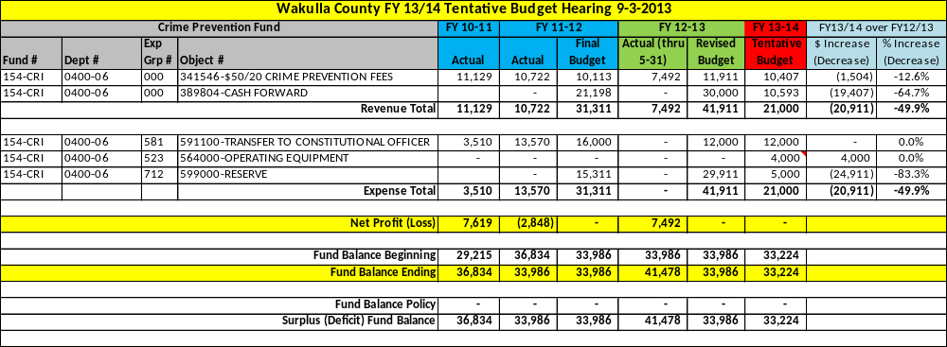

Fund 154-JUV – 25% Alternative Juvenile Court Fund. This fund is supported by 25% of a $65.00 fee imposed on felony, misdemeanor and criminal traffic cases pursuant to F.S. 939.185(1)(a). These funds are used to support alternative juvenile programs and teen court. These funds support the Juvenile Alternative Sanctions Coordinator that is located in Leon County.

Fund 154-JUV – Alternative Juvenile Court Revenue & Expense Detail

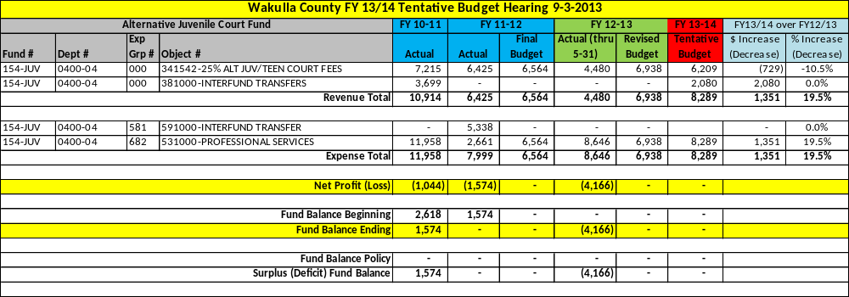

Fund 154-LAW – 25% Law Library Fund. This fund is supported by 25% of a $65.00 fee imposed on felony, misdemeanor and criminal traffic cases pursuant to F.S. 939.185(1)(a). These funds are used to support law library programs.

Fund 154-LAW – Law Library Revenue & Expense Detail

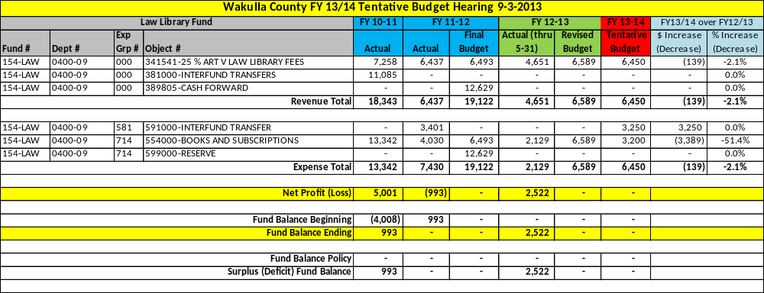

Fund 154-LEG – 25% Legal Aid Fund. This fund is supported by 25% of a $65.00 fee imposed on felony, misdemeanor and criminal traffic cases pursuant to F.S. 939.185(1)(a). These funds are used to provide legal assistance. These funds are provided to Legal Services of North Florida.

Fund 154-LEG – Legal Aid Revenue & Expense Detail

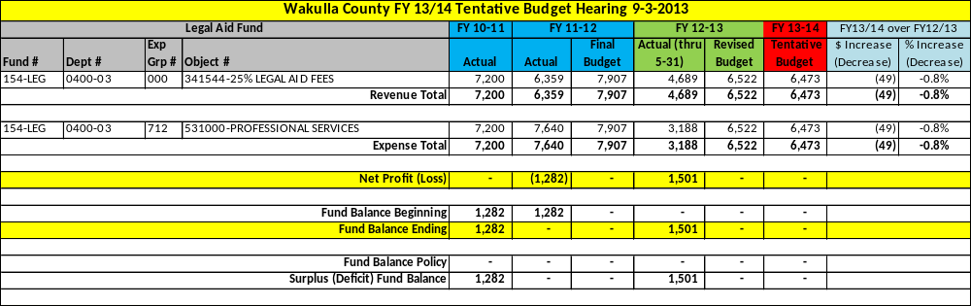

Fund 154-MAIN – Courthouse Maintenance Fund. This fund is no longer receiving revenue on an annual basis. These funds are the residual monies left over from an old revenue source intended to provide court maintenance assistance. These dollars are slowly being spent down as needed on courthouse maintenance needs. This sub-fund is also used to record the General Fund transfer which supports the Guardian Ad Litem program.

Fund 154-MAIN – Courthouse Maintenance Revenue & Expense Detail

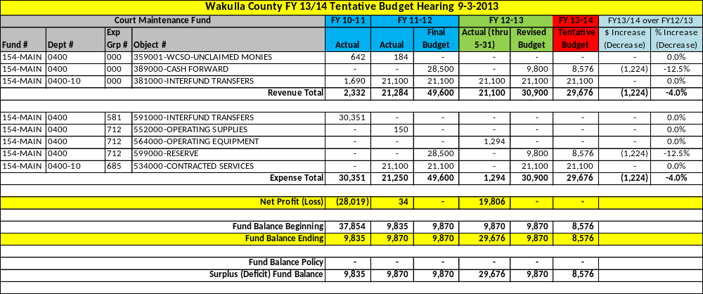

Fund 154-REC – $2 Court Information Technology Fund. This fund is supported by a $2.00 fee on every page recorded in the County Recorded Office of the Clerk’s Office pursuant to F.S. 28.41(12)(e)(1). These funds are used to provide technology support to the office of the Circuit and County Judges, the State Attorney’s Office, the Public Defender’s Office and the court-related portion of the Clerk’s Office.

Fund 154-REC – $2 Court Information Technology Revenue Detail

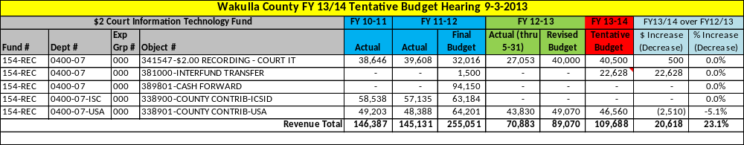

Fund 154-REC – $2 Court Information Technology Expense Detail

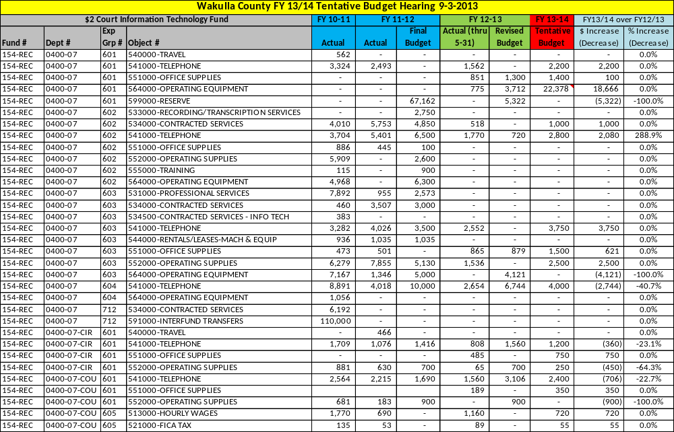

Fund 154-REC – $2 Court Information Technology Expense Detail

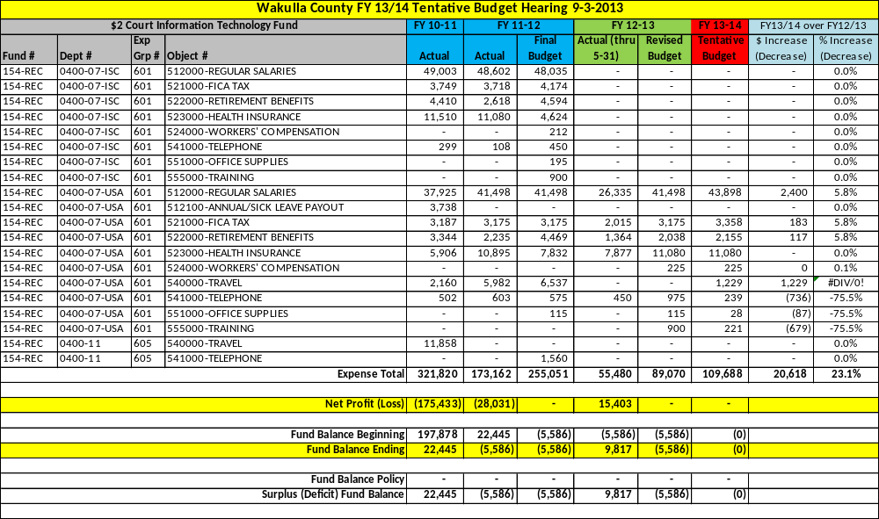

[This Page Left Blank Intentionally]

Fund 157 – Criminal Justice Fine Fund

This fund is used to account for the various court related fines that are collected by the Clerk of Court and distributed to the Board on a monthly basis. In Fund 157, there are many “sub-funds” which are smaller funds used to track the different court related fines and their restricted use. Each “sub-fund’s” revenue and related expense is described individually on the following pages.

There are several offices that funding is provided to per Florida Statute for various purposes. Those offices are: the Sheriff’s Office, the Wakulla County School Board and the Florida Highway Patrol.

Staffing
N/A – No staffing is required for these funds.

Service Outputs
N/A – The BOCC does not track any service outputs for Court Administration.

Fund 157-CRI – Criminal Justice Education Fund. This fund is supported by a $2.50 fee pursuant to F.S. 318.18©. These funds are used to provide education and training support to local law enforcement and correctional officers.

Fund 157-CRI – Criminal Justice Education Revenue & Expense Detail

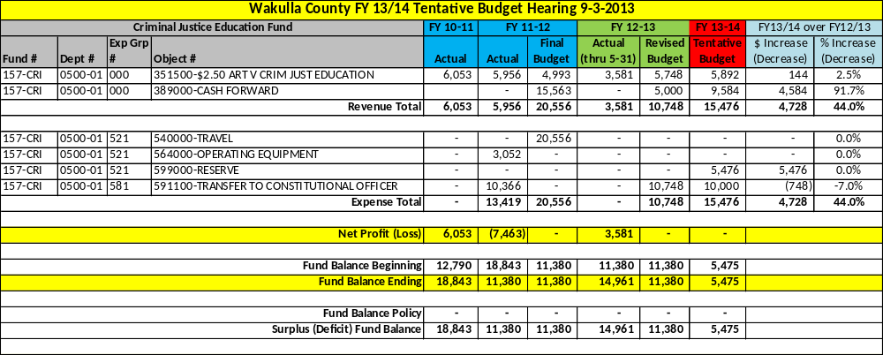

Fund 157-DOM – Domestic Violence Fund. This fund is supported by a $85.00 fee on domestic violence cases pursuant to F.S. 938.08. These funds are used to defray the costs of incarcerating persons sentenced under F.S. 741.283 and to provide training to law enforcement personnel in combating domestic violence.

Fund 157-DOM – Domestic Violence Revenue & Expense Detail

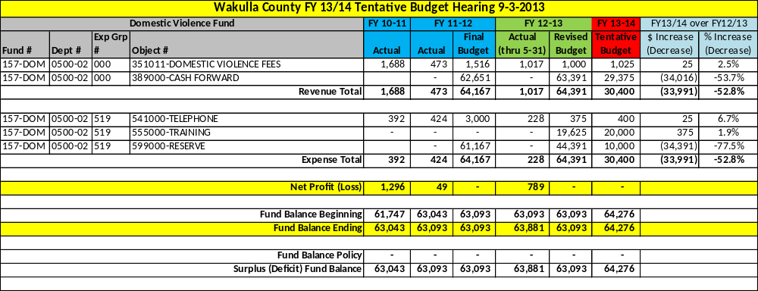

Fund 157-DRI – Driver’s Education Fund. This fund is supported by a $3.00 fee on each civil traffic penalty pursuant to Section 98, Chapter 2002-20, Laws of Florida, known as the “Dori Slosberg Driver Education Safety Act”. These funds are used to assist driver education safety programs in public and non-public schools.

Fund 157-DRI – Driver’s Education Revenue & Expense Detail

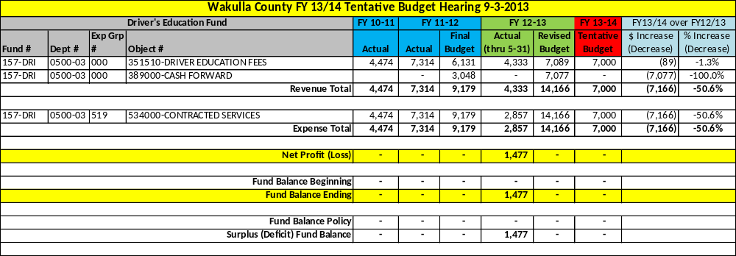

Fund 157-LAW – Law Education Fund. This fund is supported by a $2.00 fee on certain felony, misdemeanor and criminal traffic cases pursuant to F.S. 938.15; 318.18(11)(b) and 943.25. These funds are used to assist with law enforcement education and training programs.

Fund 157-LAW – Law Education Revenue & Expense Detail

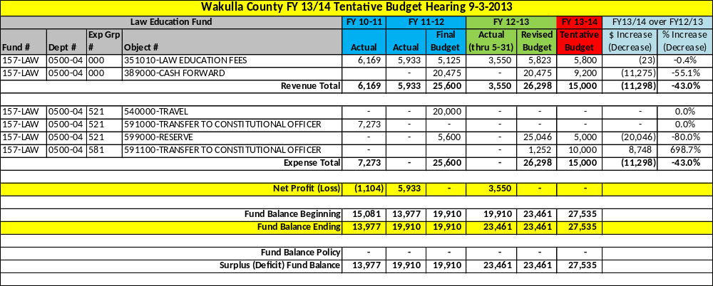

Fund 157-MOV – Moving Violations Fund. This fund is supported by a $12.50 surcharge on moving traffic violations pursuant to F.S. 316.655(6). These funds are used to local law enforcement with radio communication needs.

Fund 157-MOV – Moving Violations Revenue & Expense Detail

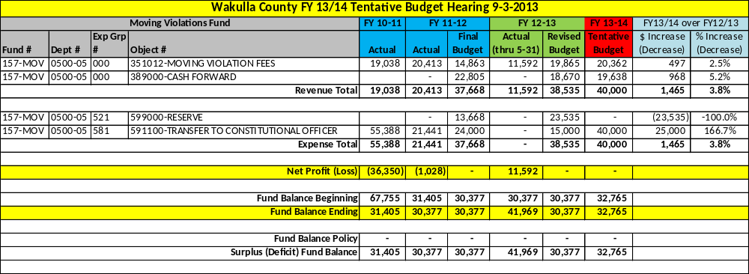

Fund 160 – Road Operating Fund

This fund is used to account for the various state and local gas taxes and their related use to maintain all of Wakulla County’s public use roads, bridges and right-of-ways. For a description of the gas taxes, please refer to Section 4 – Historical Data, Revenue History. The County contracts with ESG, Inc. for all of the Public Work related duties. There are a couple “sub-fund’s” within the Fund 160 Road Department and each will be described in the following pages.

Staffing
N/A – The BOCC contracts it road operations with ESG Inc. as a part of the Public Works Department. ESG Inc. has a staff of 22 employees dedicated to the Road Department.

Service Outputs
Fiscal Year | 2010/11 | 2011/12 | 2012/13 (thru May)
# of Call outs | 156 | 148 | 56
Feet of culverts installed | 745 | 870 | 1,370
# of culverts cleared | 207 | 274 | 427
Pot Holes Filled – Tons | 55 | 50 | 14.5
Feet of ditches cleaned | 7,645 | 12,945 | 24,011
Feet of shoulders clipped | 28,405 | 43,840 | 91,374
Miles of roads graded | 2,670 | 2,072 | 1,654
Miles of roads mowed | 650 | 919 | 834
Loads of dirt hauled | 4,090 | 1,868 | 1,303
Signs installed | 824 | 775 | 662
Feet of roads trimmed | 517,572 | 481,570 | 667,189
# of work orders completed | 352 | 1,431 | 1,478
# of driveways built up | 130 | 87 | 151
Hours of right-of-way clean up | - | - | 744

Fund 160 is used to account for all road related revenues and expenses except for the 2 Cent Gas Tax, Title III Funds and the Special Road Paving Assessments. This funds focuses on road maintenance not road paving.

Fund 160 – Road Department Revenue Detail

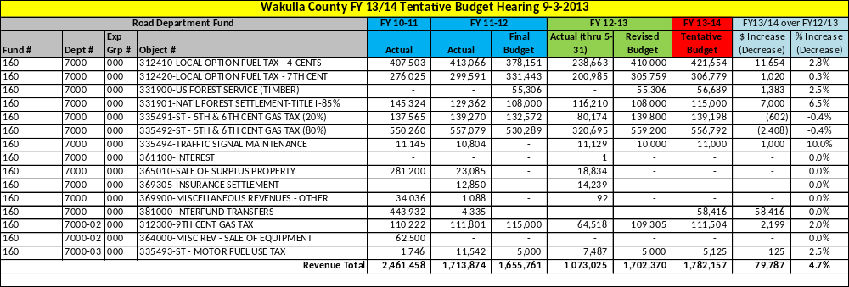

Fund 160 – Road Department Expense Detail

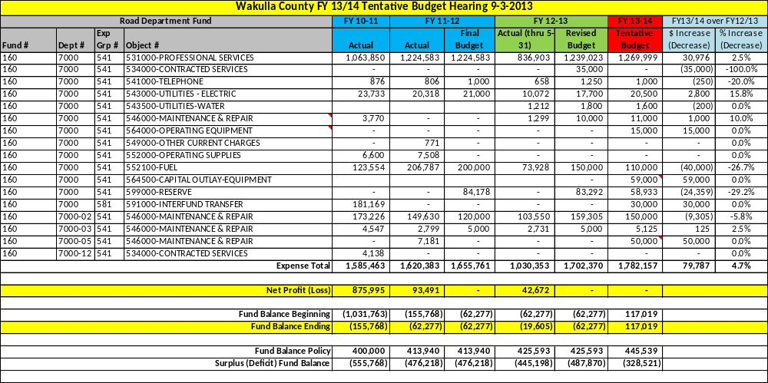

Fund 160-2CT is used to account for the 2 Cent Gas Tax proceeds. These funds are to be used for capital equipment purposes and are segregated for such use.

Fund 160-2CT – 2 Cent Gas Tax Revenue & Expense Detail

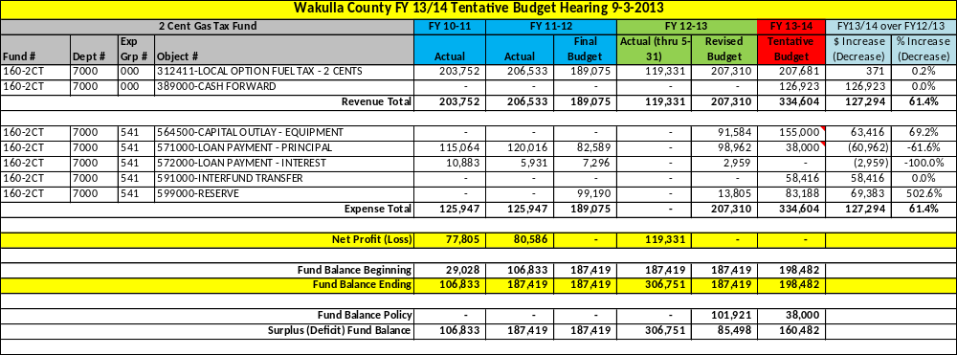

Fund 160-TTL3 is used to account for a portion of the funds received from the U.S. Government. These funds are known as “National Forest Settlement” funds and 15% of the revenue is to be set aside to be used to help keep the County’s public lands clean of debris. These funds are used to provide support to Keep Wakulla County Beautiful (KWCB). This organization provides cleanup efforts throughout the County including our national forests and refuges.

In FY 2013/14, these funds will also be used to provide “Amnesty Days” for hazardous wastes and materials so they do not find their way into the public lands.

Fund 160-TTL3 – Title 3 Revenue & Expense Detail

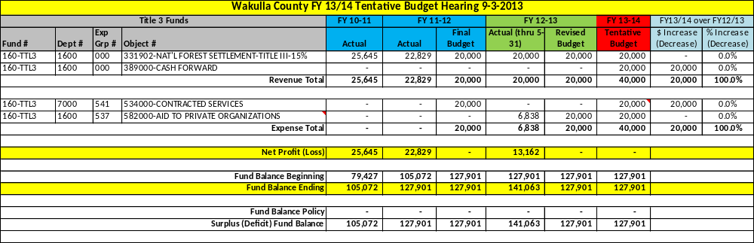

Fund 160-SUB is used to account for the payments received from homeowners in Brookforest, Tupleo Ridge and Northwoods subdivisions. These funds are used to pay back the loans incurred by the County when the subdivision roads were paved. Liens are placed on the properties and assessments are collected via the Ad Valorem tax bills that are sent out each year.

Fund 160-SUB – Special Assessment Road Paving Revenue & Expense Detail

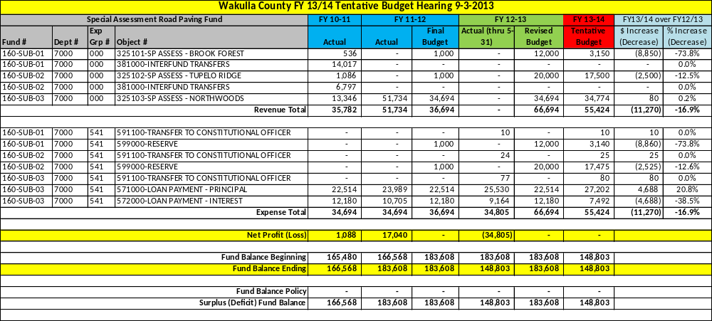

Fund 165 – Airport Grants Fund

This fund accounts for grants that are received via the Florida Department of Transportation. The funds are used to provide various planning and capital related needs to the airport. The program is administered by the County Administration staff

Staffing
N/A – No staffing is required by the BOCC. The Airport Manager position is a volunteer position.

Service Outputs
N/A – No service outputs are tracked for the Airport grants – See the Airport Department in the General Fund.

Fund 165 – Airport Grants Revenue & Expense Detail

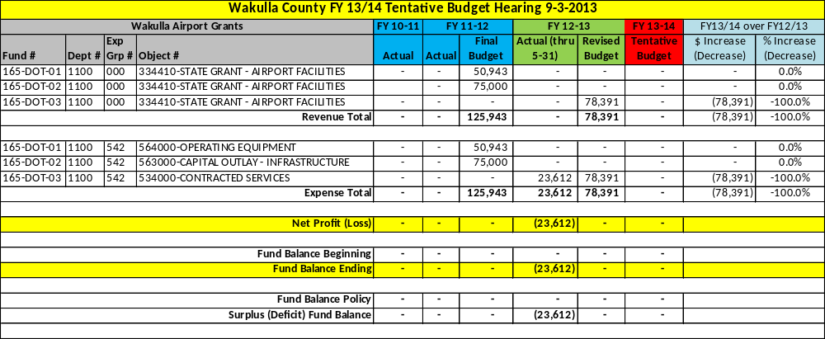

Fund 180 – Fire Municipal Service Benefit Unit (MSBU) Fund

The MSBU Fund is funded by a special assessment for fire protection services in 1985. While the Fire Department’s primary purpose is to fight fires, the department receives calls to numerous other emergency related events. The Fire Department has also implemented a dual certification program that provides pay incentives to employees that are currently certified in Florida as emergency medical technicians to be able to use their skills to help during fire emergencies. This program saves the county thousands of dollars in salaries by allowing a single employee to serve two roles.

Staffing
Michael Morgan | Fire Chief / EMS Directors | mmorgan@mywakulla.com
Colleen Skipper | Administrative Assistant | cskipper@mywakulla.com
Justin Duggan | Firefighter/EMT | jduggan@mywakulla.com
Louis Lamarche | Fire Captain/EMT | llamarche@mywakulla.com
Chad Slayton | Firefighter/EMT | cslayton@mywakulla.com
Brandon Alyea | Fire Captain / EMT | balyea@mywakulla.com
Jerry Johnson | Fire Captain / EMT | jjohnson@mywakulla.com
Erin Hindle | Firefighter / EMT | cchatham@mywakulla.com

Service Outputs
Fiscal Year | 2010 | 2011 | 2012
# of Call outs | 3,112 | 3,032 | 3,126

Fund 180 – M.S.B.U. Fire Department Revenue Detail

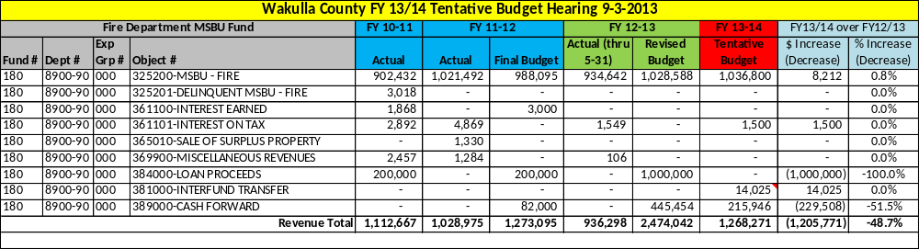

Fund 180 – M.S.B.U. Fire Department Expense Detail

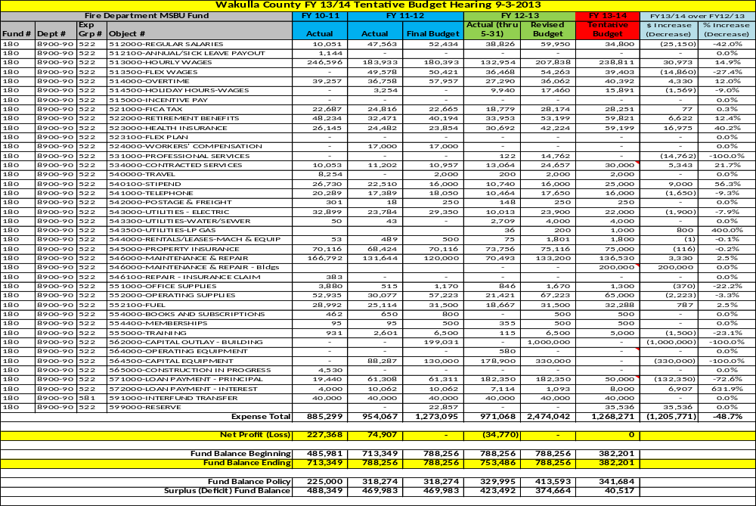

[This Page Left Intentionally Blank]

Fund 188 – Tourist Development Tax & Grant Fund

This fund is used to account for the Local Tourist Development Tax (“Bed Tax”) on short-term transient lodging. The funds are used to promote tourism for the economic impact on local businesses. The bed tax rate is 4% as amended in FY 2011/12. The Tourist Development Council was enacted by the BOCC pursuant to F.S. 125.0104. The TDC is a 9 member council that acts as an advisory board to the BOCC and administers the operation of a tourism promotion program in accordance with the annual marketing plan.

The bed tax is collected via the Florida Department of Revenue and distributed to the County on a monthly basis. This fund also has several “sub-funds” used to account separately for tourist related grants and the Big Bend Maritime Center.

Staffing
N/A – There is no staffing required by this fund. There are three contract employees funded by the bed tax. A part-time Tourist Development Council Director, a part-time administrative assistant and a part-time social media assistant.

Service Outputs
N/A – No service outputs are tracked by this fund.

Fund 188 accounts for the collection and expenditure of the bed tax.

Fund 188 – Tourist Development Revenue & Expense Detail

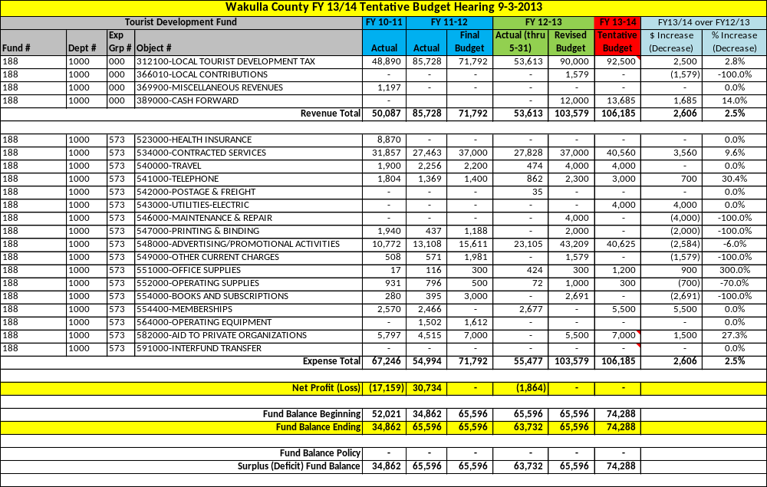
Fund 188-BBMC is used to account for the contributions, donations and festival proceeds of the “Mighty Mullet Festival”. The fund does not collect enough revenue to offset the maintenance and operating costs of the facility. Currently, the General Fund provides assistance through an annual transfer of funds.

Fund 188-BBMC – Big Bend Maritime Center Revenue & Expense Detail

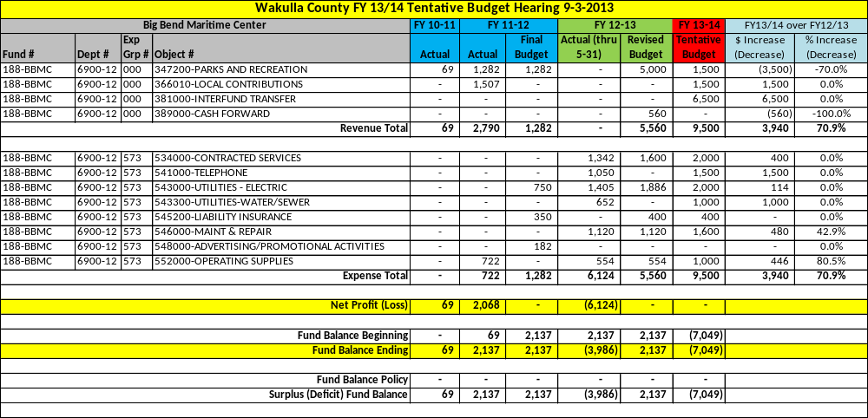

This portion of Fund 188 is used to account for the many grants received from various sources such as Florida’s Department of Environmental Protection, Department of Transportation and the Visit Florida campaign.

Fund 188 – Tourist Development Grants Revenue & Expense Detail

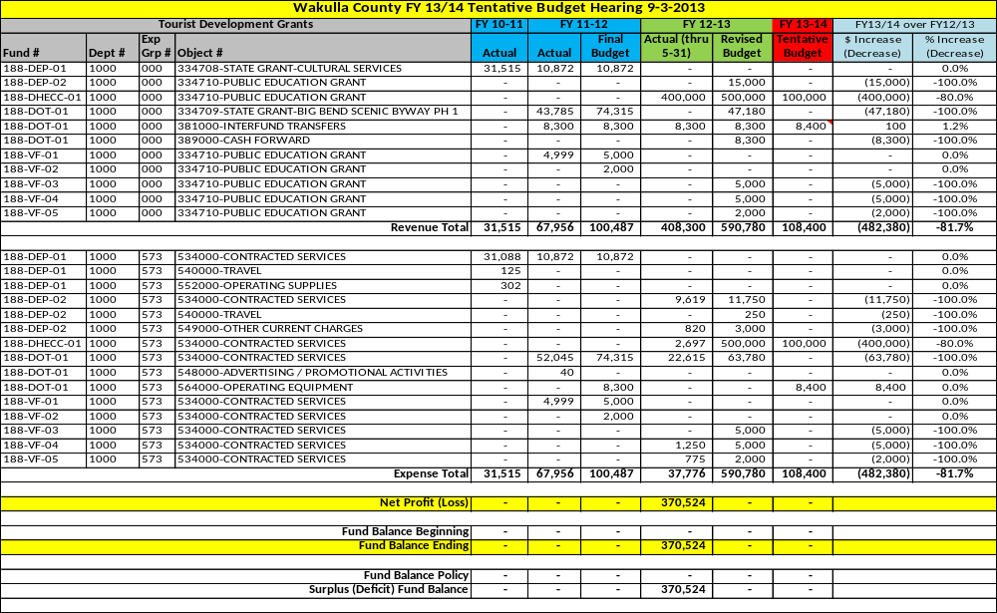
Fund 190 – E911 Surcharge & Grant Fund

This fund is used to account for the E911 surcharges collected in accordance with the Florida Emergency Telephone Act pursuant to F.S. 365.171. The revenues are the fifty cent monthly “Enhanced 911 fee” for all wireless subscribers (F.S. 365.172 and 365.173) and the fifty cent monthly “911 fee” per line (F.S. 365.171(3). The funds are used to assist the Sheriff’s E911 operations.

This fund also has a “sub-fund” used to account for E911 grant revenues.

Staffing
N/A – No staffing is required by the BOCC. Staffing is provided by the Sheriff’s Office.

Service Outputs
N/A – No service outputs are tracked by this fund. See the Sheriff’s Office Fine & Forfeiture Fund for service outputs.

Fund 190 – E911 Surcharge Revenue & Expense Detail

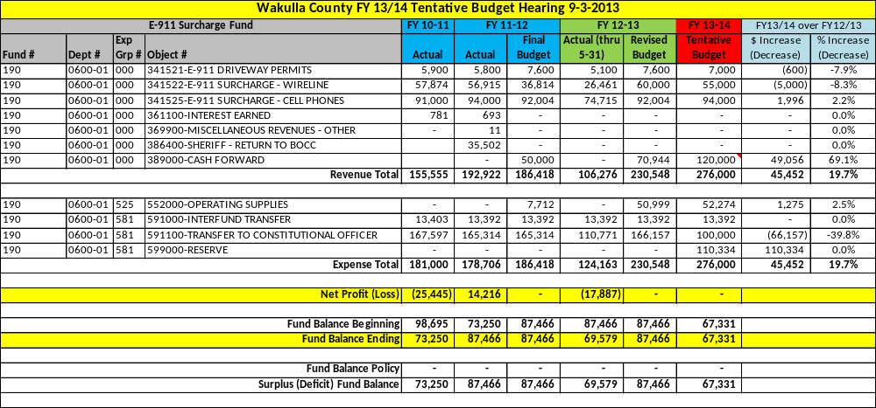

This “sub-fund” is used to account for the various E911 grants received through the Florida Department of Management Services. These funds are primarily used to maintain and upgrade the E911 equipment at the Sheriff’s Office.

Fund 190 – E911 Grant Revenue & Expense Detail

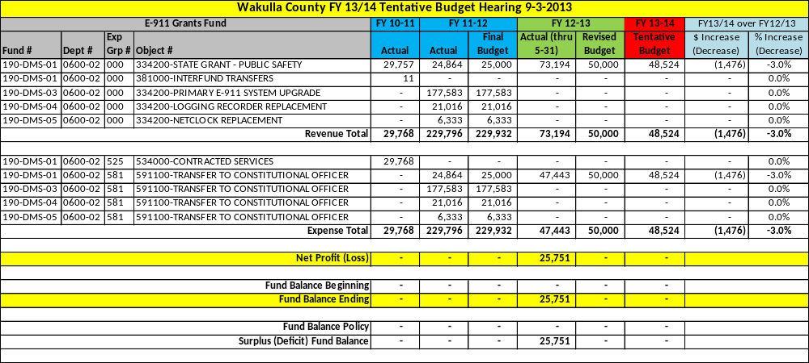

Capital Project Fund Detailed Budgets

The total tentative budget for the Capital Project Funds is $6,047,825, a decrease of $374,133 or -5.8% as compared to FY 2012/13 Budget as amended.
There are a total of 4 separate Capital Project Funds. Those funds are listed below:

- Fund 300 – Capital Projects Fund
- Fund 307 – Impact Fees Fund
- Fund 317 – One Cent Sales Tax Fund
- Fund 362 – Road Paving Grants Fund

On the following pages is a brief summary of each fund followed by a detailed line item budget. Actual data for FY 2010-11 and actual and budgetary data for FY 2011-12 and FY 2012-2013 are also provided for comparative purposes.

At the bottom of each schedule is a Net Profit / (Loss) line followed by the Beginning and Ending Fund Balance. If the fund is required to carry a minimum fund balance per the County’s Fund Balance Policy, the required minimum and surplus or deficit is shown.

Fund 300 – Capital Projects Fund

This fund is used to account for general capital infrastructure projects of the County. Funding sources are primarily grant funds and transfers from other funds to either assist with the project or match grant funds.

Staffing
N/A – No staffing is required by the BOCC for Capital Projects. Staffing from the appropriate General Fund or Public Works Department is used to complete these projects.

Service Outputs
N/A – No service outputs are tracked by this fund.

Fund 300 – Capital Projects & Grant Revenue & Expense Detail

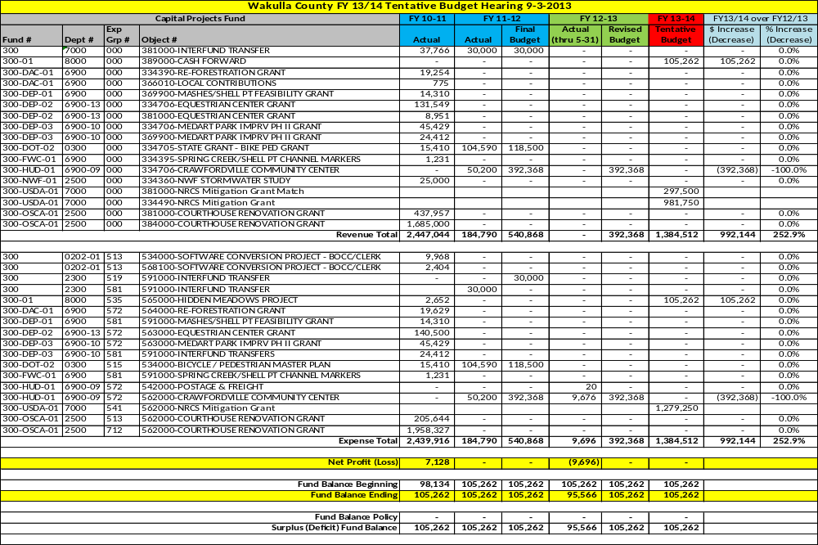

[This Page Left Intentionally Bank]

Fund 307 – Impact Fees Fund

This fund is used to account for the collection and subsequent use of impact fees. Please refer to Section 4 – Historical Data – Revenue History for a summary of impact fee revenues collected, the purpose of impact fees and what they may be spent on. Impact fees are collected for the express purpose of offsetting or diminishing the cost associated with growth in the County. Each impact fee is accounted for separately within its own “sub-fund”. In the following pages, you will find a summary of projects each impact has been spent on and the FY13/14 tentative budget.

Staffing
N/A – No staffing is required by the BOCC. Staffing from the appropriate General Fund or Public Works Department is used to complete these projects.

Service Outputs
The only service outputs that are maintained are the types of projects impacts fees have been spent on.

Fund 307-COR – Corrections Impact Fees.

Service Outputs
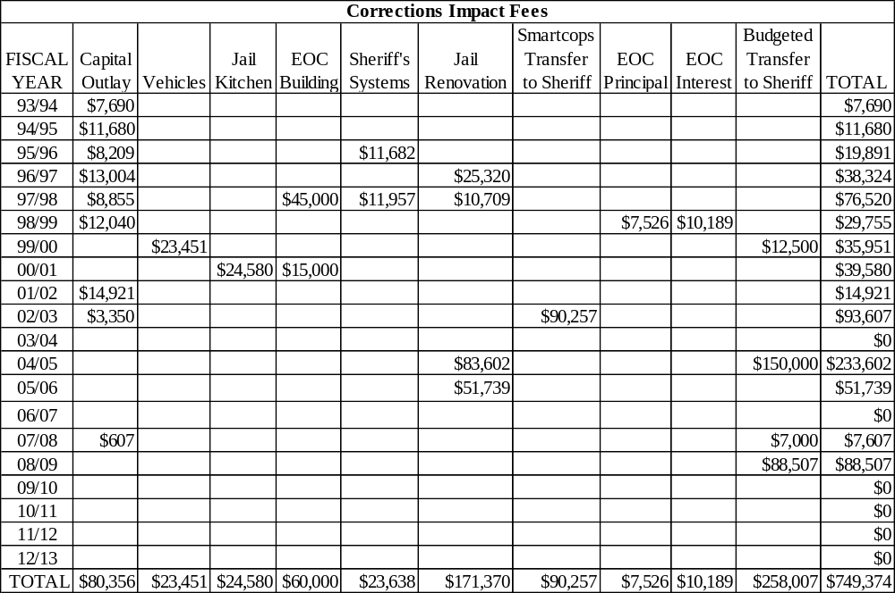

Fund 307-COR – Corrections Impact Fee Revenue & Expense Detail

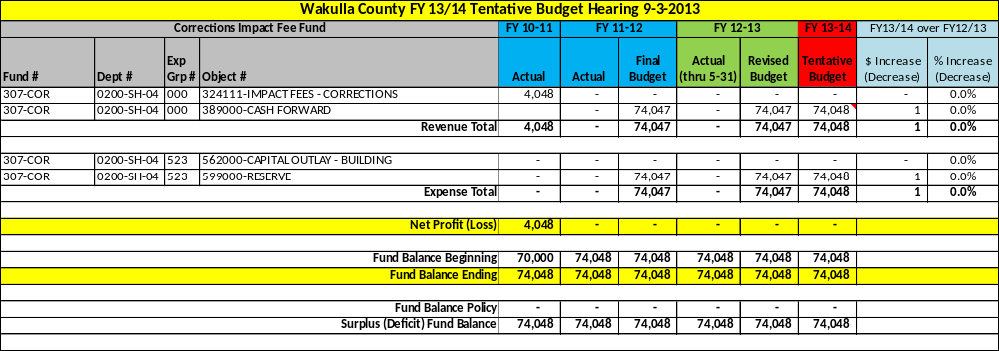

Fund 307-EMS – Emergency Medical Service Impact Fees.

Service Outputs
N/A – No emergency medical service impact fees have been spent.

Fund 307-EMS – Emergency Medical Services Impact Fee Revenue & Expense Detail

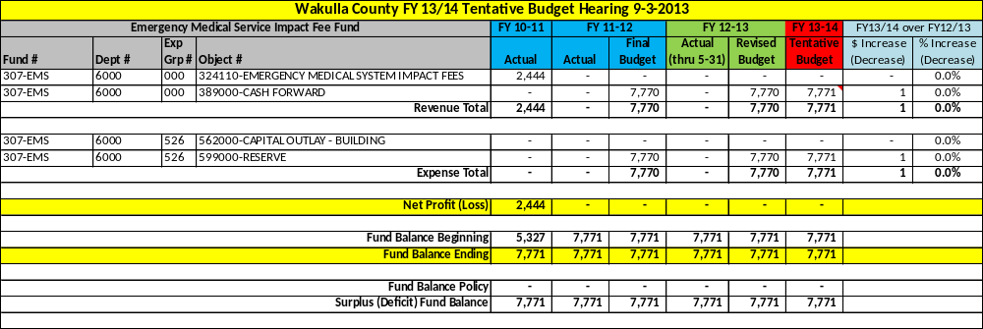

Fund 307-FIRE – Fire Service Impact Fees.

Service Outputs
N/A – No fire service impact fees have been spent.

Fund 307-FIRE – Fire Service Impact Fee Revenue & Expense Detail

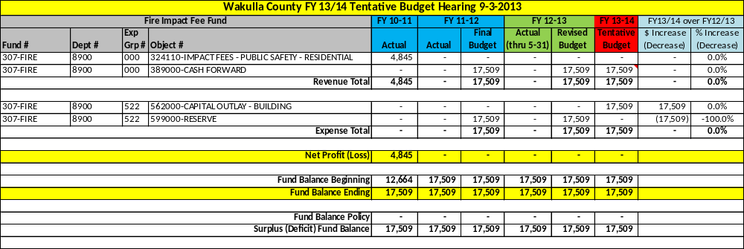

Fund 307-LAW – Law Enforcement Impact Fees.

Service Outputs
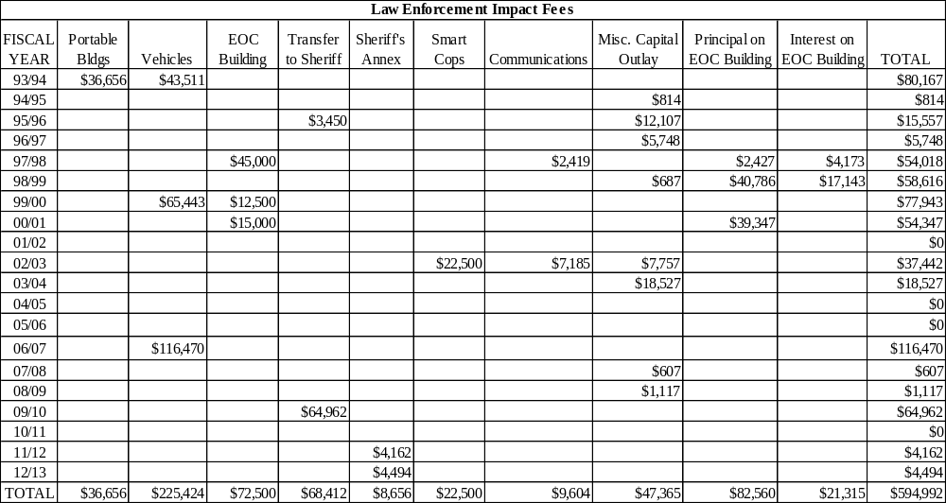

Fund 307-LAW – Law Enforcement Impact Fee Revenue & Expense Detail

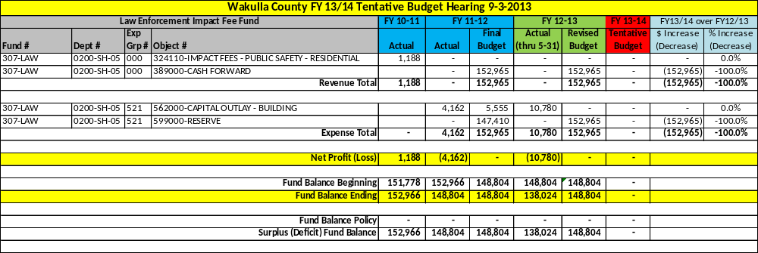

Fund 307-LIB – Library Impact Fees.

Service Outputs
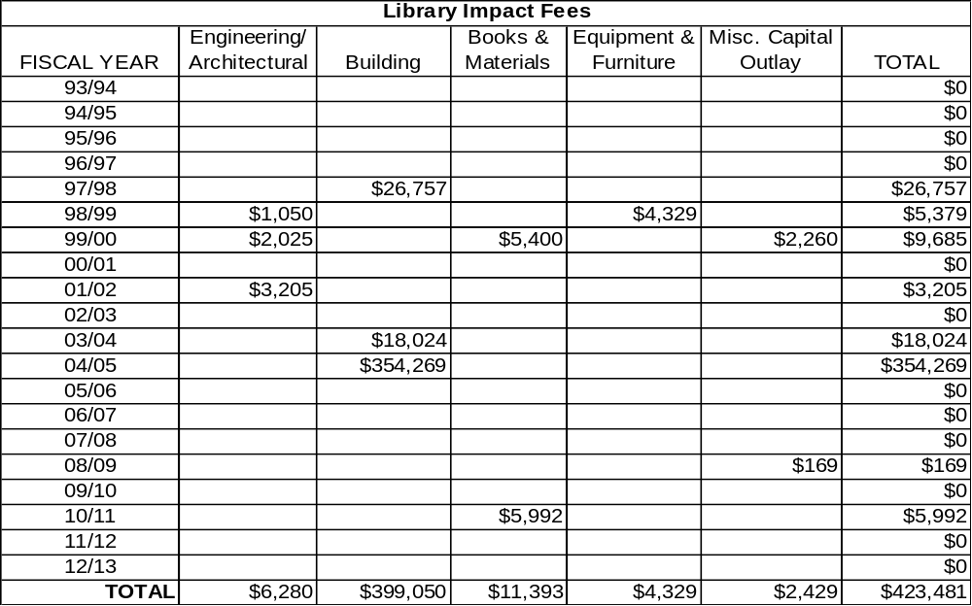

Fund 307-LIB – Library Impact Fee Revenue & Expense Detail

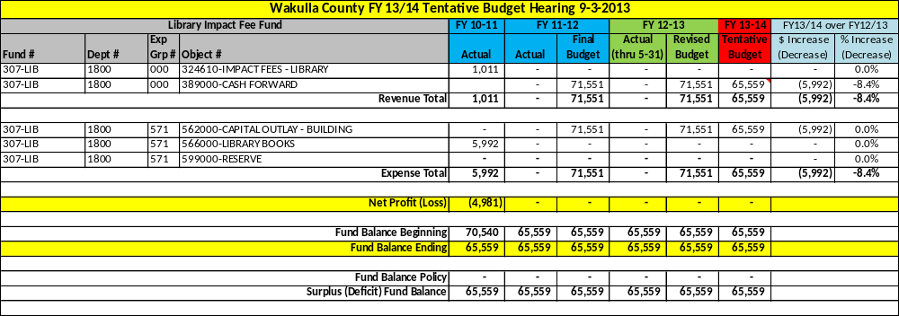

Fund 307-RDS – Road Paving Impact Fees.

Service Outputs
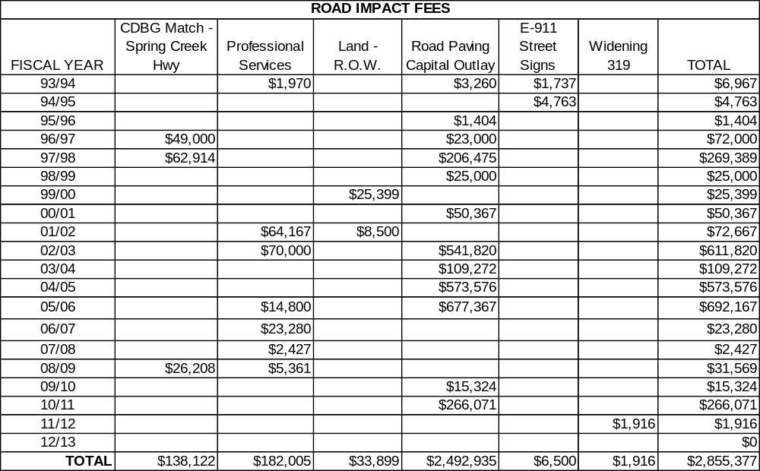

Fund 307-RDS – Road Paving Impact Fee Revenue & Expense Detail

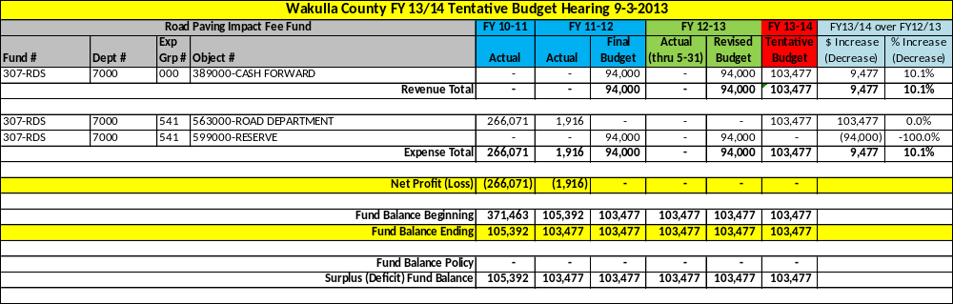

Fund 307-RDS-COAST – Coastal District Road Paving Impact Fees.

Service Outputs
N/A – No coastal district road paving impact fees have been spent.

Fund 307-RDS-COAST – Coastal District Road Paving Impact Fee Revenue & Expense Detail

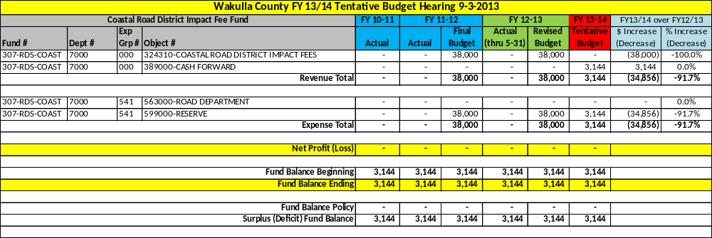

Fund 307-RDS-CVILLE – Crawfordville District Road Paving Impact Fees.

Service Outputs
N/A – No Crawfordville district road paving impact fees have been spent.

Fund 307-RDS-CVILLE – Crawfordville District Road Paving Impact Fee Revenue & Expense Detail

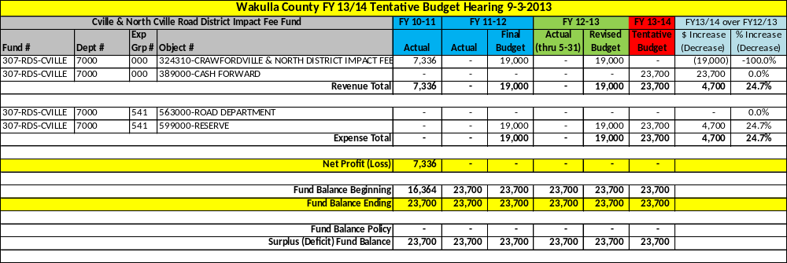

Fund 307-RDS-WEST – Western District Road Paving Impact Fees.

Service Outputs
No western district road paving impact fees have been spent.

Fund 307-RDS-WEST – Western District Road Paving Impact Fee Revenue & Expense Detail

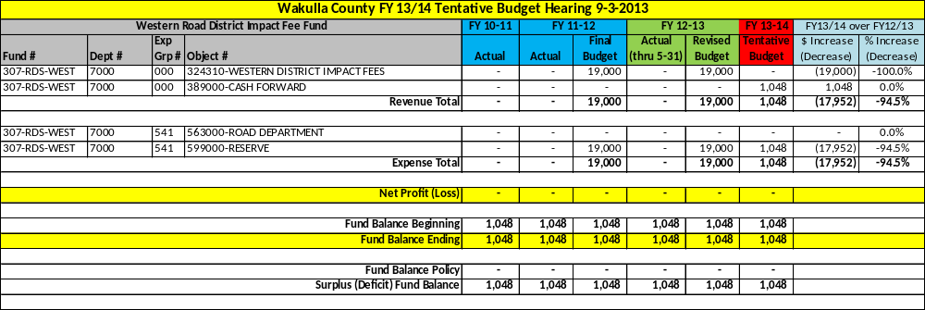

Fund 307-REC-EAST – Eastern District Park & Recreation Impact Fees.

Service Outputs
N/A – No eastern district recreation impact fees have been spent.

Fund 307-REC-EAST – Eastern District Park Impact Fee Revenue & Expense Detail

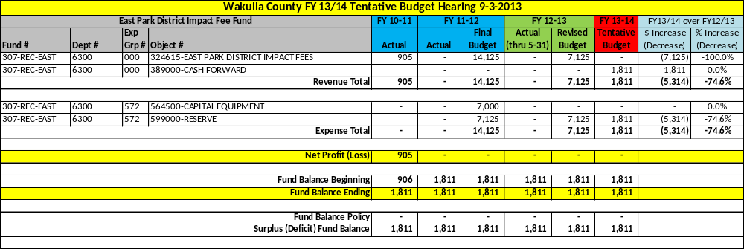

Fund 307-REC-WEST – Western District Park & Recreation Impact Fees.

Service Outputs
N/A – No western district recreation impact fees have been spent.

Fund 307-REC-WEST – Western District Park Impact Fee Revenue & Expense Detail

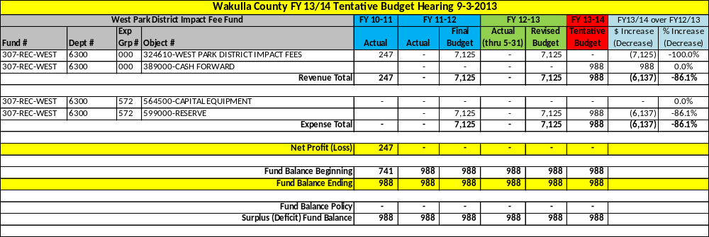

Fund 317 – One Cent Sales Tax Fund

This fund is used to account for the proceeds of the One Cent Sales Tax revenue. Florida Statute 212.054 authorizes counties to impose a local discretionary sales tax on all sales transactions pursuant to Chapters 202 and 212. The citizens of Wakulla approved the original one cent sales tax in 1987 for the duration of 15 years and, in September 2002, voters renewed the sales tax for another 15 years.

The proceeds of the one cent sales tax are divided into four “sub-funds”:
- 60% to Road Paving Infrastructure
- 20% to Public Facilities Infrastructure
- 15% to Public Safety Infrastructure
- 5% to Parks & Recreation Infrastructure

Each “sub-fund” is summarized on the following pages and a list of projects the current one cent sales tax proceeds have been spent on is provided in the Service Outputs section of each.

Staffing
N/A – No staffing is required by the BOCC. Staffing from the appropriate General Fund or Public Works Department is used to complete these projects.

Service Outputs
The only service outputs that are maintained are the types of projects impacts fees have been spent on.

Fund 317-ROAD – 60% Road Paving 1 Cent Sales Tax

The proceeds may be used for road paving, repaving, bridge construction, bridge repair and other road related capital infrastructure related expenses. The County leveraged these dollars in the past to pave a large number of roads at one time. That debt will be paid off in the same year the one cent sales tax proceeds expire.

Service Outputs
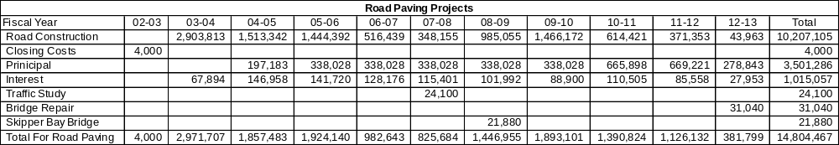

Fund 317-ROAD – Road 1 Cent Sales Tax Revenue & Expense Detail

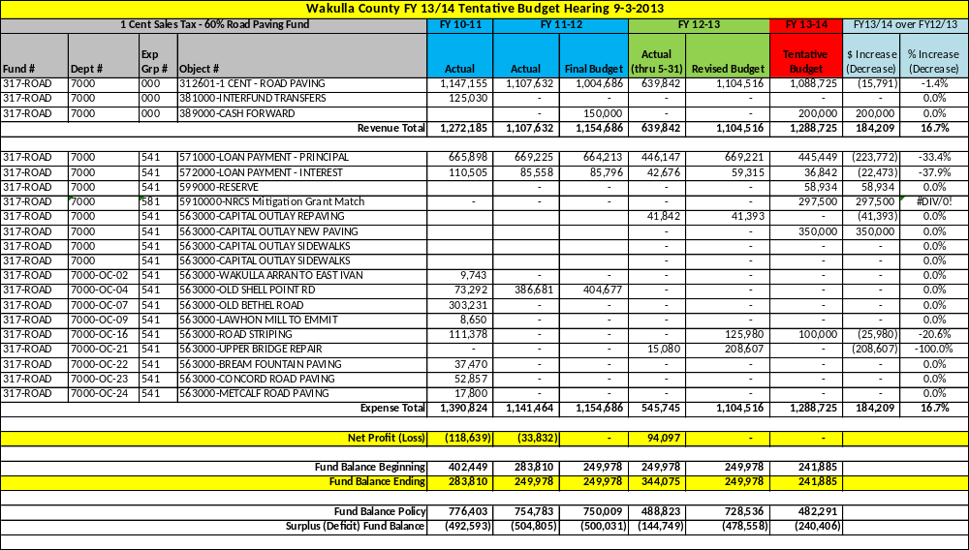

Fund 317-FACI – 20% Public Facility 1 Cent Sales Tax

The proceeds may be used for any “public facility”. “Public facility” can be any number of capital infrastructure related projects. The County leveraged these dollars in the past to renovate the Courthouse facility. That debt will be paid off in the same year the one cent sales tax proceeds expire.

Service Outputs
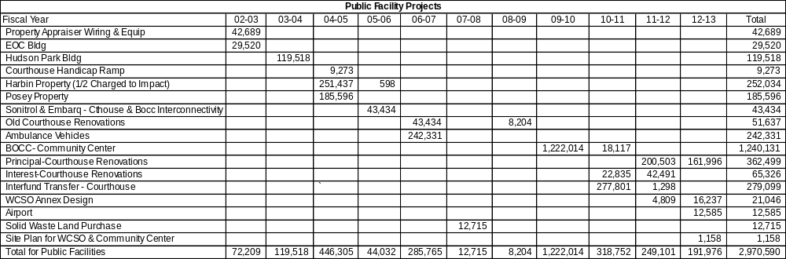

Fund 317-FACI – Public Facility 1 Cent Sales Tax Revenue & Expense Detail

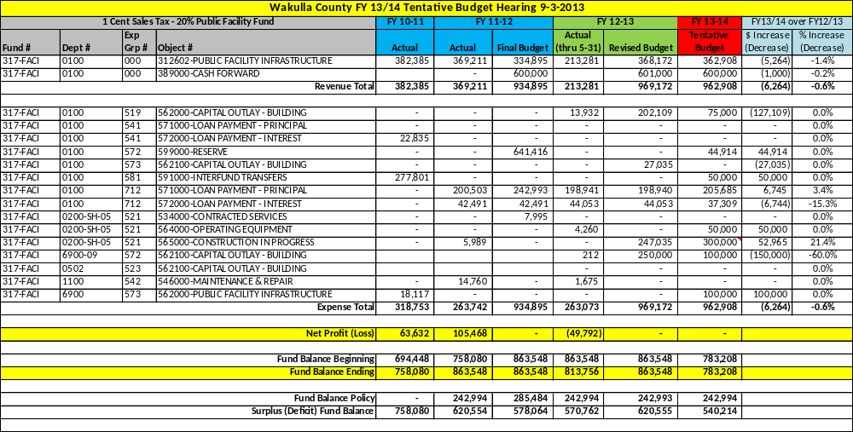

Fund 317-SAFE – 15% Public Safety 1 Cent Sales Tax

The proceeds may be used for any capital public safety need. The County typically uses the proceeds to purchase public safety vehicles for Emergency Medical Services and the Sheriff’s Office.

Service Outputs
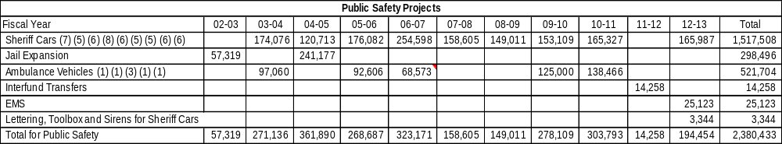

Fund 317-SAFE – Public Safety 1 Cent Sales Tax Revenue & Expense Detail

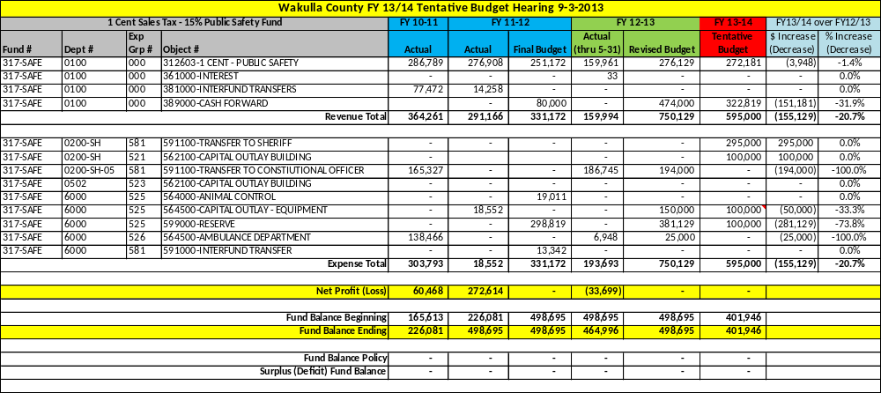

Fund 317-PARK – 5% Parks & Recreation 1 Cent Sales Tax

The proceeds may be used for any capital park or recreational need. The County typically uses the proceeds to purchase maintenance vehicles and equipment and repair, build or expand park amenities.

Service Outputs
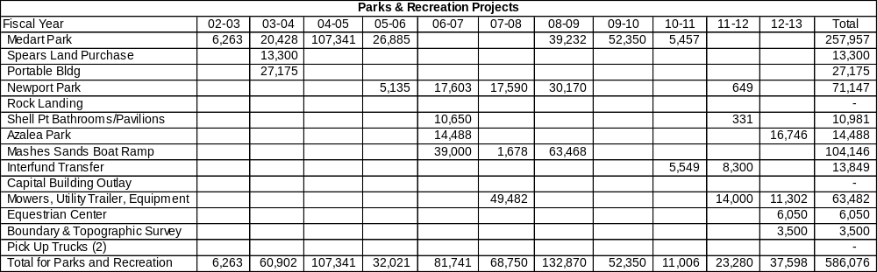

Fund 317-PARK – Parks & Recreation 1 Cent Sales Tax Revenue & Expense Detail\

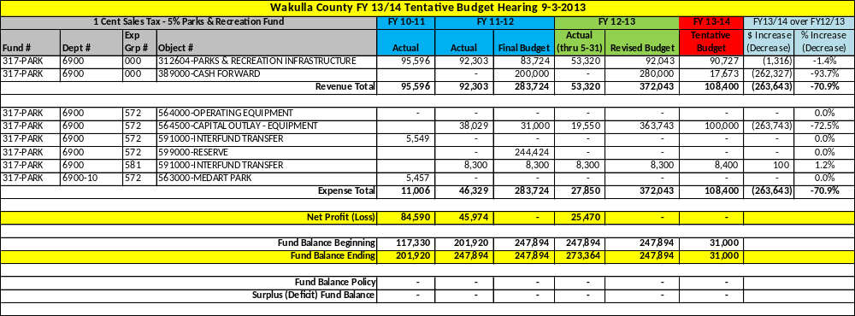

Fund 362 – Road Paving Grants Fund

This fund is used to account for road repaving grants received from the Florida Department of Transportation through its various programs to assist local governments with road construction needs. Two examples are the Small Counties Rural Assistance Program (SCRAP) and the Small Communities Opportunity Program (SCOP).

Staffing
N/A – No staffing is required by the BOCC. Staffing from the appropriate General Fund or Public Works Department is used to complete these projects.

Service Outputs
Fiscal Year | 2009/10 | 2010/11 | 2011/12 | 2012/13 Budget
Shell Point Road | 130,515 | 915,428
Live Oak Island Road | 85,894 | 719,585
Wakulla Gardens |  | 454,268
New Light Church Road |  | 670,824
Rewinkel Road |  |  | 1,664,433
Spring Creek Road |  |  |  | 1,159,208
Emmett Whaley Road |  |  |  | 737,525
High Drive – Ochlockonee St |  |  |  | 428,905
Total | 216,409 | 2,760,105 | 1,664,433 | 2,325,638

Fund 362 – Road Paving Grant Revenue & Expense Detail

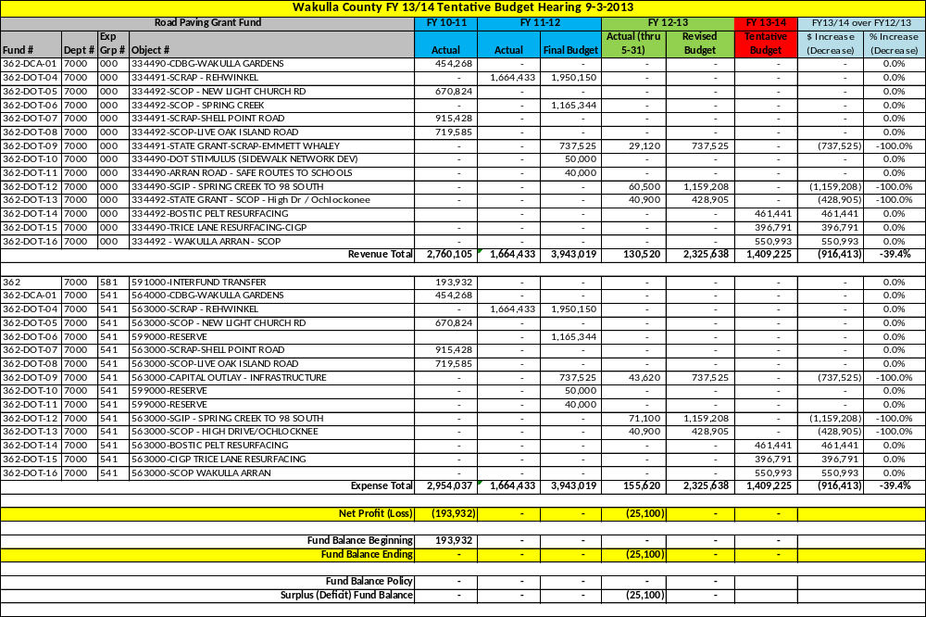

[This Page Left Intentionally Blank]

Enterprise Fund Detailed Budgets

The total tentative budget for the Enterprise Funds is $5,965,396, a decrease of $767,681 or -11.4% as compared to FY 2012/13 Budget as amended.
There are a total of 3 separate Enterprise Funds. Those funds are listed below:

- Fund 435 – Sewer Operating Fund
- Fund 435-RVR – Riversink Water Operating Fund
- Fund 440 – Solid Waste Operating Fund

On the following pages is a brief summary of each fund followed by a detailed line item budget. Actual data for FY 2010-11 and actual and budgetary data for FY 2011-12 and FY 2012-2013 are also provided for comparative purposes.

At the bottom of each schedule is a Net Profit / (Loss) line followed by the Beginning and Ending Fund Balance. If the fund is required to carry a minimum fund balance per the County’s Fund Balance Policy, the required minimum and surplus or deficit is shown.

Fund 435 – Sewer Operating Fund

This fund is used to account for all sewer related activity. The revenue sources are sewer fee paid by the customers on the sewer system, access fees paid by developers or home owners hooking onto the sewer system and various grants funded by agencies such as Florida Department of Environmental Protection.

The sewer system consists of a .6MGD (million gallon per day) plant and a collector system of pipeline and lift stations. The County has leveraged the revenues from the Sewer Fund to pay for necessary upgrades and expansions of the sewer system. The debt for the sewer system is provided in Section 4 – Historical Data – Long-term Debt. The County is currently working with the U.S. Department of Agriculture on a long-term plan for upgrading and expanding the existing sewer plant to 1.2MGD capacity with advanced wastewater treatment specifications. This plan is still being reviewed by U.S.D.A and has not been incorporated into the tentative FY 2013/14 budget or the Five Year Plan found in Section 5.

Staffing
N/A – The BOCC contracts it sewer operations with ESG Inc. as a part of the Public Works Department. ESG Inc. has a staff of 5 employees dedicated to the Sewer Department.

Service Outputs
Fiscal Year | 2010/11 | 2011/12 | 2012/13 (thru May)
Treatment Plant
Avg. effluent flow | .488mgd | .506mgd | .414mgd
# of compliance samples taken | 6,120 | 6,120 | 4,080
# of tons of sludge removed | 1,594 | 1,125 | 1,079
# of plant work orders completed | 20 | 45 | 39
# of disconnects for non-payment | 135 | 92 | 64
# of gallons from septic haulers | 1,346,700 | 1,524,755 | 1,026,775
# of grease traps checked | 210 | 277 | 242
Lift Stations
# of lift stations maintained | 72 | 72 | 73
# of lift station call outs | 129 | 137 | 102
# of lift station overflows | 17 | 7 | 4
# of corrective maintenance tasks | 45 | 468 | 223
# of preventive maintenance tasks | - | 394 | 393
# of emergency repairs | 58 | 11 | 5
# of odor complaints | 18 | 10 | 4
# of lift station work orders completed | 218 | 953 | 646
Fund 435 – Sewer Department User Fee & Grant Revenue Detail

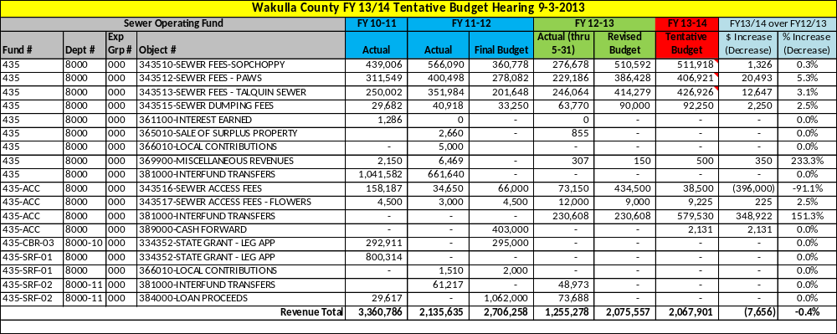

Fund 435 – Sewer Department User Fee & Grant Expense Detail

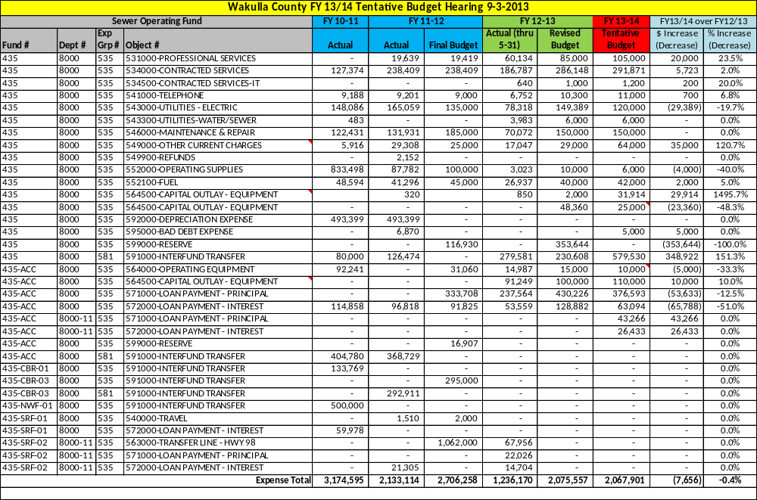

Fund 435 – Sewer Department User Fee & Grant Revenue & Expense Detail

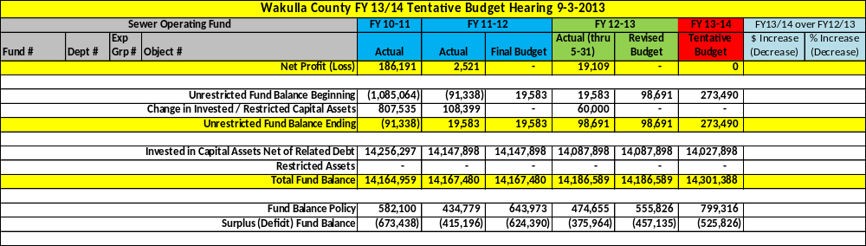

Fund 435-RVR – Riversink Water Operating Fund

This fund is used to account for the water operations at Riversink. The water plant consists of two (2) 145 foot deep water wells and a 125,000 gallon elevated water storage tank. The plant is permitted by the State to draw and treat 85,000 gallons of water per day. The water distribution system contains nearly 4.5 miles of water pipe and currently serves 108 customers.

Staffing
N/A – The BOCC contracts it water operations with ESG Inc. as a part of the Public Works Department. ESG Inc. has a staff of 1 employee dedicated to the Water Department.

Service Outputs
Fiscal Year | 2010/11 | 2011/12 | 2012/13 (thru May)
# of gallons sold | 8,476,913 | 7,894,329 | 4,426,639
# of gallons treated/pumped | 9,719,600 | 8,993,600 | 5,268,300
# of gallons pumped from fire hydrant | 63,200 | 208,750 | 150,000
# of emergency repairs | 2 | 0 | 0
# of taste/odor complaints | 1 | 3 | 1
# of compliance samples taken | 71 | 256 | 464
# of disconnects for non-payment | 44 | 40 | 25
# of work orders completed | 54 | 74 | 62

Fund 435-RVR – Riversink Water Department User Fee Revenue & Expense Detail

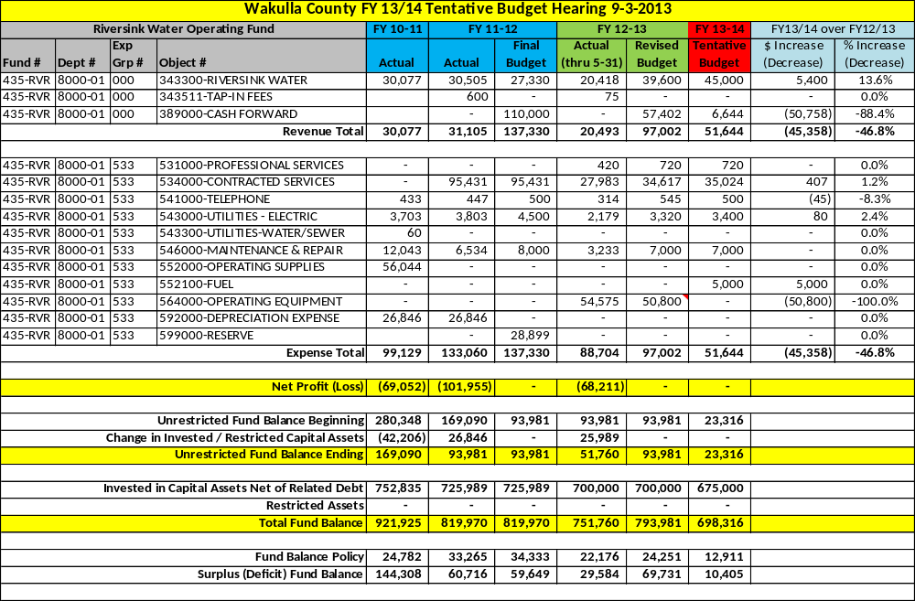

Fund 440 – Solid Waste Operating Fund

This fund is used to account for the collection and disposal of solid waste and to provide for the recycling of materials to prevent pollution and protect our environment and natural resources.

The Florida Department of Environmental Protected mandated the closure of the County’s only open landfill. In 2012 the BOCC approved a program of “curbside” pickup and contracted with WastePro Inc. for residential and commercial garbage collection and recycling services. WastePro operates the closed landfill as a “transfer station” or temporary collection site where all county garbage is hauled to a landfill facility outside of Wakulla County. As noted below, FY 2010/11 is the last year the County operated an open landfill.

Staffing
N/A. The BOCC contracts it solid waste operations with WastePro Inc. as a part of the Public Works Department. ESG Inc. monitors the operations of WastePro Inc. on behalf of the County as part of its contract with the County and employs 1 person for Solid Waste activity.

Service Outputs
Fiscal Year | 2010/11 | 2011/12 | 2012/13 (thru May)
# of tons of garbage | 5,940 | - | -
# of tons of construction debris (C&D) | 1,183 | - | -
# of work orders completed | 4 | - | -
# of pounds of plastic recycled | 47,280 | - | -
# of pounds of glass recycled | 0 | - | -
# of pounds of metal recycled | 409,620 | - | -
# of pounds of cardboard recycled | 299,420 | - | -
# of gallons of used motor oil recycled | 805 | - | -
# of pounds of batteries recycled | 8,940 | - | -
# of pounds of newspaper/paper recycled | 101,060 | - | -

Fund 440 – Solid Waste Department User Fee & Grant Revenue Detail

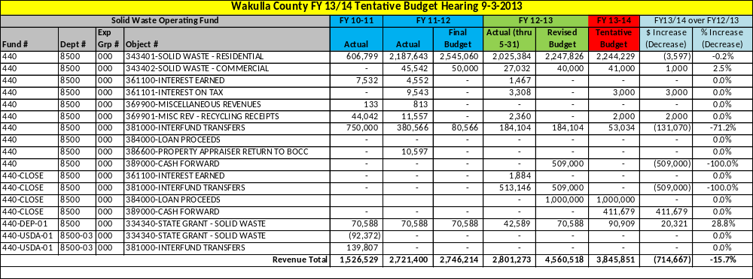

Fund 440 – Solid Waste Department User Fee & Grant Expense Detail

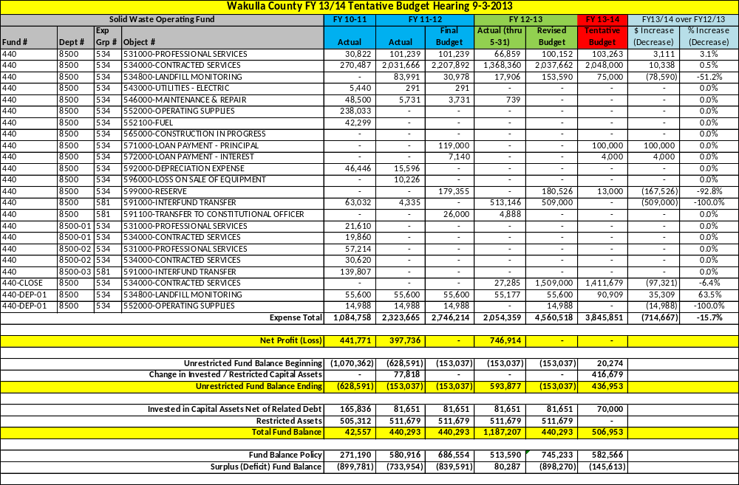

Section 4

Historical Data

[This Page Left Intentionally Blank]

Major Revenue History

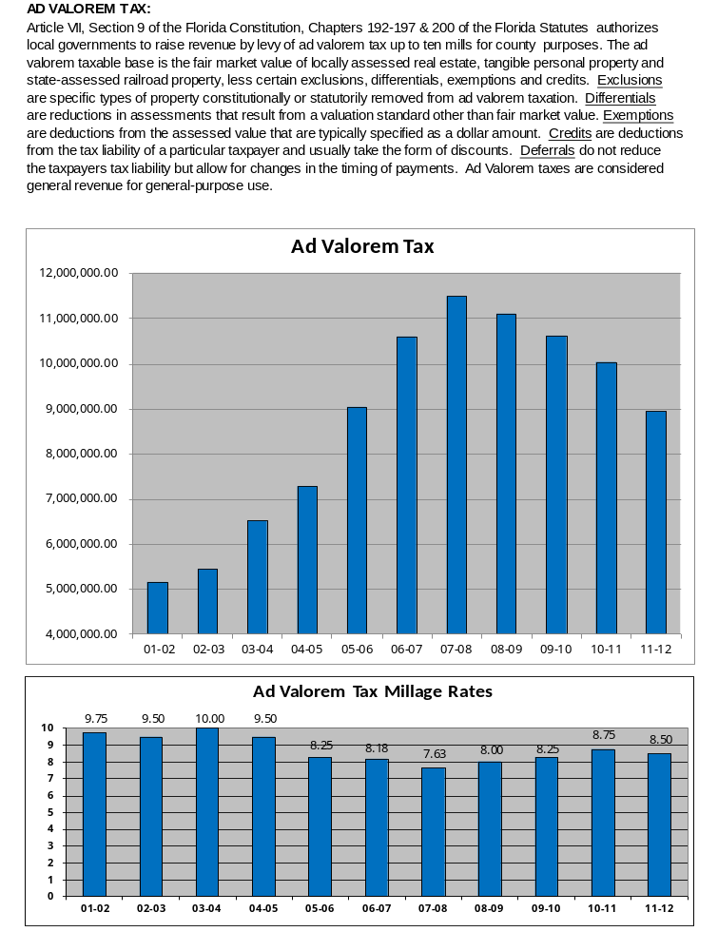
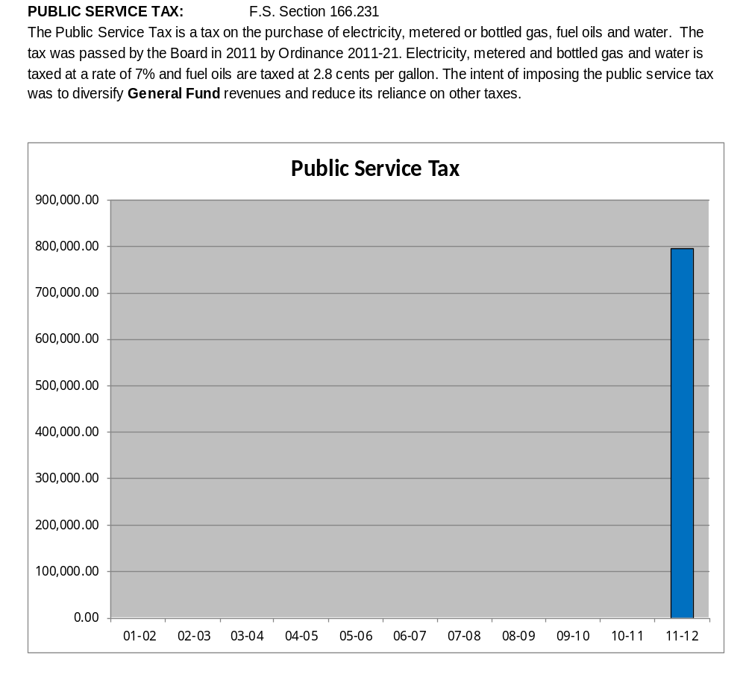

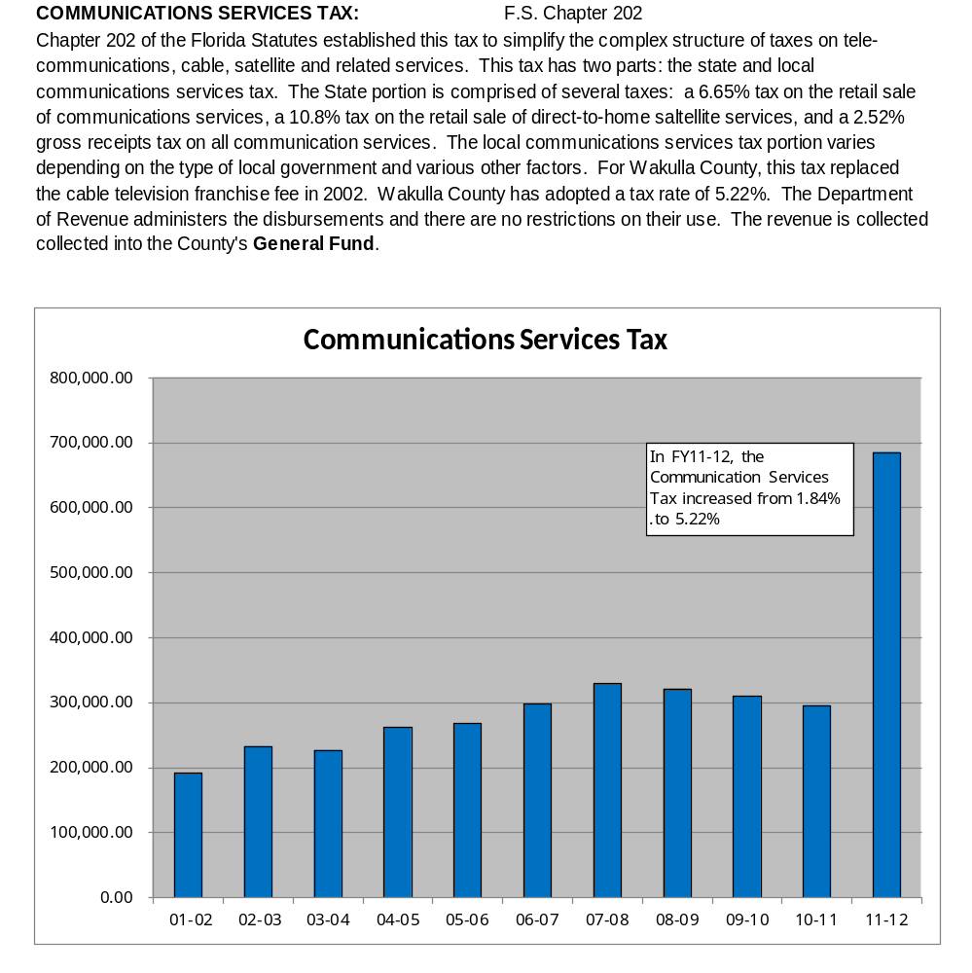

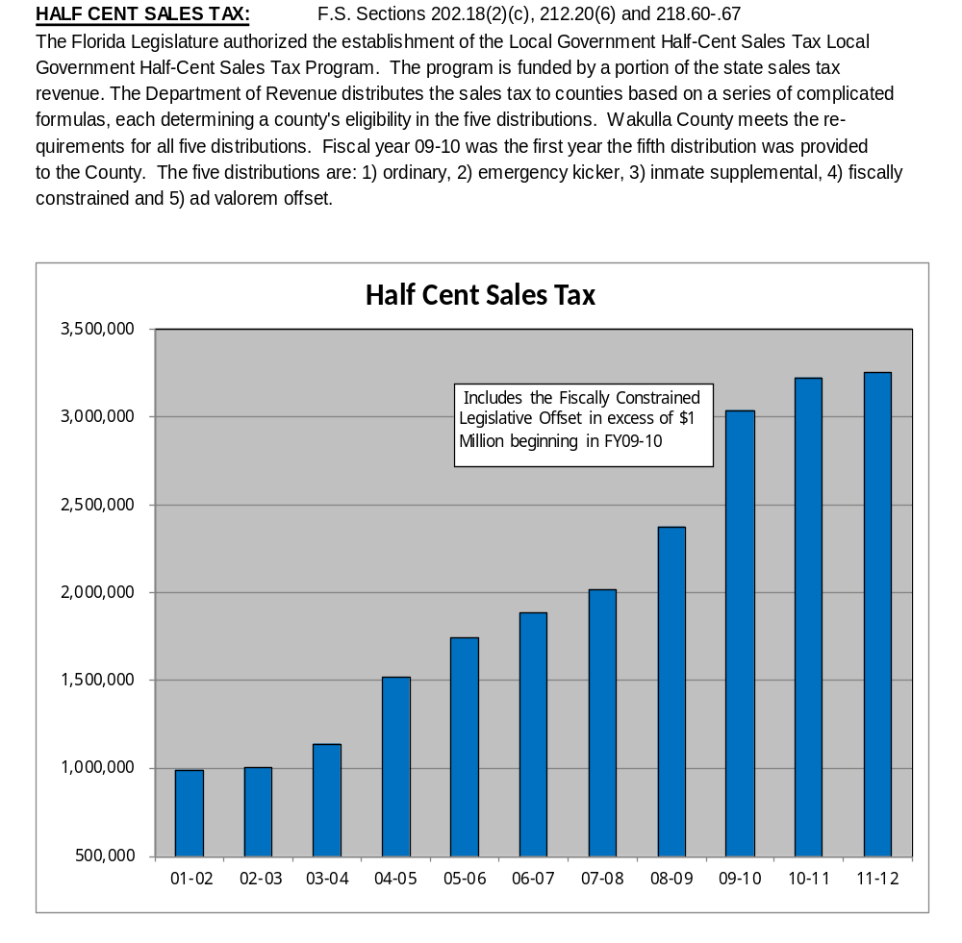

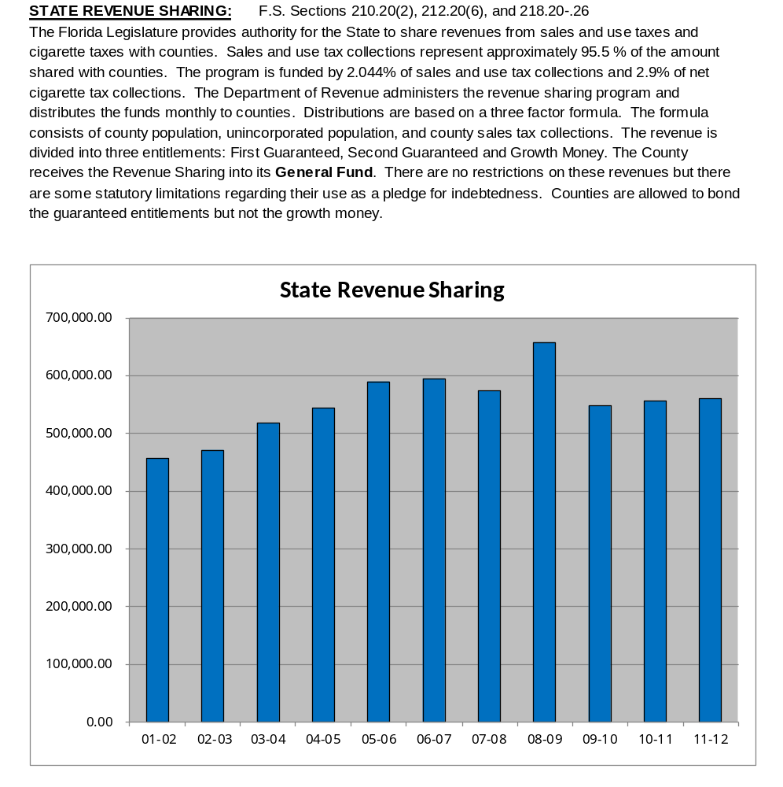

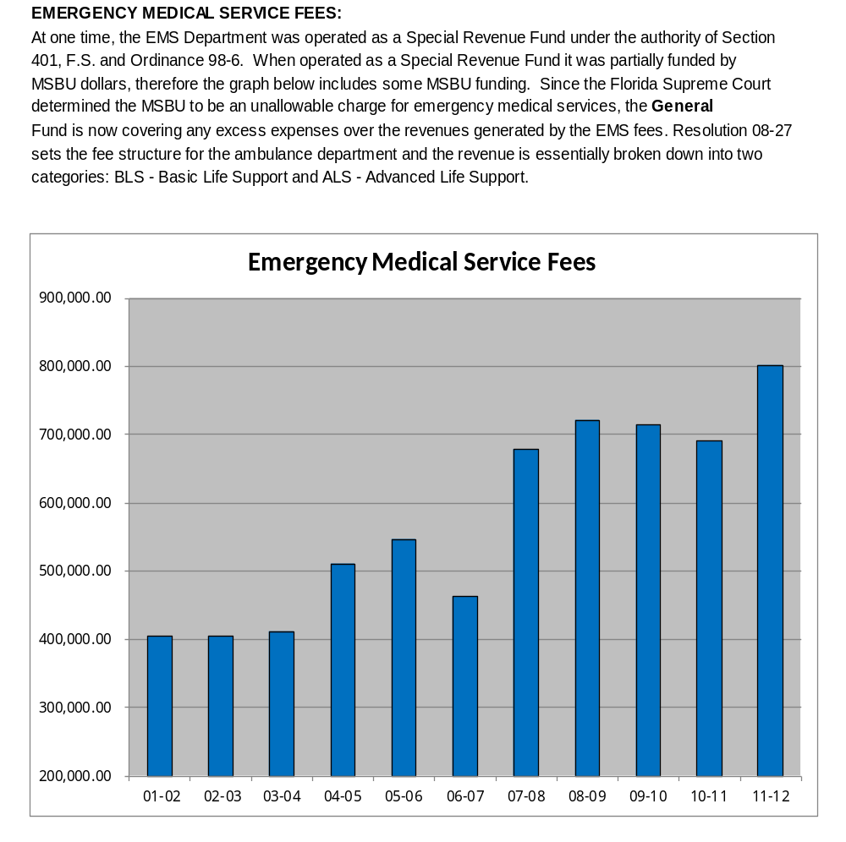

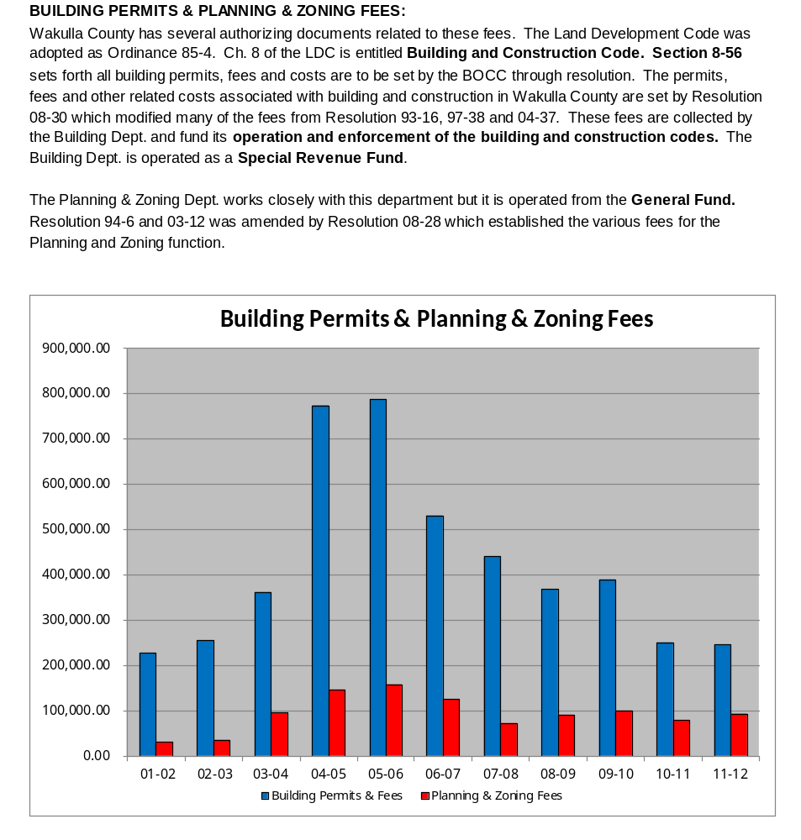

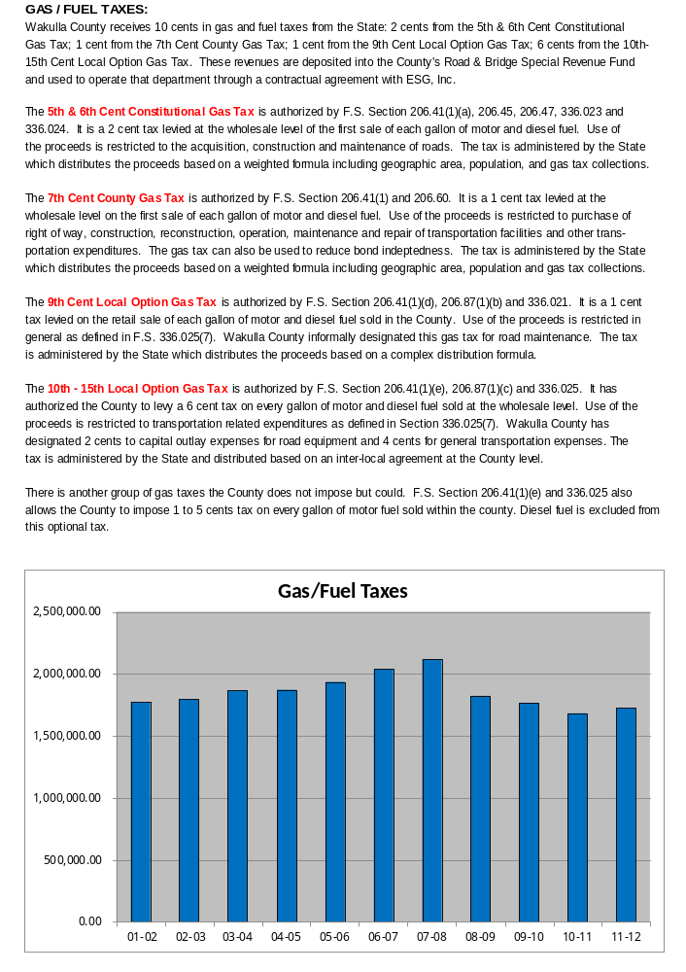
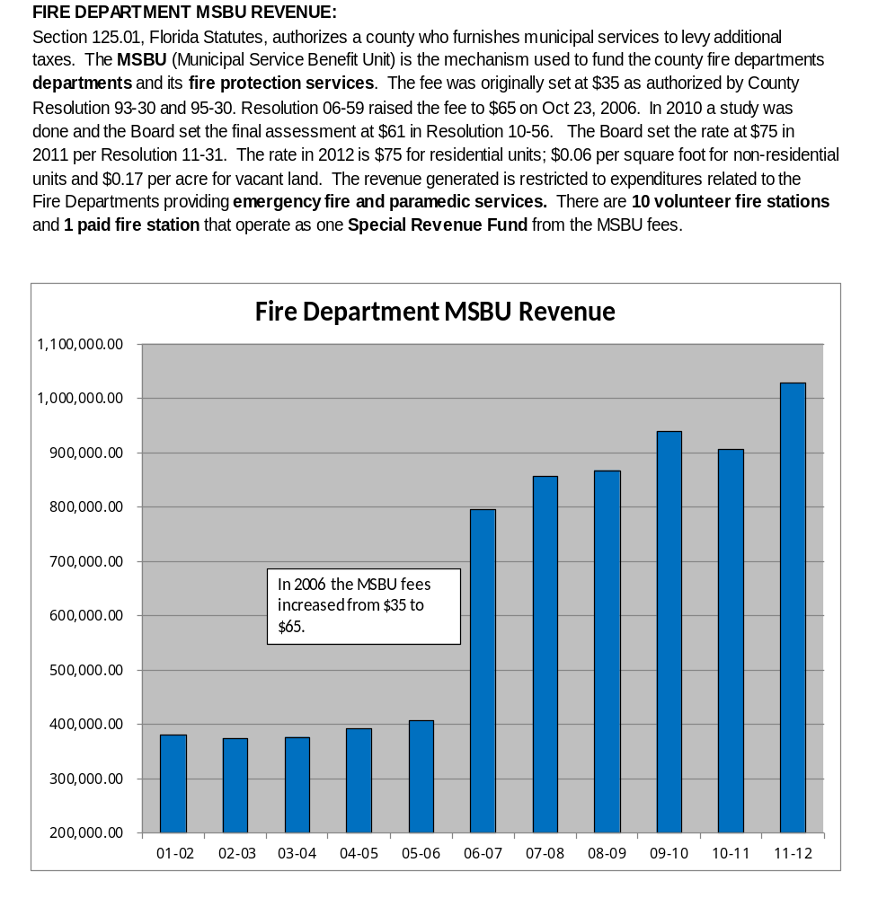

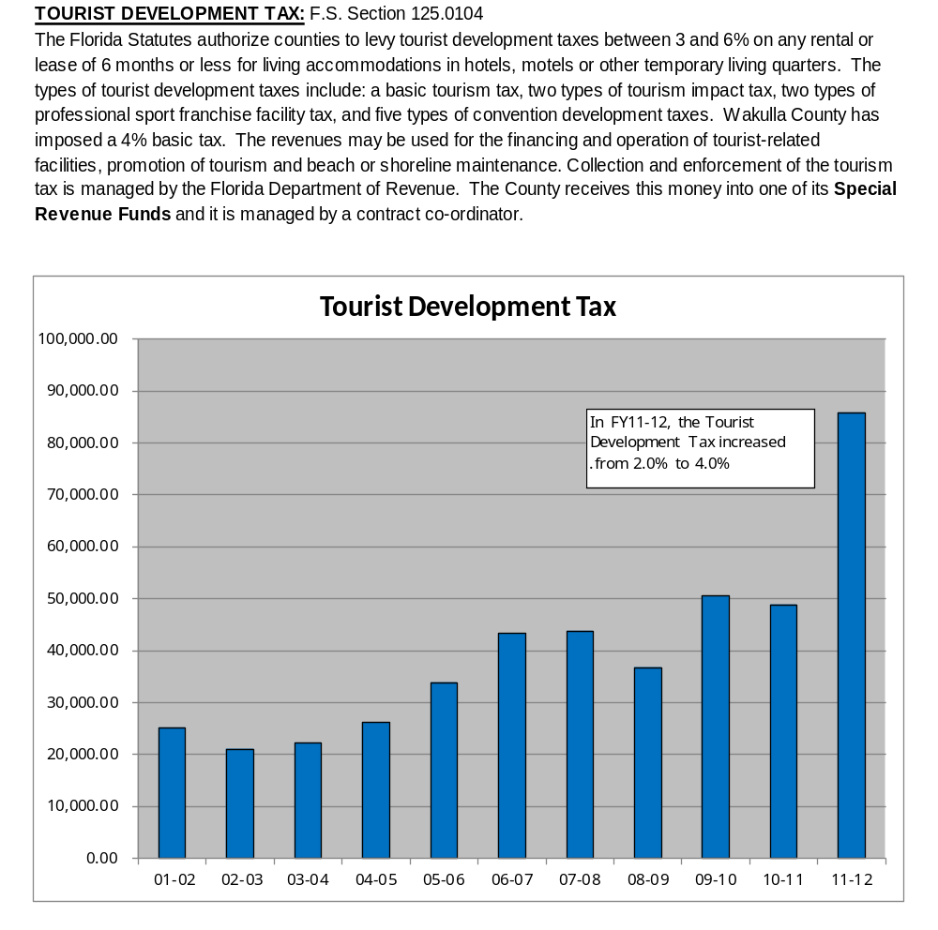

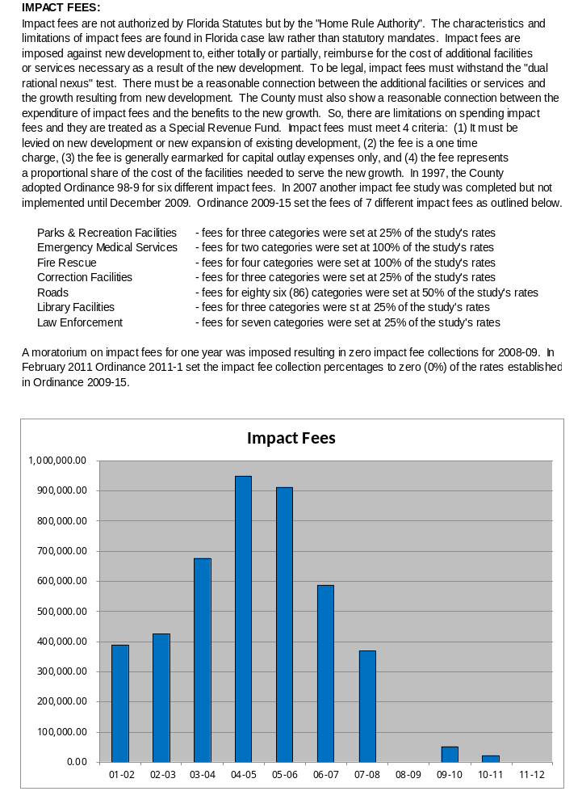
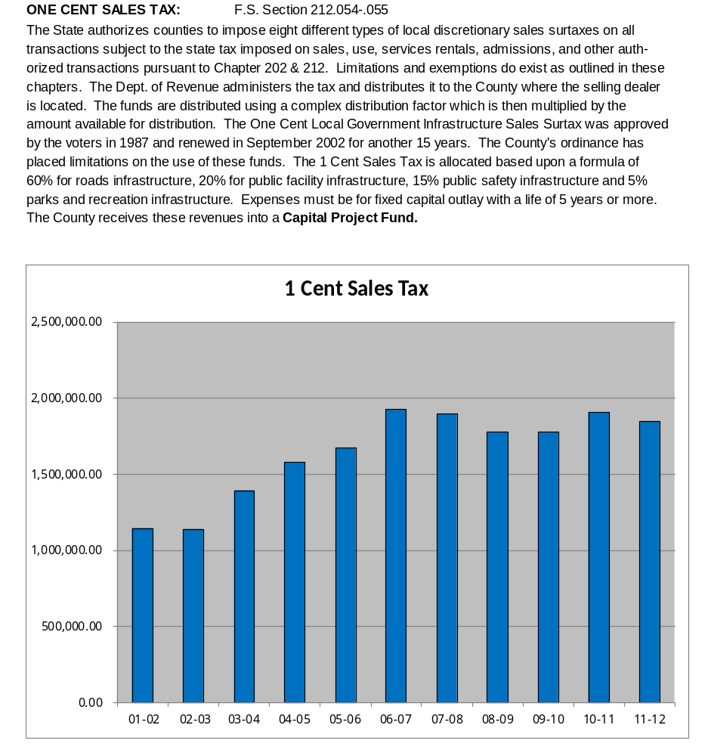

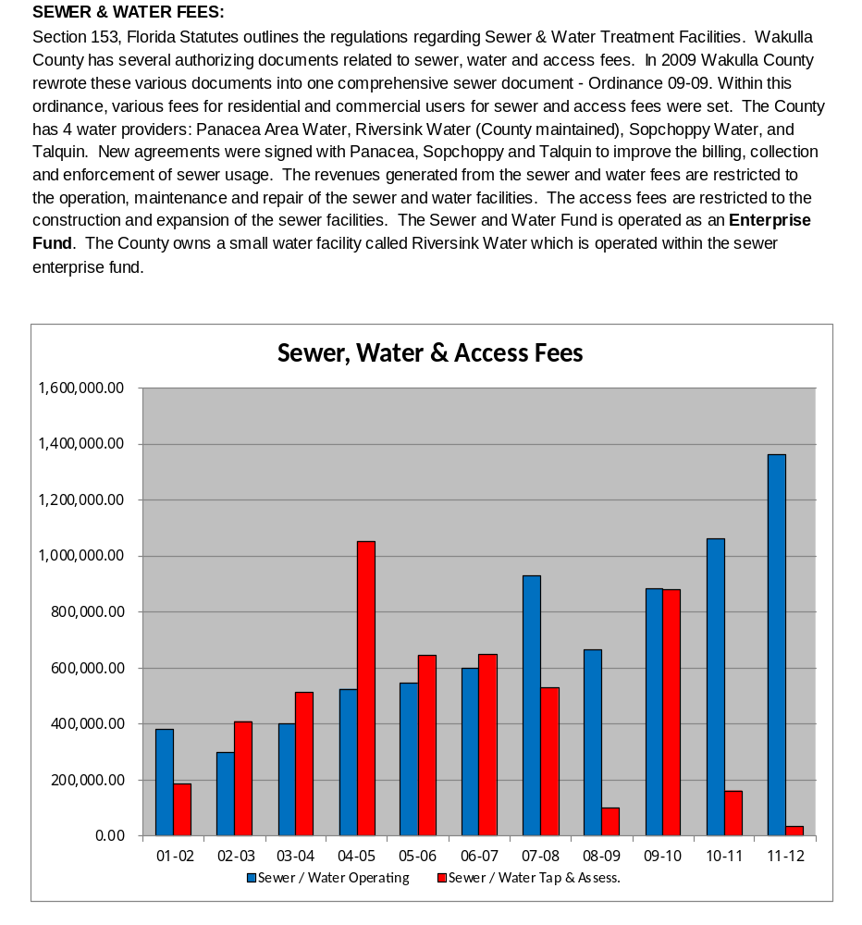

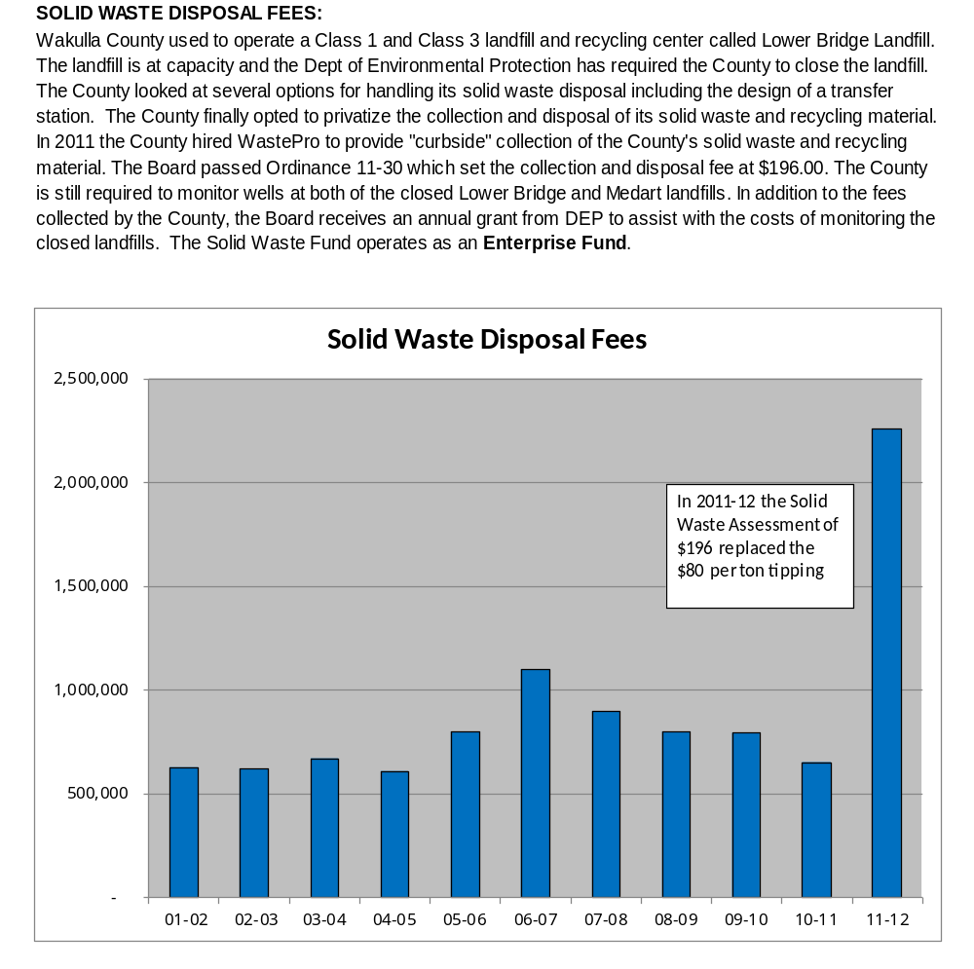

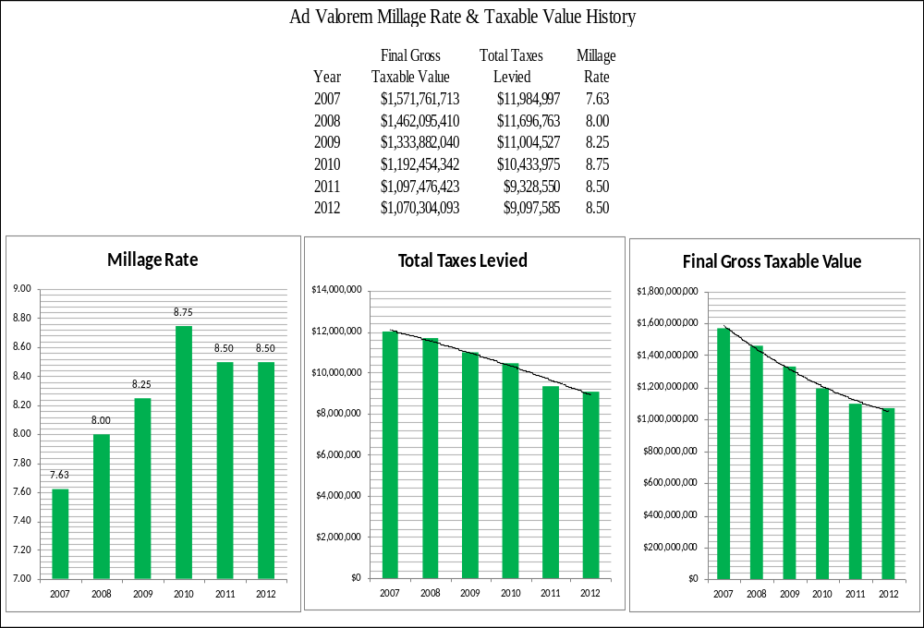

General Fund Cash History

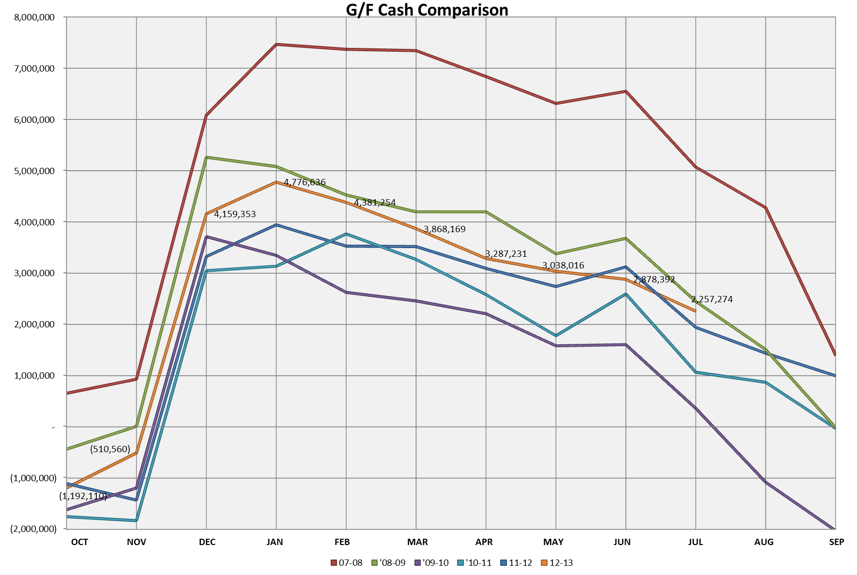

Long Term Debt Schedule

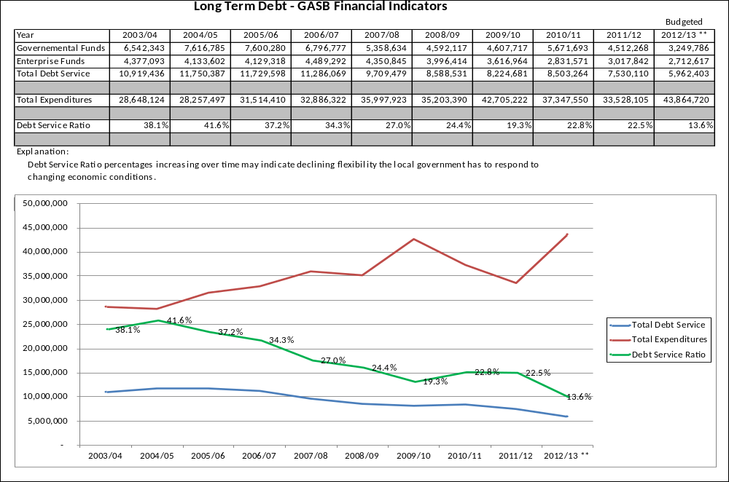

[This Page Left Intentionally Blank]

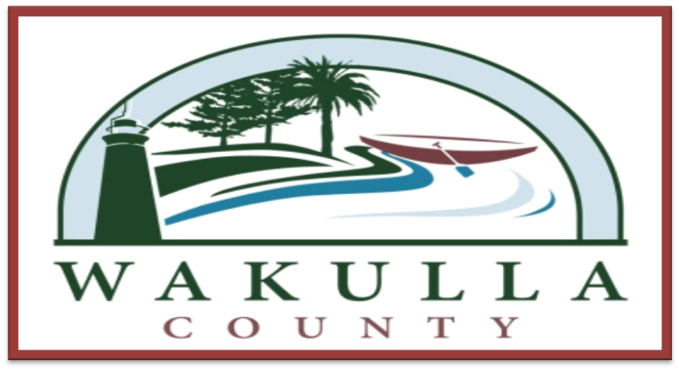

Section 5

FY 2014-15 to FY 2018-19

Five Year Plan

[This Page Left Intentionally Blank]

FY 2014-15 to FY 2018-19 Five Year Plan

Forecast Summary & Assumptions

The Five Year Plan is based on a rather conservative economic forecast for Wakulla County. The economy in this model is predicted to grow slowly and steadily over the next five years with property values leveling out in FY 14/15 and then a slight increase of 1% the following year and 2% each year thereafter. Other revenues reflect the same type slow increase over the next five years.

Housing starts play a key role in the success of the forecast. We have assumed a very low 2% growth year over year. This growth affects revenues in all of the key funds. This forecast works without tax increases only if the anticipated growth is realized. If the growth does not occur then either revenues will need to increase through tax increases or services will need to be cut.

Expenses are forecast to continue to increase from 1% to 4% depending on the fund. A cost of living adjustment has been built into the plan for all employees in the general fund starting in FY14/15.

The Five Year Plan does not tackle many of the maintenance and under-staffing issues that currently hamper the County’s ability to deliver quality service in some areas. If the economic outlook improves, these issues will need to be addressed.

There are a number of variables that could have a detrimental effect on the budget in the coming years. Listed below is a brief description of each.

- Continued property value devaluation.
- State revenue sharing and funding for fiscally constrained counties. Loss of or a reduction of this funding is a possibility with future legislatures.
- Health care costs. The Affordable Health Care Act continues to be a serious unknown as to the final cost to the County. The proposed budget was increased to compensate for the first mandate for insuring all employees. A 5% rate increase each year is used in the Plan.
- Race Track Funding. This revenue has been stable for a long time, but speculation is that the greyhound racing industry is declining and will likely close up shop in Florida in the future.
- The Sheriff’s Fund is currently forecast to go into the negative in FY15/16; tough decisions have not been made.
- Medicaid payments for ambulance service have decreased over the past couple of years. If this trend continues, the burden will be put back on the general tax base to overcome this revenue loss.
- One cent sales tax renewal. The current discretionary sales tax ends in 2017. Renewal of this sales tax is a major concern. Currently, plans are to have the One Cent Sales Tax renewal put on the 2014 ballot. If this revenue source is lost then capital projects and public safety equipment replacement will not be possible without a tax increase elsewhere.
- The Sewer collection system has 73 lift stations with the majority of these being 10 years old or older. To date, we have re-plumbed and re-lined one lift station at a cost of $100k. A system wide failure is a real possibility as funding has not been dedicated in the past for major maintenance or replacement of lift stations.

General Fund Five Year Plan

Forecast:
This fund may reach the Board’s fund balance goals in FY2013/14. If there are any unforeseen costs such as weather related disasters or uncontrolled costs related to the contamination cleanup, this fund balance goal will not be met. It is anticipated that future expenditure growth will outpace revenue growth thus a decline in the fund balance is shown each year.

Revenue Assumptions
- Millage rate remains at 8.5 mills, of which, 1.1 mills is assigned to this fund.
- Property values level in FY14/15 and tick up by 1% in FY15/16 and 2% thereafter.
- PST and CST rates remain the same.
- PST and CST revenue is predicted to increase 2% each year due to population growth.
- The Half Cent Sales taxes are forecast to increase 2% each year.
- Fiscally Constrained funding is forecast to remain at the same level.
- Charges for services are forecast to increase 2% each year.

Expense Assumptions
- Employee cost of living adjustments are forecast each year at 2%.
- General expenses are forecast to increase 2% each year based on the consumer price index.
- In FY14/15 the recreation department is forecast to hire a director.
- Health insurance is forecast to increase 5% each year.
- The soil contamination cleanup project should be completed by FY15/16. $600,000 of fund balance has been set aside for this project.
- Facilities Management department is forecast to increase its maintenance service level of all buildings beginning in FY14/15. Projects planned are carpet replacement in all buildings and interior and exterior painting.

General Fund Five Year Plan

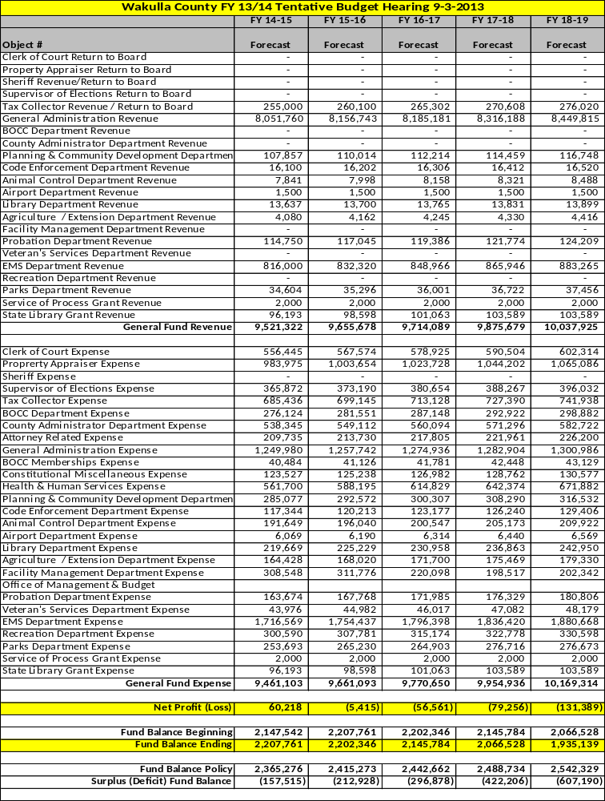
Building Department Fund

Forecast:
The fund balance for this fund has grown to a considerable amount. In the current year, FY2012/13, the BOCC approved lowering the permit and inspection fees in order to deplete some of this fund balance. This will also have the effect of assisting the County’s citizens in cost-savings related to building and development plans and hopefully spur economic growth.

The forecast is for a steady decrease in fund balance for the next 5 years. The economic recovery and housing market growth will determine when or if fees will need to be increased again. This forecast considers an increase in fees starting in FY 15/16 and continuing each year with an increase till the fund stabilizes.

Revenue Assumptions
- Forecast 2% housing start growth each year.
- Forecast 3% increase in fees in FY 14/15.
- Forecast 5% increase each year after.

Expense Assumptions
- Employee cost of living adjustments are forecast each year at 2%.
- General expenses are forecast to increase 2% each year based on the consumer price index.
- Health insurance is forecast to increase 5% each year.

Building Department Fund Five Year Plan

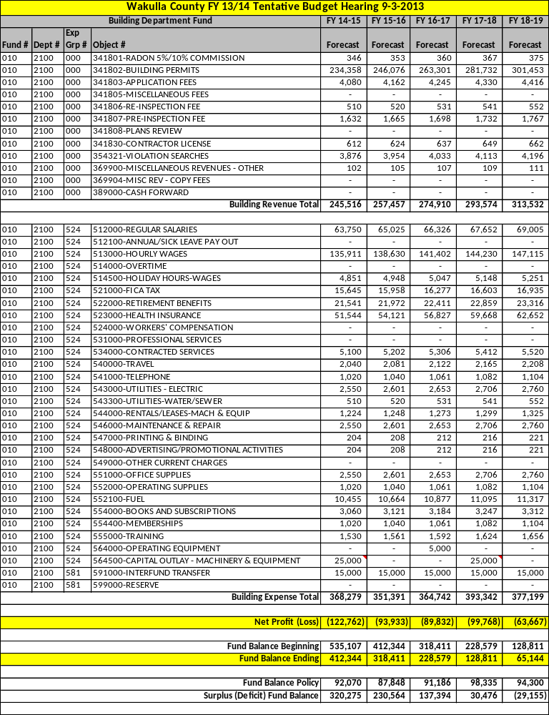
Major Special Revenue Funds Five Year Plan

Sheriff’s Fine and Forfeiture Fund

Forecast:
This fund is forecast to have a negative fund balance in FY 15/16 and beyond. Anticipated cuts of $150,000 in FY 13/14 and FY 14/15 will provide a small surplus of fund balance in the following years.

Revenue Assumptions
- Millage rate remains at 8.5, of which, 7.4 mills is assigned to this fund.
- Property values level in FY14/15 and tick up by 1% in FY15/16 and 2% thereafter.
- Forecast receiving $2,550,000 in Jail Bed revenue each year.. This assumes that a contract will be signed with ICE in the near future for either guaranteed minimum revenue or an increase in per diem rates.

Expense Assumptions
- Employee cost of living adjustments are forecast each year at 2%.
- General expenses are forecast to increase 2% each year based on the consumer price index.
- Health insurance is forecast to increase 5% each year.

Sheriff’s Fine & Forfeiture Fund Five Year Plan

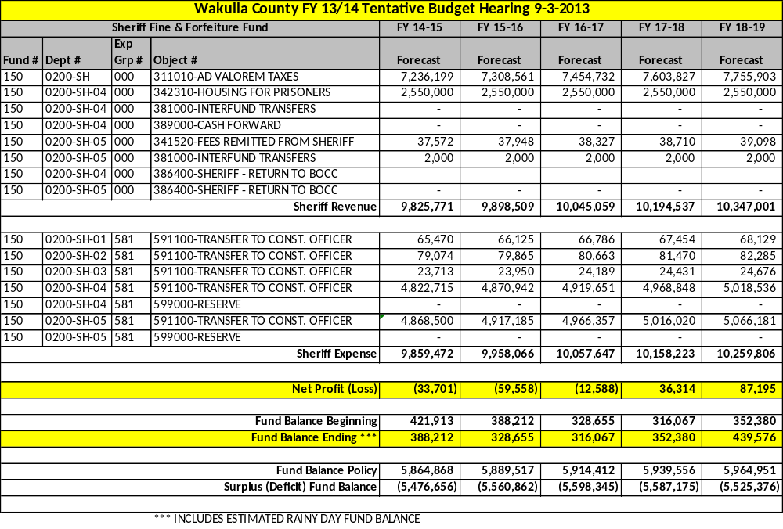

[This Page Left Intentionally Blank]

Road Department Fund

Forecast:
This fund has finally recovered from deficit fund balances and all sub-funds within this fund should reach full fund balance at the end of the five year forecast.

Revenue Assumptions
- Forecast 2% for all revenues each year.

Expense Assumptions
- General expenses are forecast to increase 2% each year based on the consumer price index.

Road Department Fund Five Year Plan

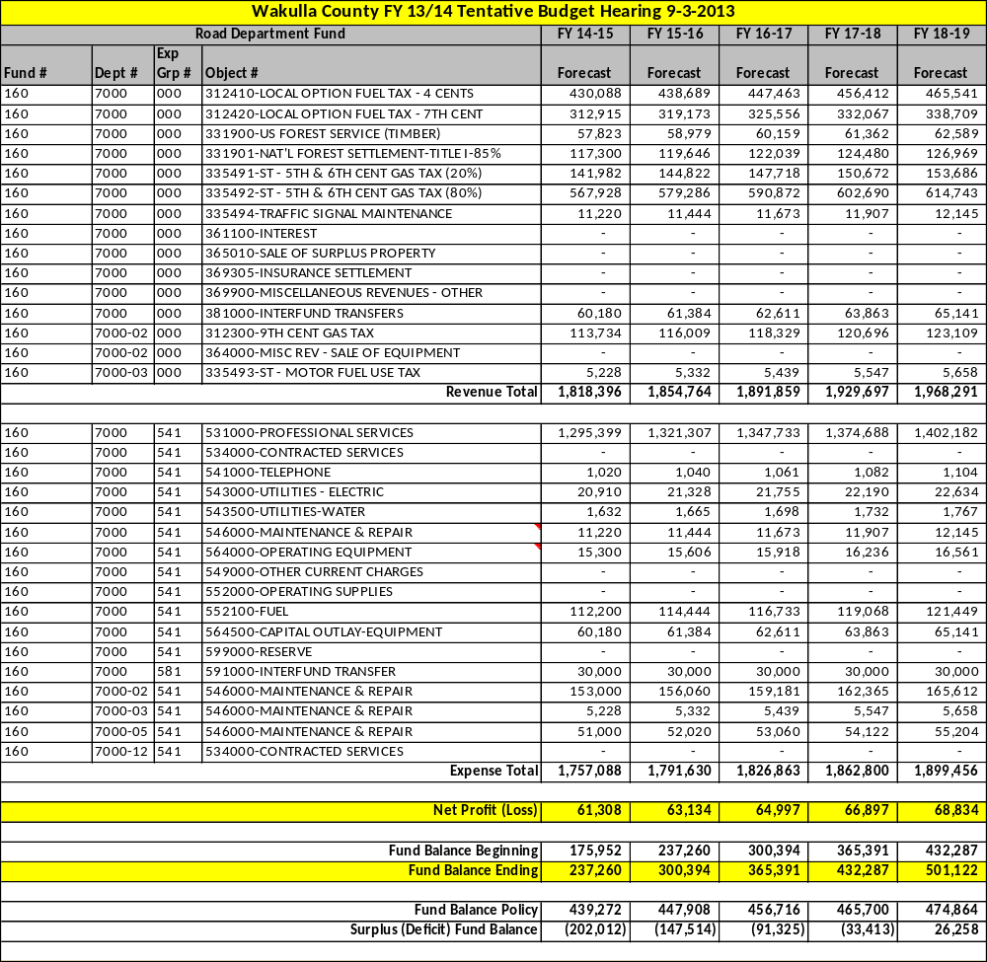
Road 2 Cent Gas Tax Fund Five Year Plan

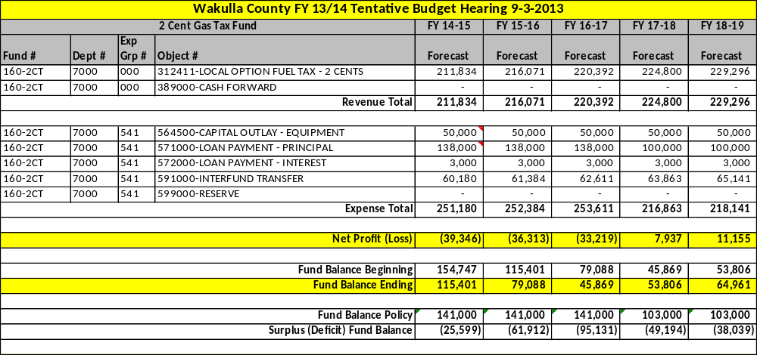

Road Title III Fund Five Year Plan

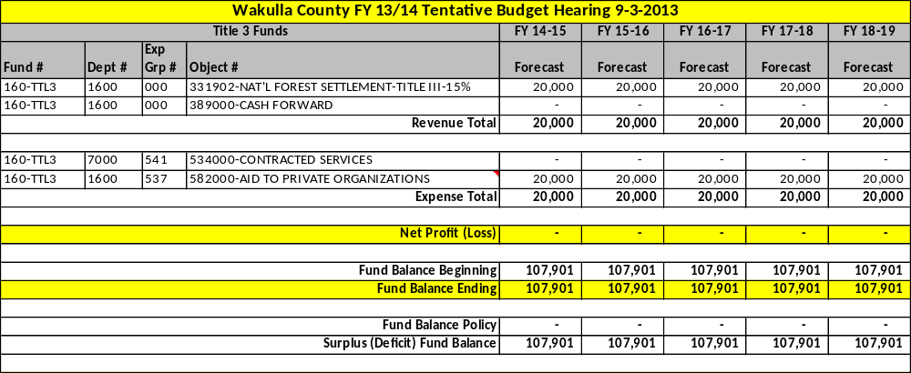

Fire MSBU Fund

Forecast:
This fund is forecast to deplete its fund balance over the 5 year period. Major needed projects are planned that will cause this fund balance decline. Once the projects are paid for then the fund balance will begin to grow again.

Revenue Assumptions
- Forecast 2% growth due to population growth each year.
- Forecast an increase in the MSBU Fee from $75 to $80 in FY16/17 to keep pace with inflation.

Expense Assumptions
- General expenses are forecast to increase 2% each year based on the consumer price index.
- Health insurance is forecast to increase 5% each year.
- Forecast includes a new fire station being financed beginning in FY15/16.

Fire MSBU Fund Five Year Plan

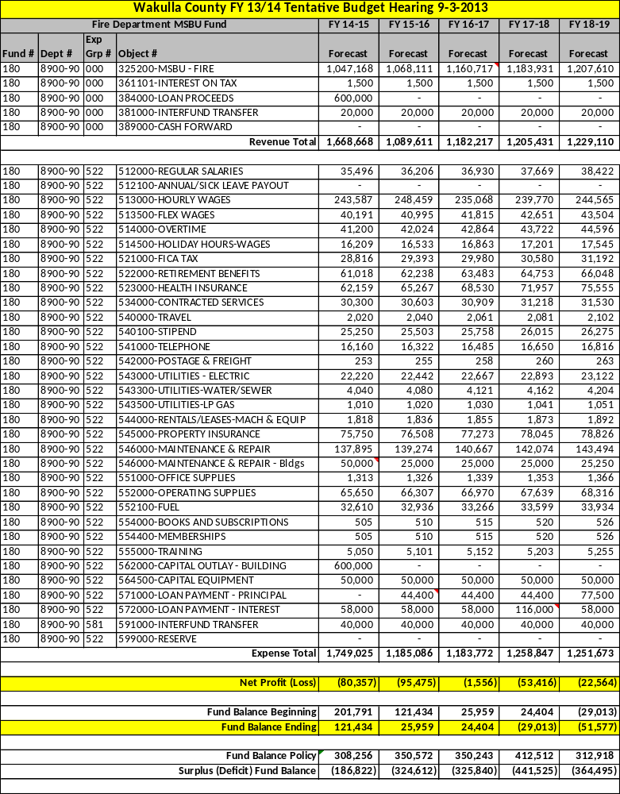

Major Capital Project Funds Five Year Plan

One Cent Sales Tax Fund

Forecast:
This fund is forecast to deplete its fund balance over the 5 year period in anticipation of the expiration of the tax in 2017. The plan includes putting the renewal of the sales tax on the 2014 ballot prior to its expiration. If the sales tax is renewed in 2014, the long range plan will involve restoring a healthy fund balance.

Revenue Assumptions
- Forecast 2% growth each year.

Expense Assumptions
- General expenses are forecast to increase 2% each year based on the consumer price index.
- Expenses associated with oil and fuel costs are anticipated to rise which will drive up the cost of paving roads or limit the number of miles we will be able to pave.

1 Cent Sales Tax Road Paving Fund Five Year Plan

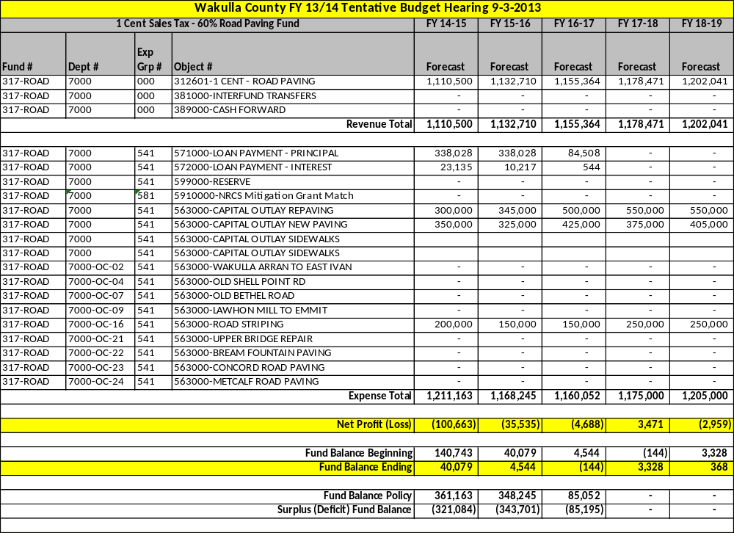
1 Cent Sales Tax Public Facility Fund Five Year Plan

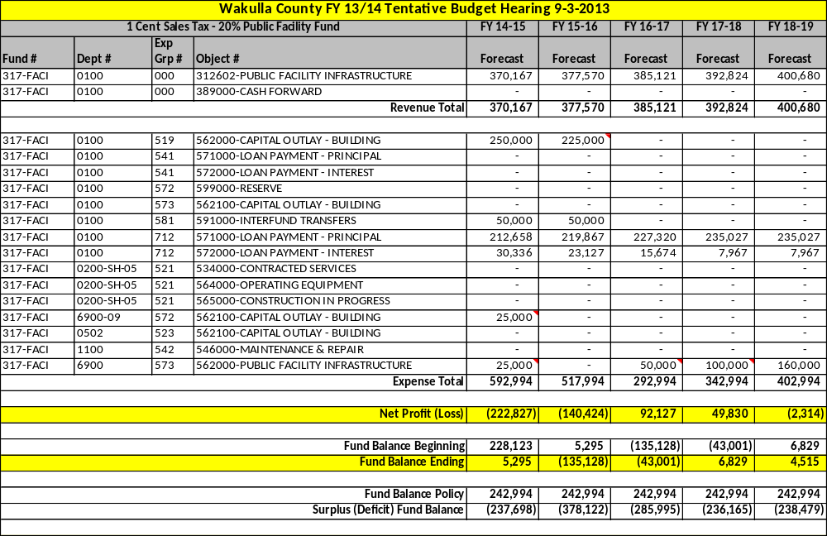

1 Cent Sales Tax Public Safety Fund Five Year Plan

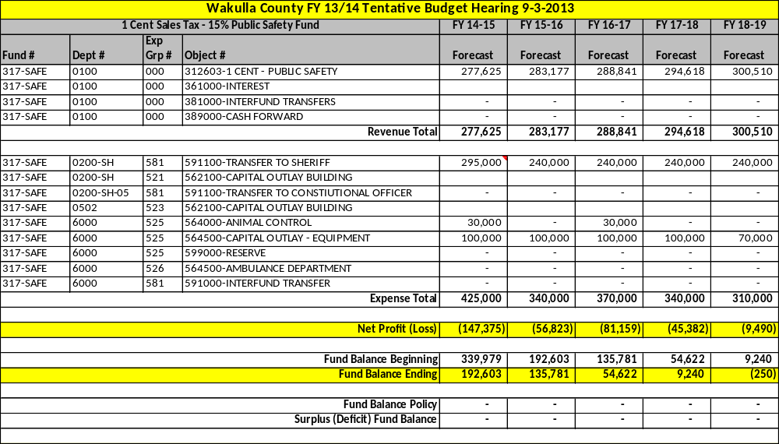

1 Cent Sales Tax Parks & Recreation Fund Five Year Plan

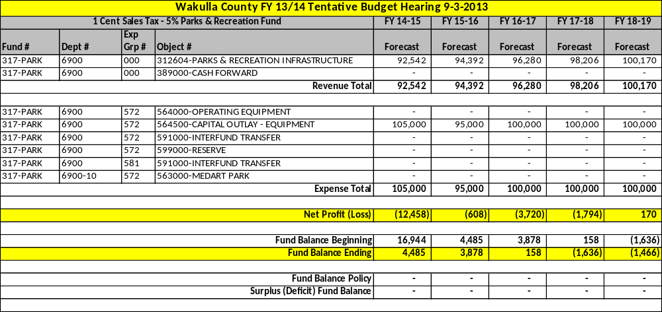

Road Paving Grant Fund

Forecast:
The forecast of this fund is based on the Florida Department of Transportation’s Five Year Plan. This plan is dependent upon approved funding levels by the Legislature and is subject to change.

Revenue Assumptions
- No assumptions are made at the County level.

Expense Assumptions
- No assumptions are made. The expenditures will match the funding levels set by FDOT.

Road Paving Fund Five Year Plan

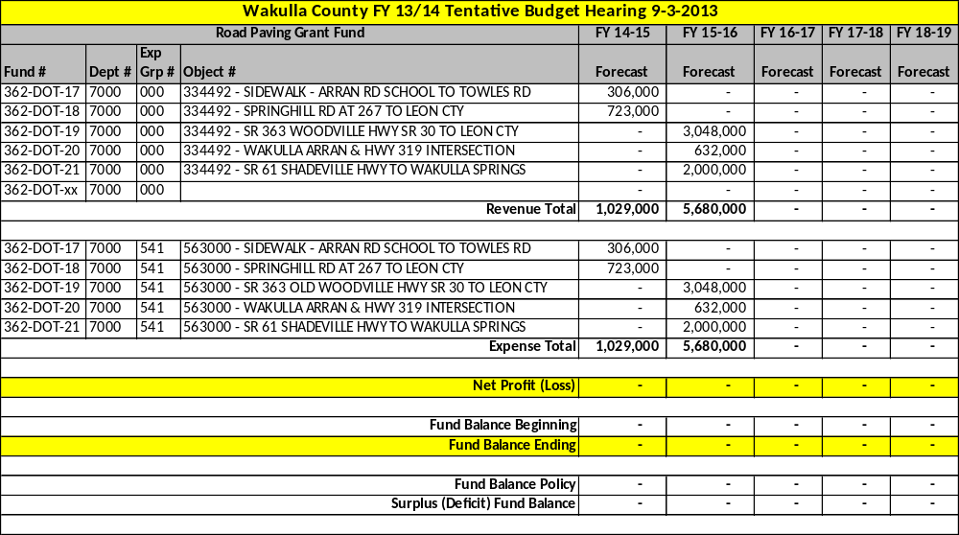

Enterprise Funds Five Year Plan

Sewer Fund

Forecast:
This fund has finally recovered from deficit fund balance and is forecast to sustain a positive fund balance through the 5 year plan period. A much needed plant expansion has not been incorporated into this model as various financing options are still being reviewed. If the U.S.D.A. grant/loan proposal is approved, the long range outlook for this fund will substantially improve.

Revenue Assumptions
- Forecast 2% increase due to population growth.

Expense Assumptions
- General expenses are forecast to increase 2% each year based on the consumer price index.

Sewer Fund Five Year Plan

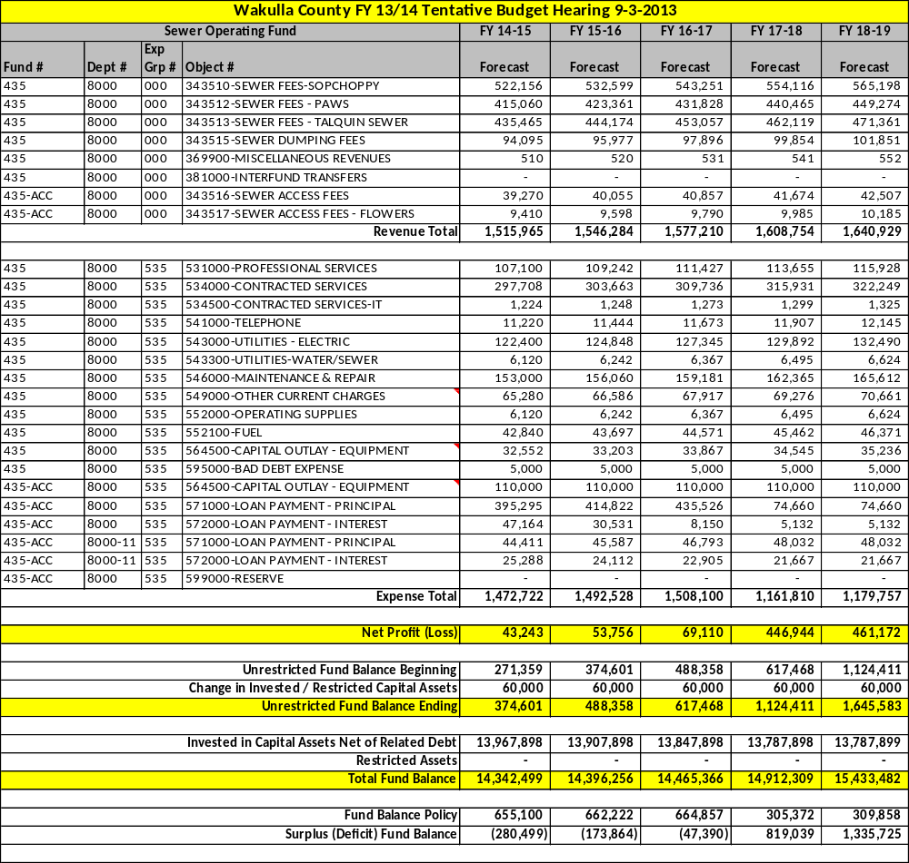

Riversink Water Fund

Forecast:
This fund is forecast to sustain a positive fund balance through the 5 year period. Any significant mechanical or equipment failures will deplete fund balance.

Revenue Assumptions
- Forecast 2% increase due to population growth.

Expense Assumptions
- General expenses are forecast to increase 2% each year based on the consumer price index.

Riversink Water Fund Five Year Plan

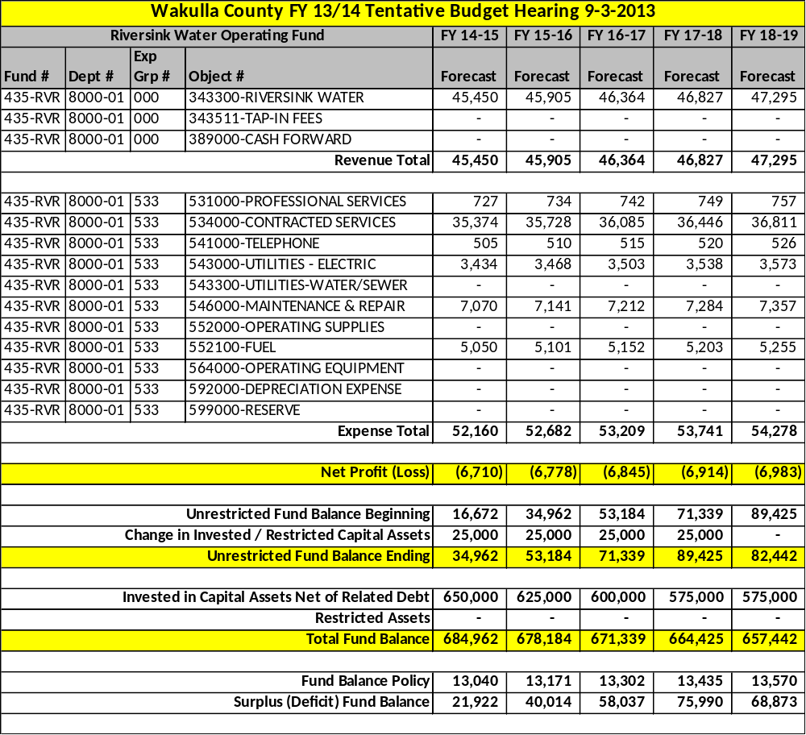

Solid Waste Fund

Forecast:
This fund has finally recovered from deficit fund balance and is forecast to sustain a positive fund balance through the 5 year plan period. The capping of the landfill, as required by Florida Department of Environmental Protection, is a project that may endanger the success of this fund depending on the final costs of the project.

Revenue Assumptions
- Forecast 2% increase due to population growth.
- An increase in the $196 fee is not planned. WastePro’s contract allows for the company to request a rate increase which would need Board approval.

Expense Assumptions
- General expenses are forecast to increase 2% each year based on the consumer price index.
- Financing of the landfill closure project is feasible with the current cost estimates. Any significant changes to these costs will be problematic for this fund.

Solid Waste Fund Five Year Plan

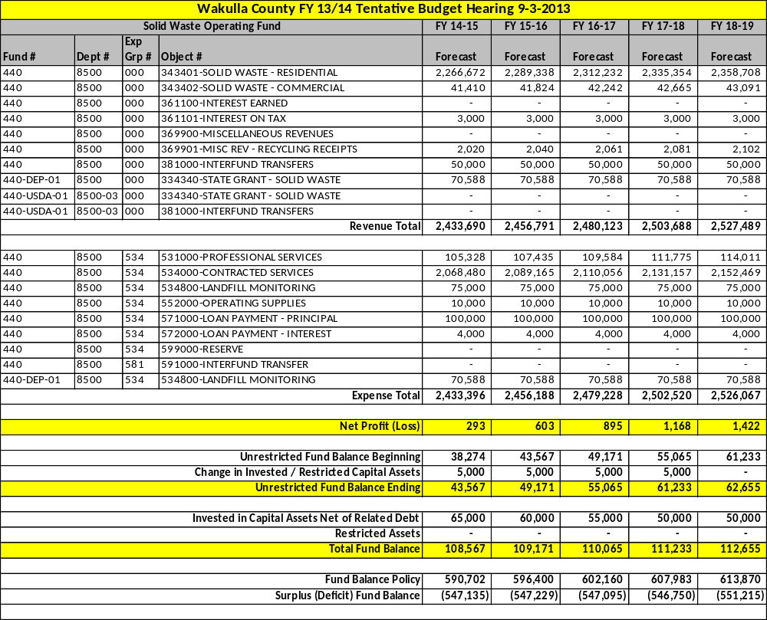
Capital Projects 5 Year Plan

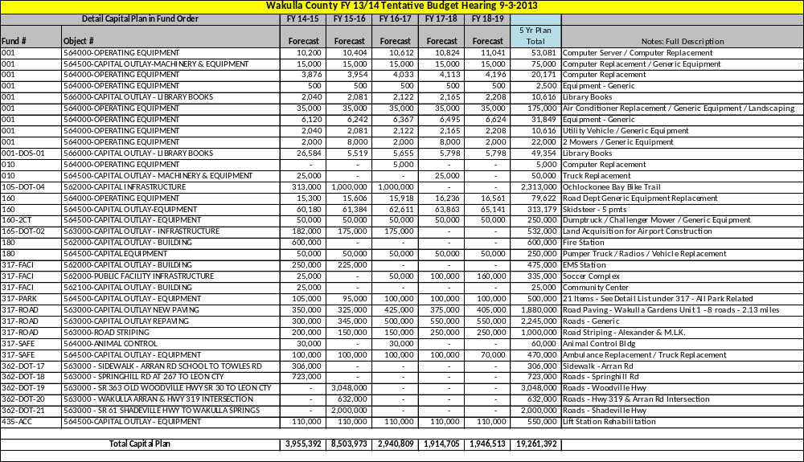

Section 6

FY 2013-14 Constitutional Officers

Detailed Budgets

[This Page Left Intentionally Blank]

Clerk of Court
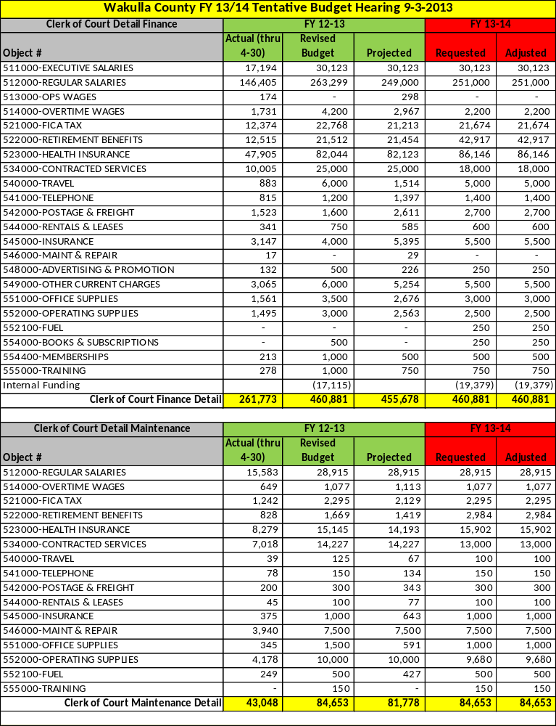
Property Appraiser
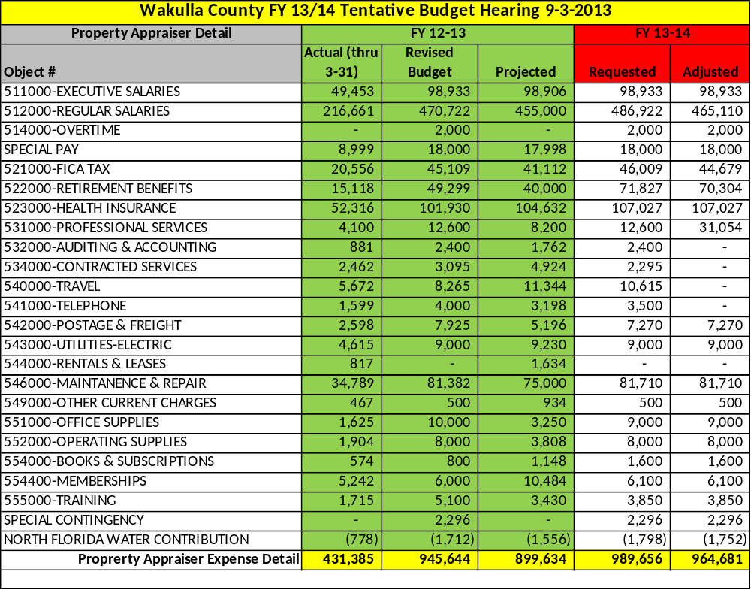

Sheriff
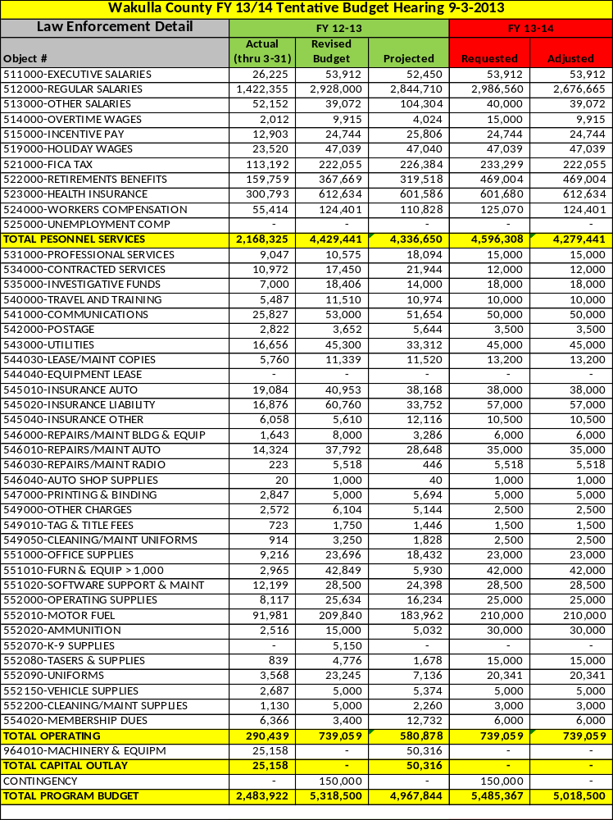
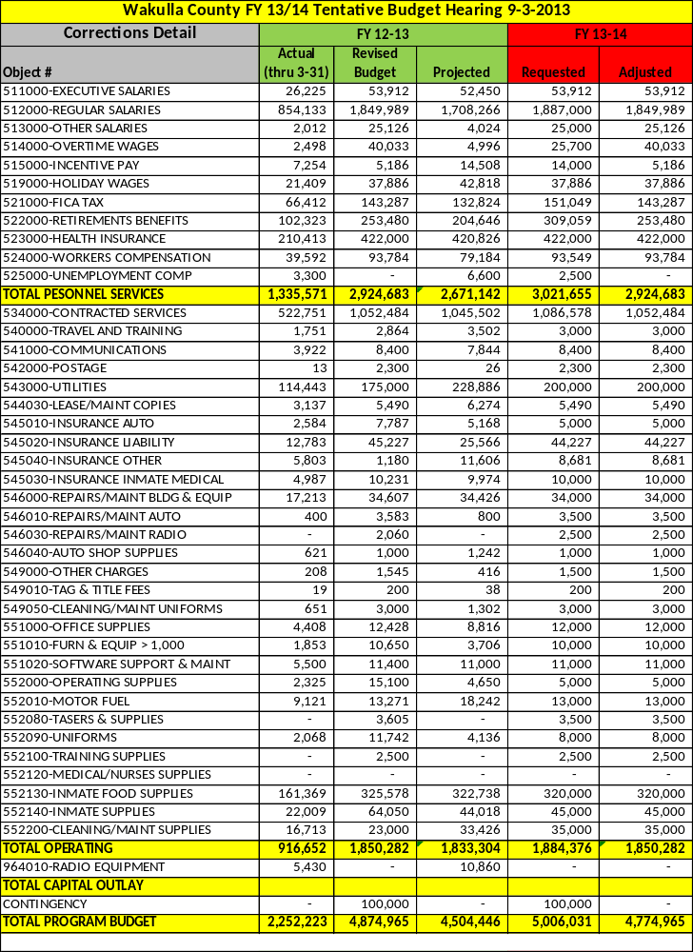
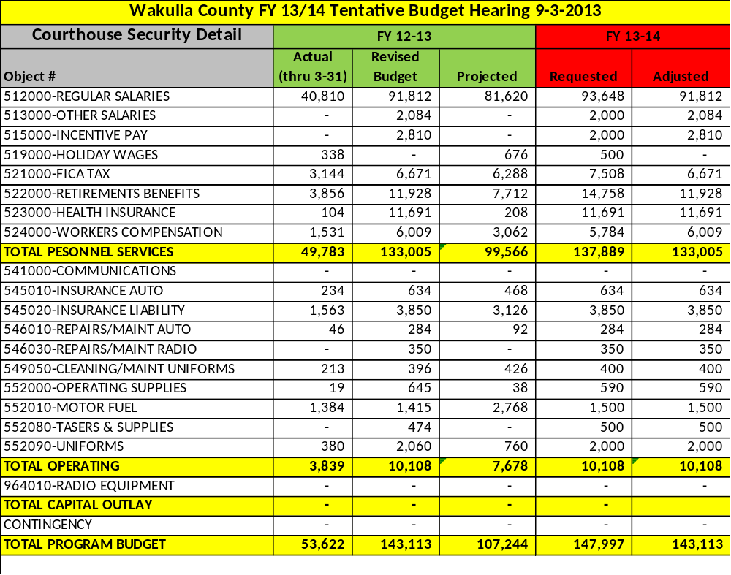

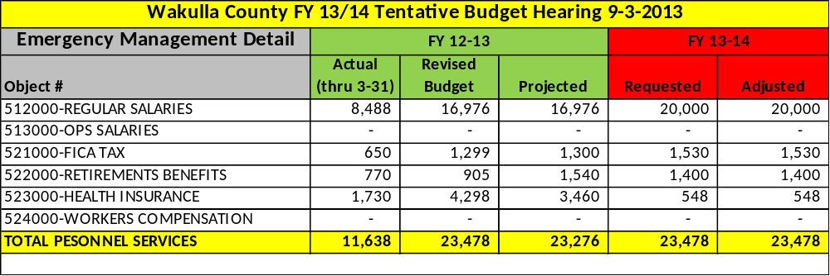

Supervisor of Elections
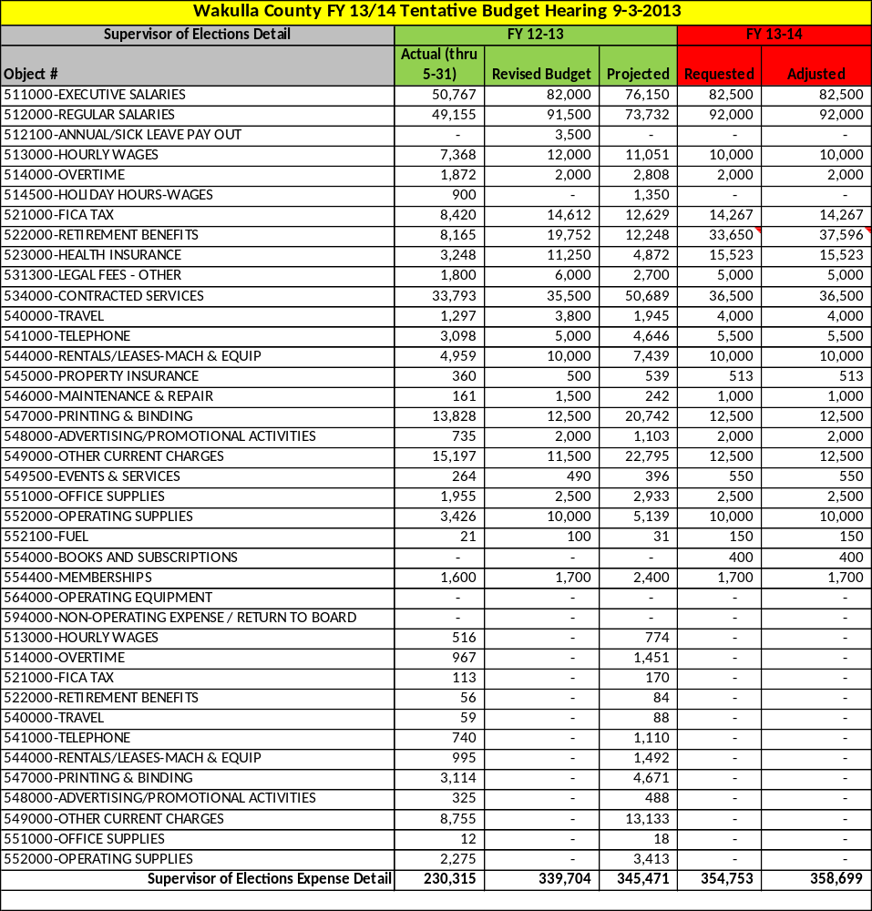

Tax Collector
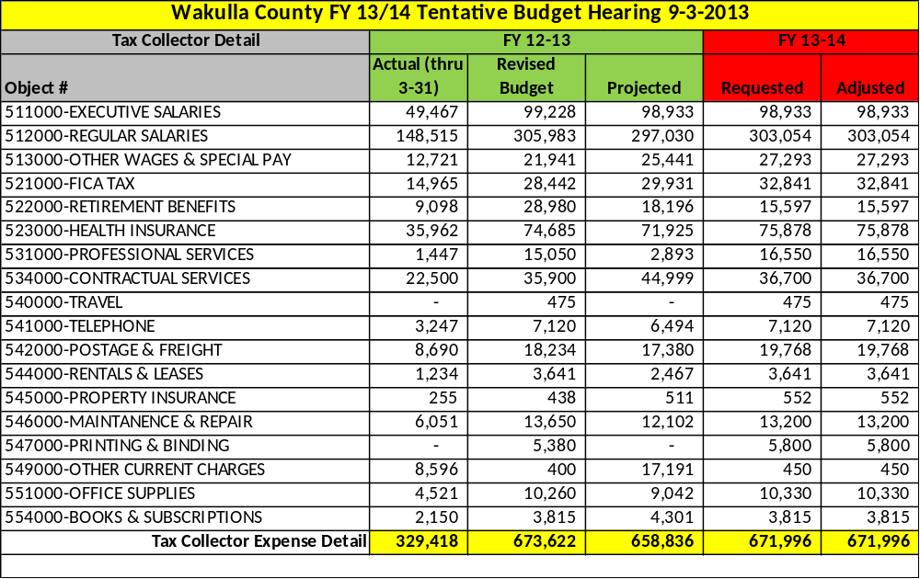

Thank you for reading the Wakulla County FY 2013/14 Tentative Budget and Five Year Plan. If you have any questions regarding the contents of this document, please don’t hesitate to call. If you have any suggestions for improving the County’s budget document or budget process, please let me know. Thank you.

J. David Edwards, County Administrator
Wakulla County Commission Complex
3093 Crawfordville Highway
Crawfordville, FL 32327
(850) 926-0919

