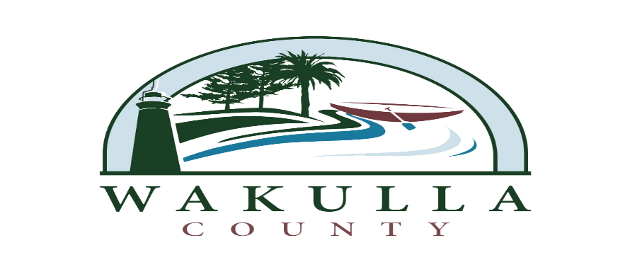
RFQ 2014-07
OBBT PHASE 3 – CEI SERVICES

AMENDMENT #2 AND NOTICE
Issued on April 23, 2014
DUE DATE/TIME FOR PROPOSALS CORRECTED – SEE BELOW

ONLY TWO PROPOSALS WERE RECEIVED IN RESPONSE TO THE RFQ 2014-07. PURSUANT TO FDOT REQUIREMENTS FOR FEDERALLY FUNDED LAP PROJECTS, WAKULLA COUNTY MUST REACH OUT TO VENDORS ON THE FDOT QUALIFIED VENDOR LIST FOR CEI SERVICES, TO SOLICIT INTERST IN THE PROJECT IN ACCORDANCE WITH THE RFQ 2014-7 CEI SERVICES/OBBT PHASE 3. THE VENDORS CONTACTED ON THE FDOT LIST, WILL HAVE UNTIL MONDAY, APRIL 28 21, 2014 @ 10:00 9:00 AM TO SUBMIT A PROPSAL IN ACCORDANCE WITH THE RFQ 2014-07 DOCUMENT(S).

VENDORS THAT SUBMITTED A PROPALS ON THRUSDAY, APRIL 3RD DO NOT HAVE TO REAPPLY.

