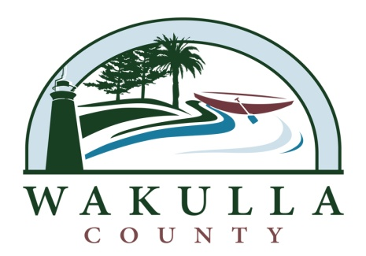

ADDENDUM #1
Project Title: OCHLOCKONEE BAY TRAIL – PHASE III
Project No.: ITB 2014-07

Section 5.0 Schedule of Events – Amended to read as follows:
Event | Date/Time
Release of Request for Proposal | MONDAY, MARCH 17, 2014, 8:00 A.M.
Technical Questions Due from Prospective Respondents | Wednesday, March 26, 2014, 3:00 P.M.
Mandatory Pre-Proposal Conference | NOT APPLICABLE
Responses to technical questions posted | Friday, March 28, 2014, 5:00 P.M.
PROPOSALS DUE TO BOCC | Thursday, April 10, 2014 Monday, April 28, 2014 @ 10:00 a.m. *
Preliminary Scoring/Shortlisting Proposers | Monday, April 14, 2014, 5:00 P.M. Monday, May 5, 2014, 5:00 p.m.*
Oral presentations/Interviews of Shortlist Proposers (IF APPLICABLE) | Tuesday, April 15, 2014 Thursday, May 8, 2014 *
Final Scoring/Ranking/Selection | Wednesday, April 16, 2014, 8:00 A.M. * Tuesday, May 13, 2014
Posting of Intended Award | Wednesday, April 16, 2014, 8:00 A.M. * Tuesday, May 13, 2014
Board Consideration of Intended Award and Contract | Monday, April 21, 2014 ASAP after FDOT Approval of Preliminary Award (contingent upon FDOT Approval)
Anticipated Beginning of Work | Upon FDOT APPROVAL and Issuance and Acceptance of Notice to Proceed

*See Amendment #2 to this RFQ; changes were required to the Schedule of Events and all changes are as modified.

