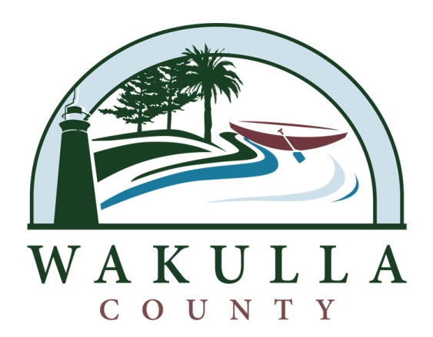
Legal Advertisement

WAKULLA COUNTY BOARD OF COUNTY COMMISSIONERS

BOSTIC PELT ROAD NRCS DRAINAGE IMPROVEMENTS
Invitation to Bid No. ITB 2014-02
Advertisement Begin Date/Time: January 1, 2014, 8:00 am

Board Decisions will be available at: 3093 Crawfordville Highway, Crawfordville, FL 32327.

Sealed responses for Bostic Pelt Road NRCS Drainage Improvements addressed to the Wakulla County Purchasing Director, at 3093 Crawfordville Highway, Crawfordville, FL 32327 will be received until January 29, 2014, 11 am, at which time all proposals will be publicly opened. Any responses received after the time and date specified will not be accepted and shall be returned unopened to the Proposer.

Please direct all questions to:
Katie Taff
Phone: 850.926.0919 Ext 704, FAX: 850.926.0940
e-mail: ktaff@mywakulla.com

Copies of the Invitation to Bid and the Plans and Specifications Packages may be obtained at the Wakulla County Purchasing Office at 3093 Crawfordville Highway, Crawfordville, FL 32327 for a non-refundable deposit of $50.00 beginning January 1, 2014, 8am. Checks or money orders only please - made payable to: Preble-Rish, Inc.

No pre-bid meeting will be held for this project. All Bidders are encouraged to visit the site to become familiar with the project area.

Any person with a qualified disability requiring special accommodations at the bid opening shall contact purchasing at the phone number listed above at least 5 business days prior to the event. If you are hearing or speech impaired, please contact this office by using the Florida Relay Services which can be reached at 1.800.955.8771 (TDD).

The Board of County Commissioners reserves the right to reject any and all bids or accept minor irregularities in the best interest of Wakulla County.

Richard Harden, Chairman
Katie Taff, Procurement and Contracts Management Coordinator

