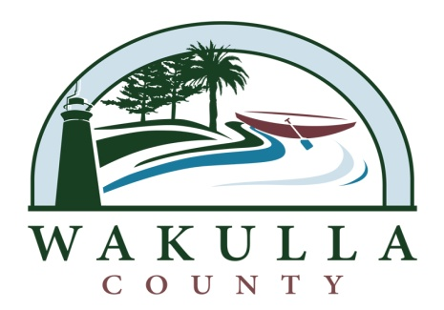

ADDENDUM #1

SECTION 00410 – BID SCHEDULE
Project Title: OCHLOCKONEE BAY TRAIL – PHASE III
Project No.: ITB 2014-08

CALENDAR OF EVENTS

EVENT | DATE & LOCATION
ITB Released and Advertised | Monday, March 24, 2014
Technical Questions Due from Prospective Respondents | Monday, March 31, 2014
MANDATORY PRE-BID MEETING  29 ARRAN RD. CRAWFORDVILLE, FL | Thursday, April 3, 2014 @ 9:30 am, Wakulla County Board of County, Commissioners Chambers
Responses to Technical Questions Posted | Monday, April 7, 2014
Prequalification Documents Submitted to BOCC | Wednesday, April 9, 2014
Vendor Prequalification List Posted | Monday, April 14, 2014
Prequalified Vendor Questions to BOCC | Thursday, April 17, 2014
BOCC Answers to Prequalified Vendor Questions | Monday, April 21, 2014
BIDS DUE TO BOCC | Thursday, April 24, 2014 3:00 P.M.
Posting of Intended Award | Thursday, May 1, 2014
To Board for Final Approval | Monday, May 5, 2014
Anticipated Start Date | Upon Notice to Proceed

** All sections of this ITB for bid submittal shall proceed with the date and time of Thursday, April 24, 2014 at 3:00 p.m.

