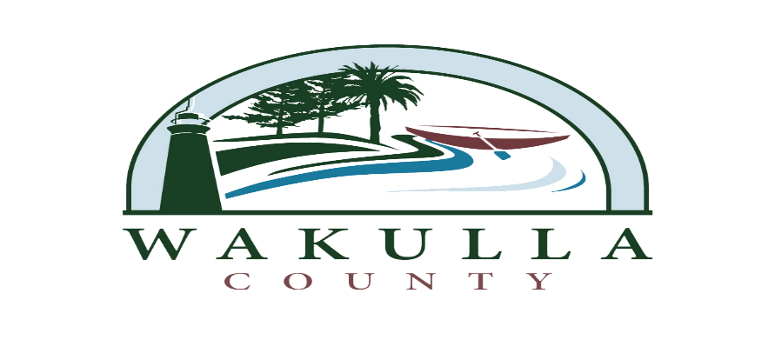
ITB 2014-08
OBBT PHASE 3 – CONSTRUCTION
PRE-QUALIFIED FIRMS

- Allen’s Excavating
6403 Woodville Highway
Tallahassee, FL

- CW Roberts
3372 Capital Circle NE
Tallahassee, FL

- M of Tallahassee
4223 Capital Circle NW
Tallahassee, FL

- North Florida Asphalt
2909 Plant St.
Tallahassee, FL

- Peavy and Son
P.O. Box 2369
Havana, FL

